

**Help**



# **MASTERS**

## **User Management**

### Step1- For first time login

use following credentials

* **User- username as provided**
* **Password -Pass123**
* **Company -Test**
* **Audit- Test**

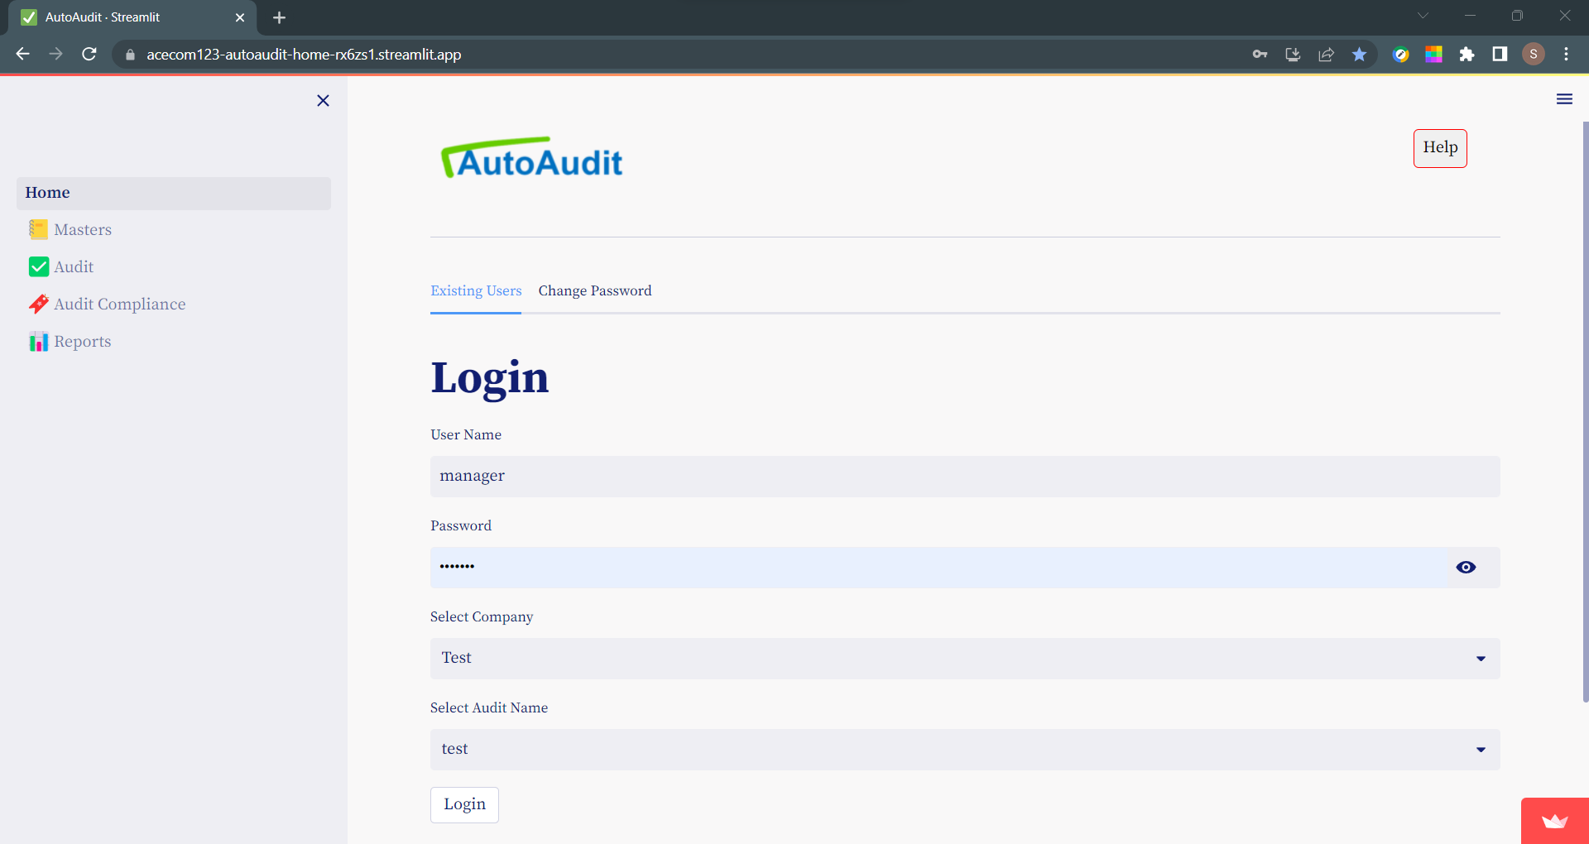

### Stet2- Create Company

This user with Manager rights- can now create a company.

Inter following details:

* name of company
* address of company and
* email address
* Fields marked with **\*** symbol are mandatory

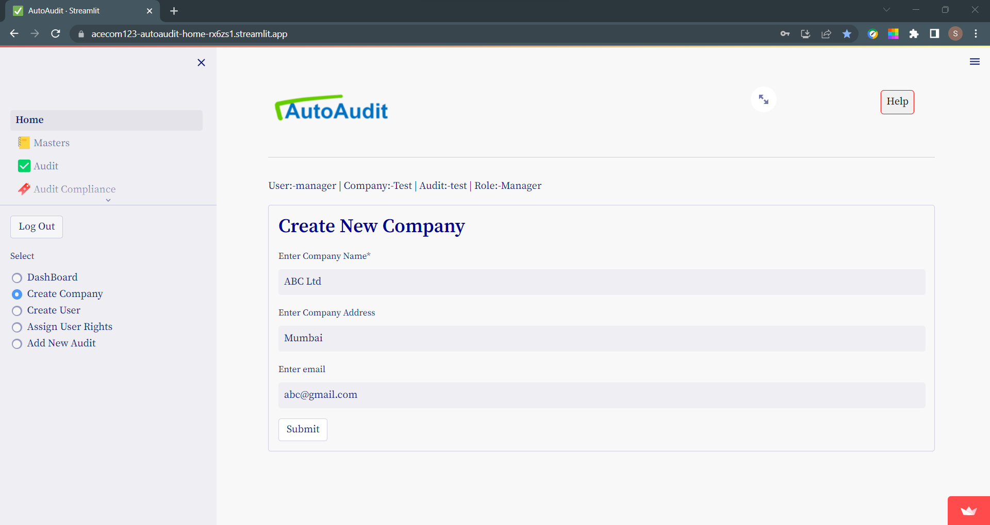

### Step 3- Create User

To create user-

Click on **Home** menu & then click on **create user** option button

Enter the details as under:

* user id (id can not be Duplicate)
* default password (*New user will login with default password and he can change his password later on)
* designation
* Fields marked with **\*** symbol are mandatory

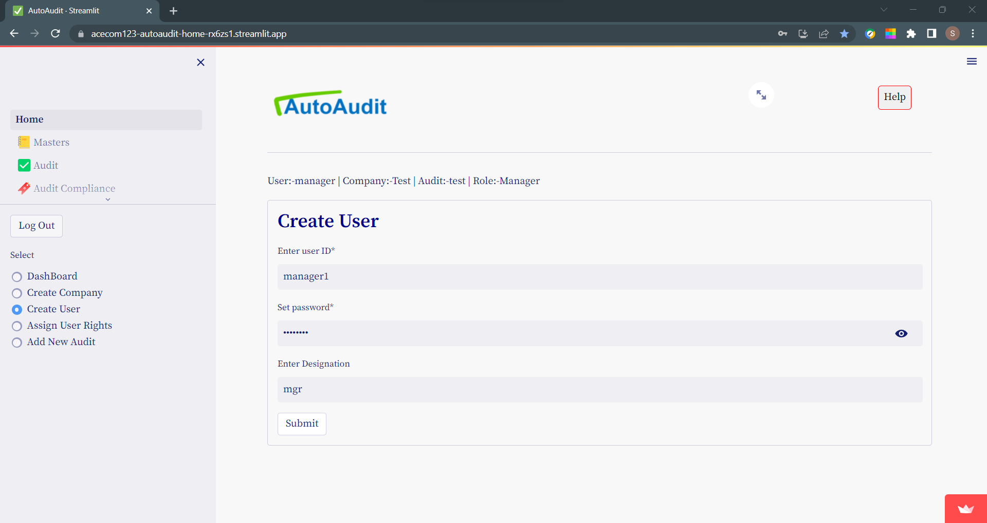

### Step 4- Assign User Rights for Company

For each Company –

* Create At least 1 user with User Right – Manager
* Create At least 1 user with User Right – Auditee
* 1 person can have Only 1 Role in that Company.

To assign user rights- select **Home** menu then select **Assign user rights** option button

* First select the company - then select user.
* Now select the User Role.

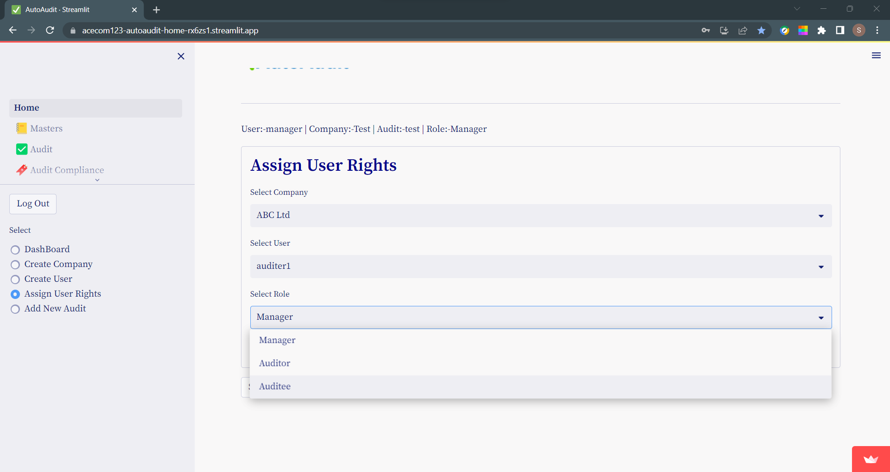

To see user rights - click on **show user rights** button.

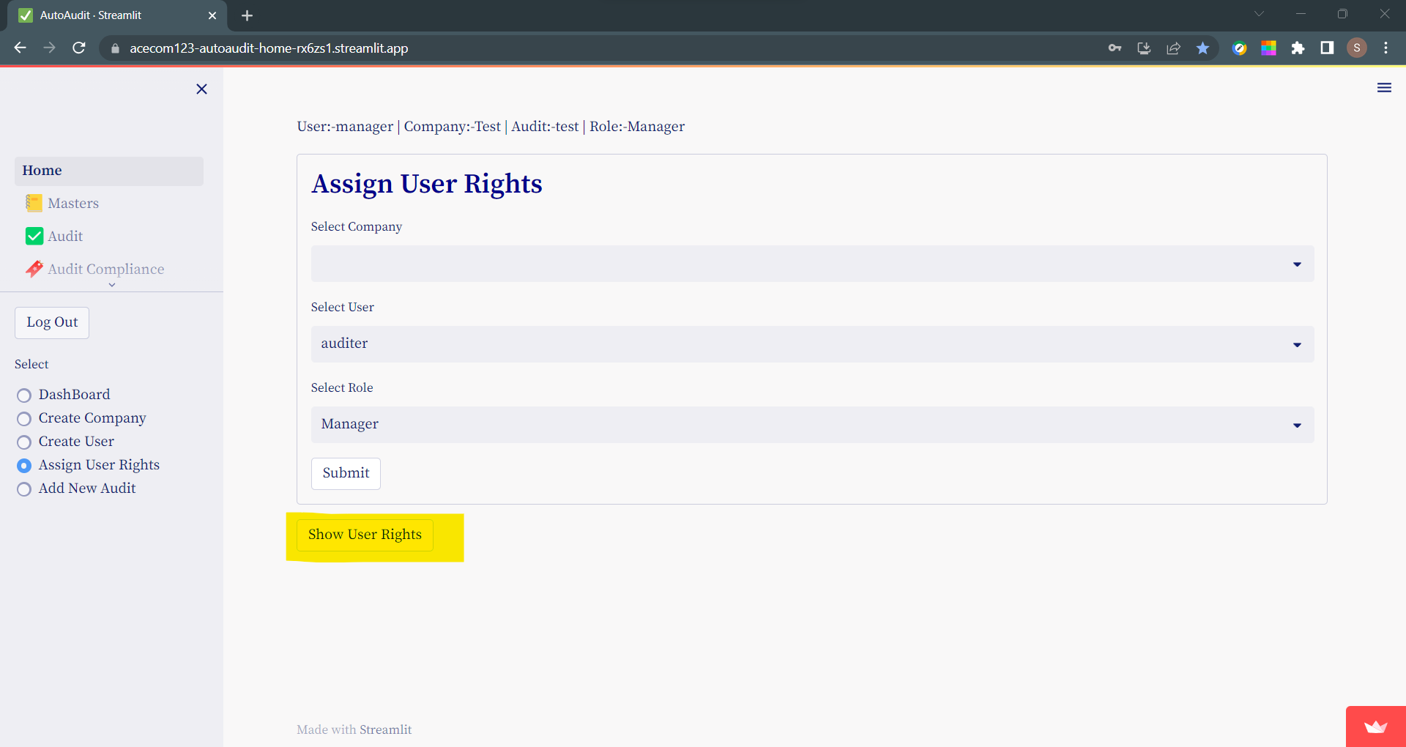

### Step 5- Create Audit

User with User Right – **Manager** -can only create Audit.

For each company there can be multiple audits.

To create new audit - select **Home** menu then select **Add new audit** option button

Enter following details:

* audit name (must be unique)
* company
* audit period
* remarks

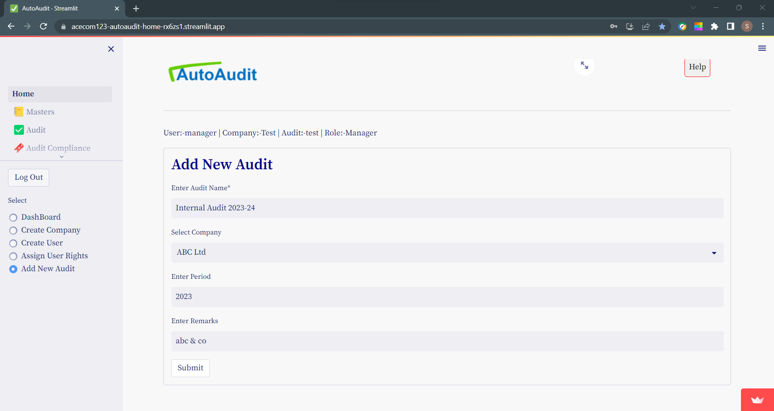

### Types of Users

|  |  |  |
| --- | --- | --- |
| **Type** | **Access /Rights** | **Can Not Access** |
| Manager | Admin Rights / Access to all |  |
| Auditor | Can Do All Audit Activities | User Management  Company Management  Audit Management  Auditee Role |
| Auditee | Reply to Audit Queries | User Management  Company Management  Audit Management  Auditor Role |

## **Import Data for Audit**

Find Vouching, Verification and other auditing procedures data can be imported in AutoAudit.

We call this Data as Data Set.

Data can be imported in various formats & modes- like csv, xlsx ,JSON,api, sql.

To import data for Audit: Go to menu **Masters** and then select option button- **Add new dataset**

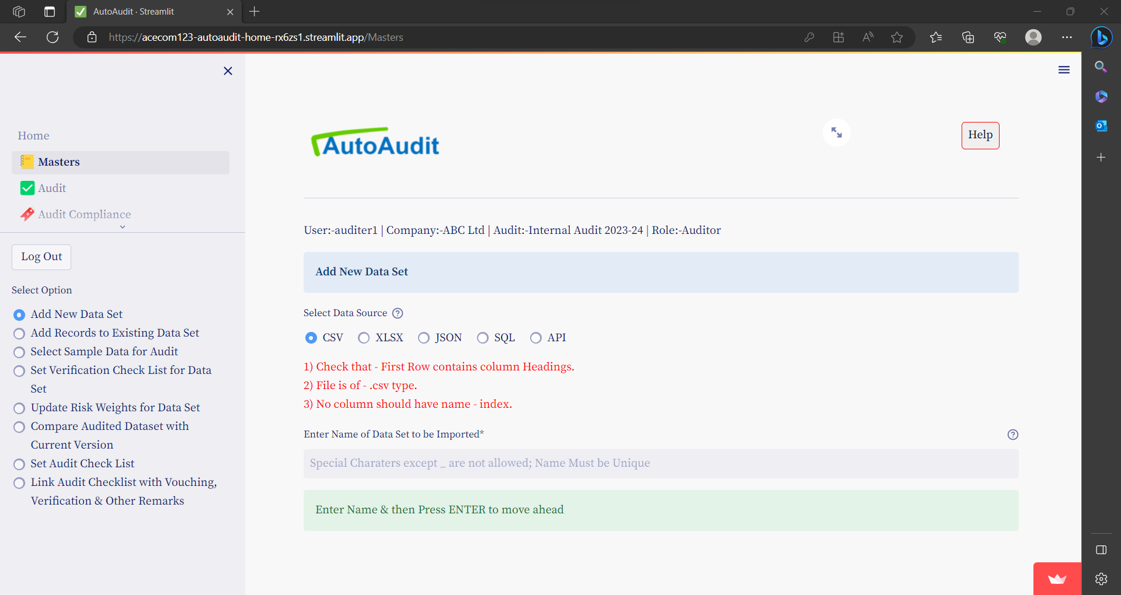

### Import CSV files

To import data for Audit: Go to menu **Masters** and then select option button- **Add new dataset**

Under Select Data Source- select option button- **CSV**



1) Check that - First Row contains column Headings.  
2) File is of - .csv type.  
3) No column should have name - index.

Enter Name of Data Set to be Imported & Press ENTER

Following Additional Fields will appear

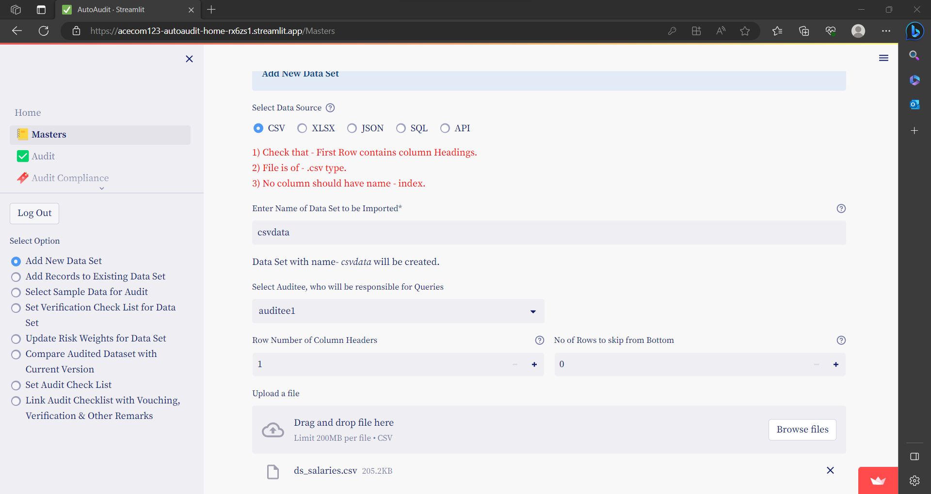

* Select Auditee, who will be responsible for Queries
  + Select Auditee from Drop Down-Select Auditee, who will be responsible for Queries
* Row Number of Column Headers
  + Row Number for Header...from this row Data will be imported.
* No of Rows to skip from Bottom
  + for these rows from Bottom of Table, Data will be imported.
* To upload CSV file Click of Browse Files & select file to upload
* Preview Data
  + Once file is uploaded you can see Preview of Data & can Alter above Fields get desired output

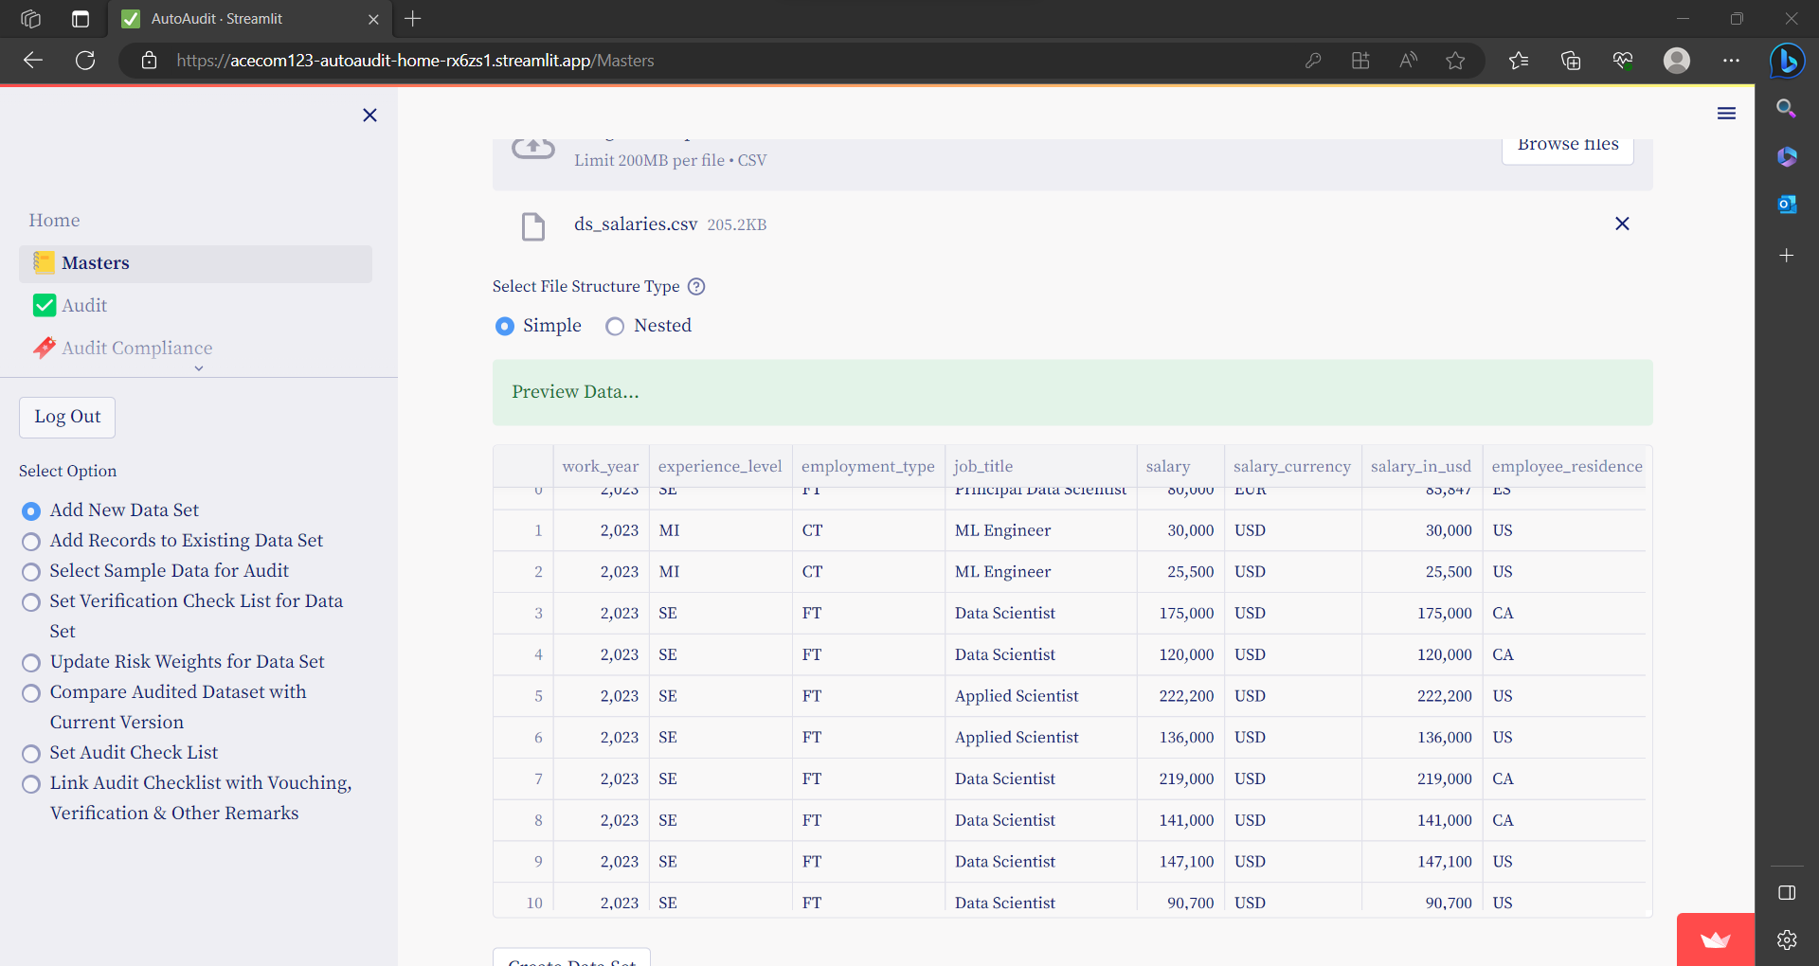

* Finally to import above Data click on **Create Data Set** Button

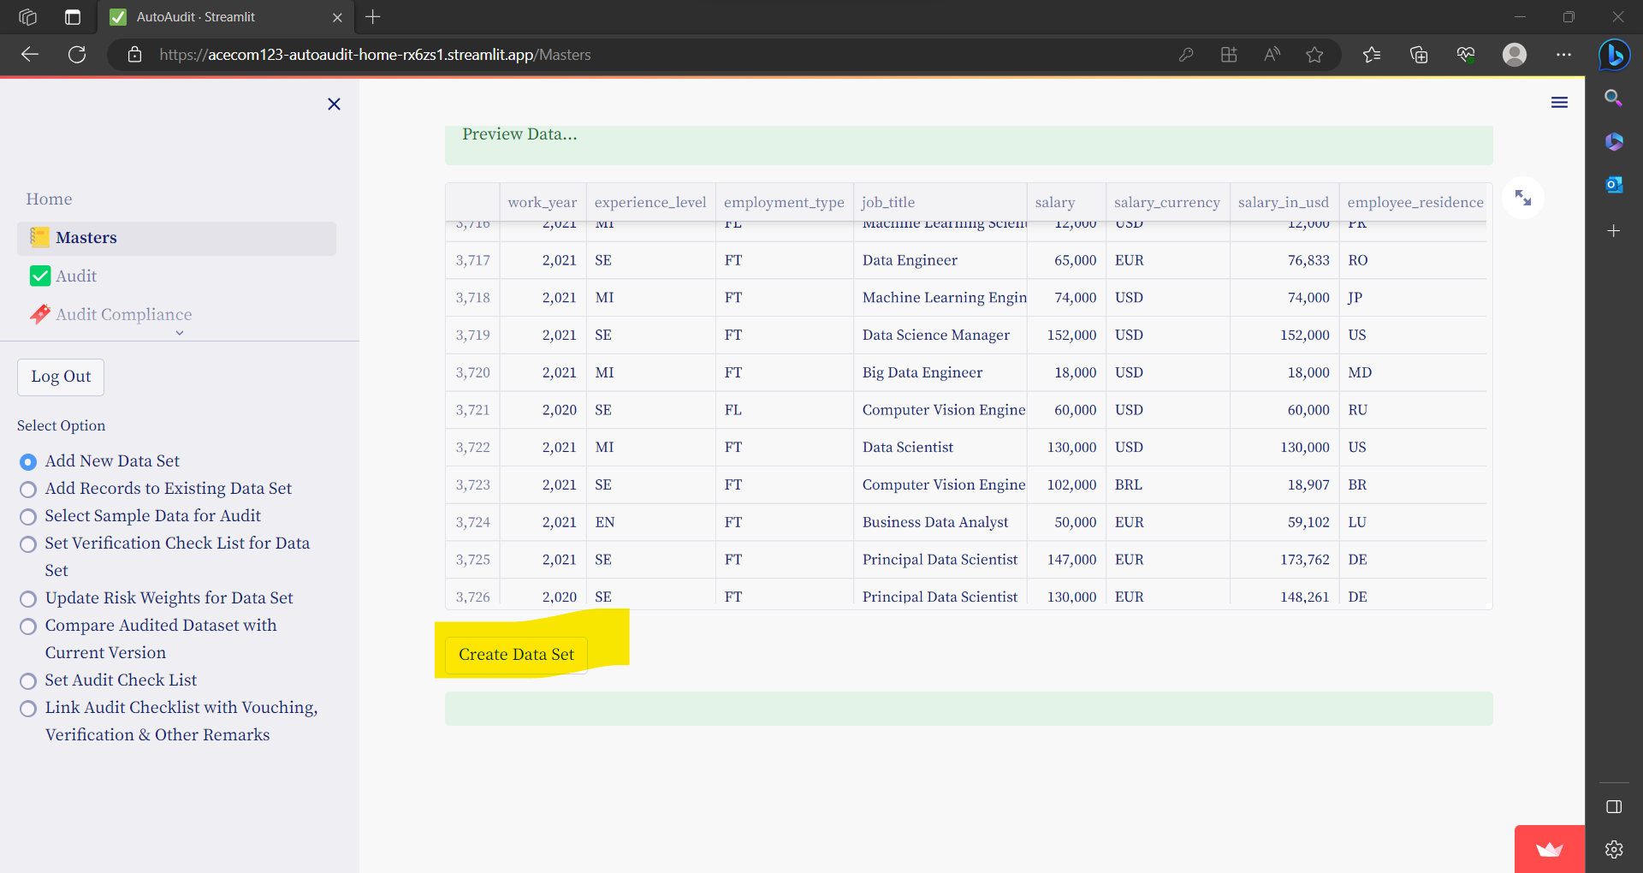

* On successful Import following Message will appear

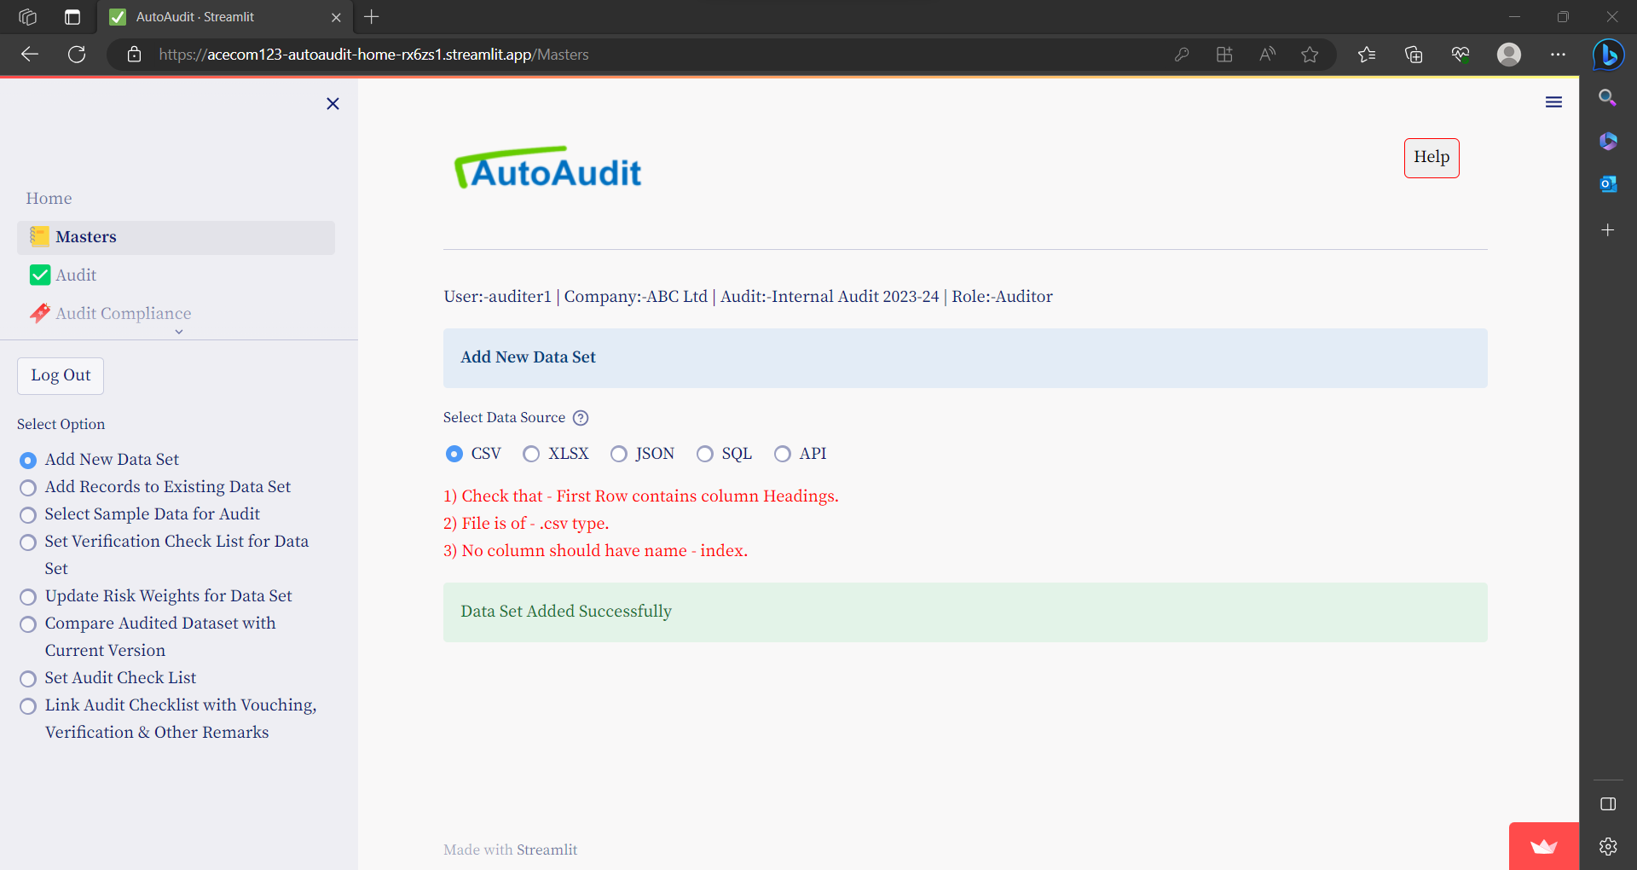

#### Import Nested CSV

Nested csv is the file in which parent and child records are all listed.

For example, every sales invoice has multiple stock items.

So in such csv file, sales invoice number is repeated.

Eg

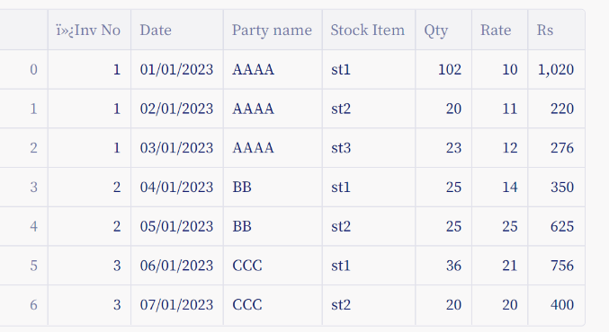

By using **nested** csv format ,you can show data for each sales invoice in single line item. Like under-

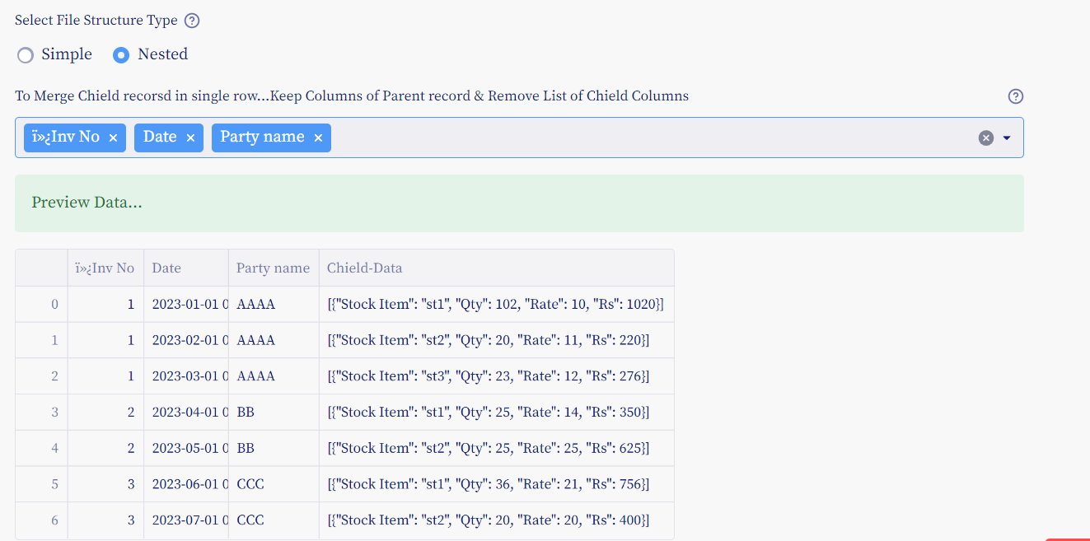

To get only Parent such output- keep fields (like Sales Invoice No ,Date ,Party Name) & remove all child fields (like- Stock item , Qty, Rate Rs)

### Import XLSX files

To import data for Audit: Go to menu **Masters** and then select option button- **Add new dataset**

Under Select Data Source- select option button- **XLSX**

1) Check that - First Row contains column Headings.  
2) File is of - .xlsx type.  
3) File contains only 1 sheet.  
4) No column should have name - index.

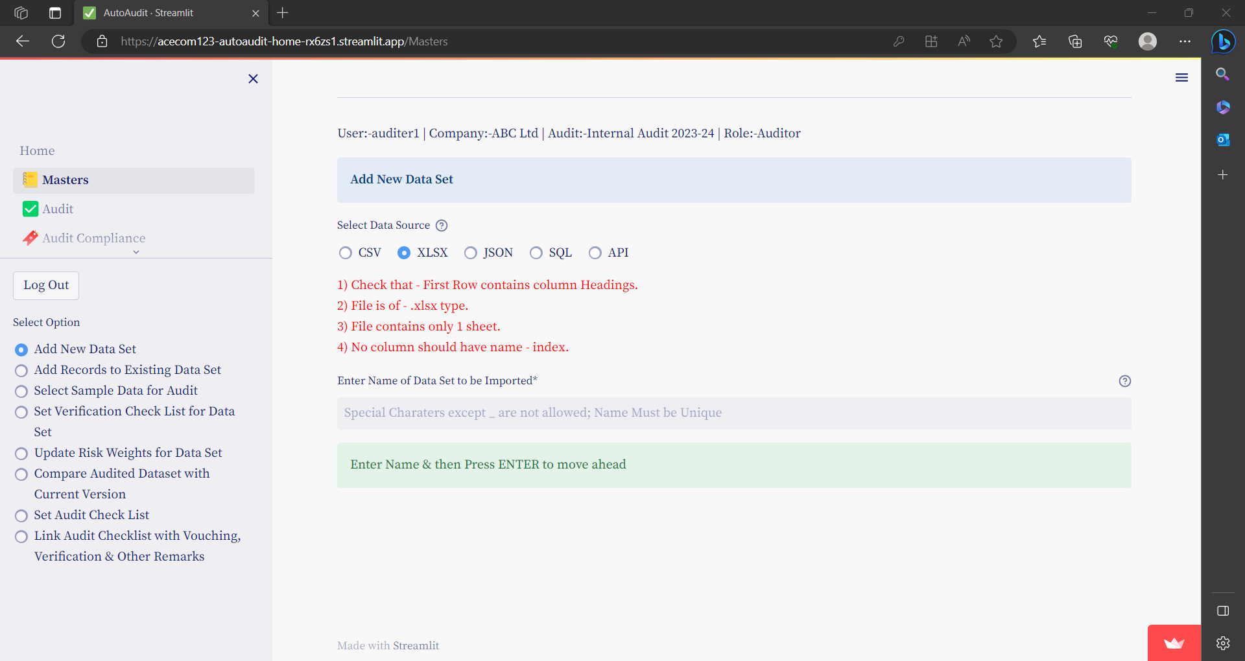

Enter Name of Data Set to be Imported & Press ENTER

Following Additional Fields will appear

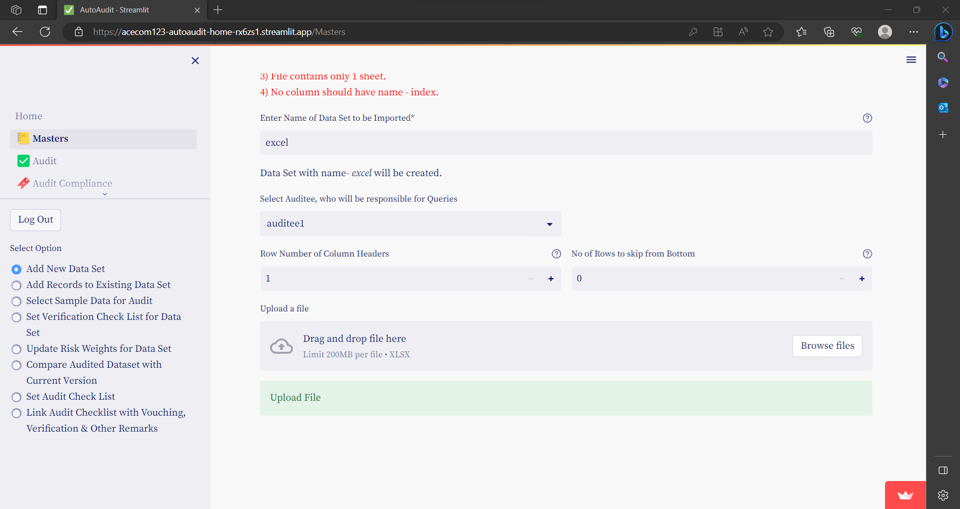

* Select Auditee, who will be responsible for Queries
  + Select Auditee from Drop Down-Select Auditee, who will be responsible for Queries
* Row Number of Column Headers
  + Row Number for Header...from this row Data will be imported.
* No of Rows to skip from Bottom
  + for these rows from Bottom of Table, Data will be imported.
* To upload XLSX file Click of Browse Files & select file to upload
* Preview Data
  + Once file is uploaded you can see Preview of Data & can Alter above Fields get desired output

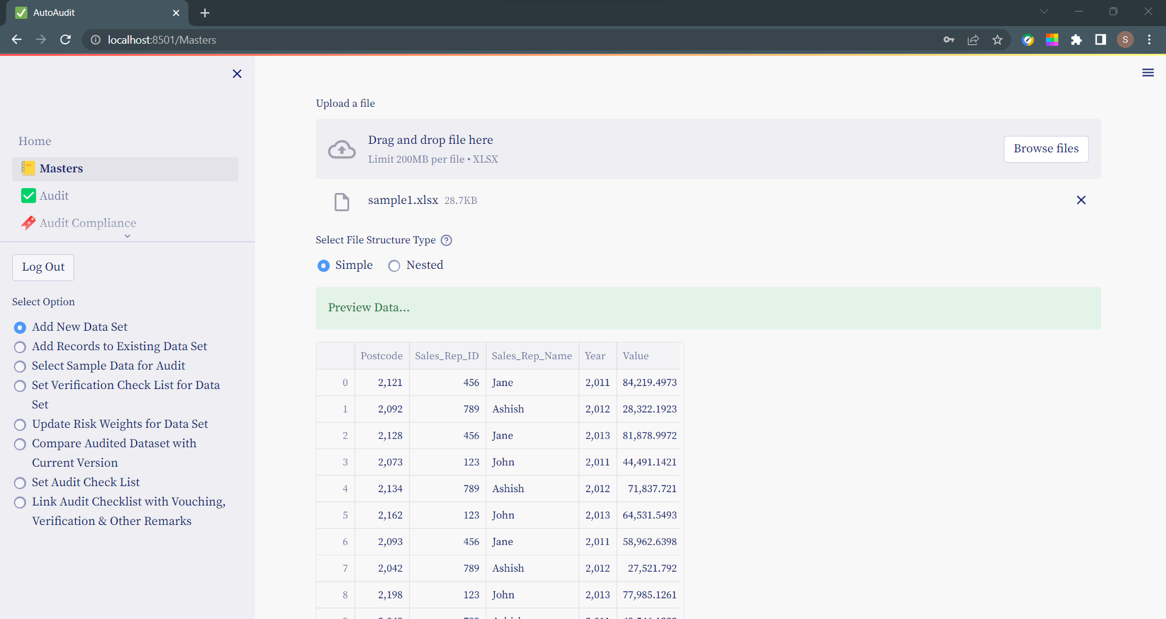

* Finally to import above Data click on **Create Data Set** Button

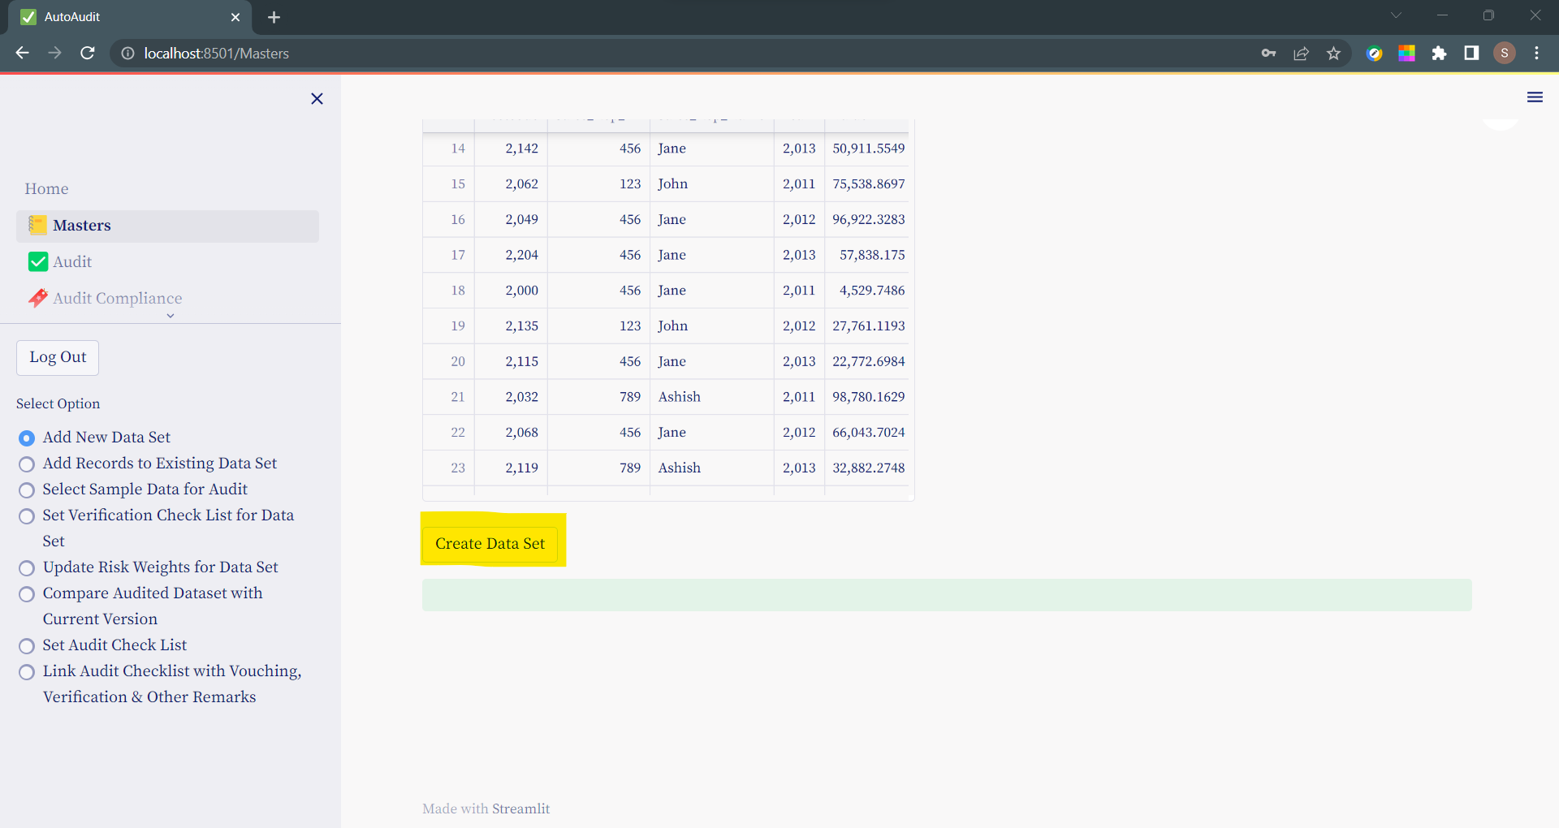

* On successful Import following Message will appear

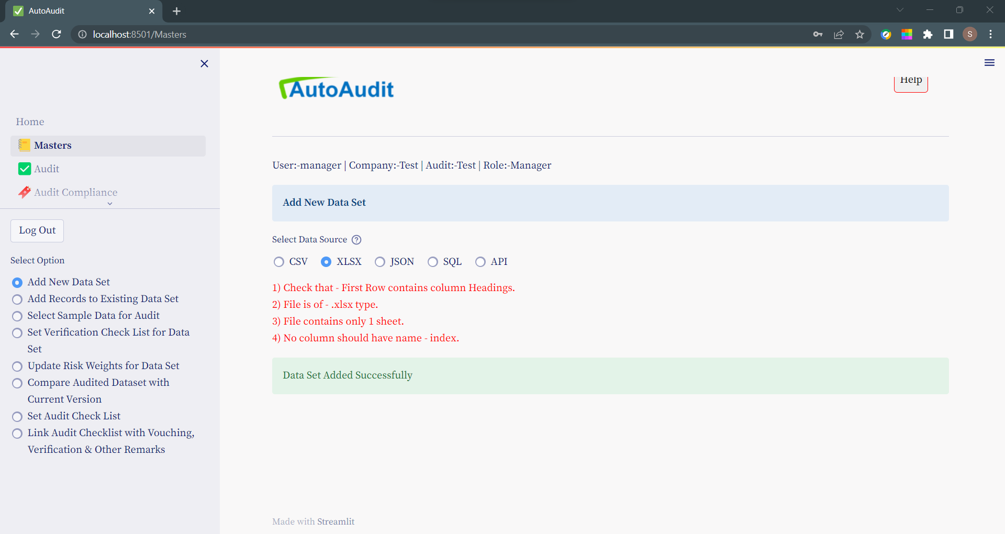

#### Import Nested XLSX

Nested csv is the file in which parent and child records are all listed.

For example every sales invoice has multiple stock items.

So in such file ,sales invoice number is repeated.

Eg



By using **nested** format ,you can show data for each sales invoice in single line item. Like under-



To get such output- keep only Parent fileds (like Sales InvoiceNo ,Date ,Party Name) & remove all child fields (like- Stock item , Qty,Rate Rs)

### Import JSON files

To import data for Audit: Go to menu **Masters** and then select option button- **Add new dataset**

Under Select Data Source- select option button- **JSON**

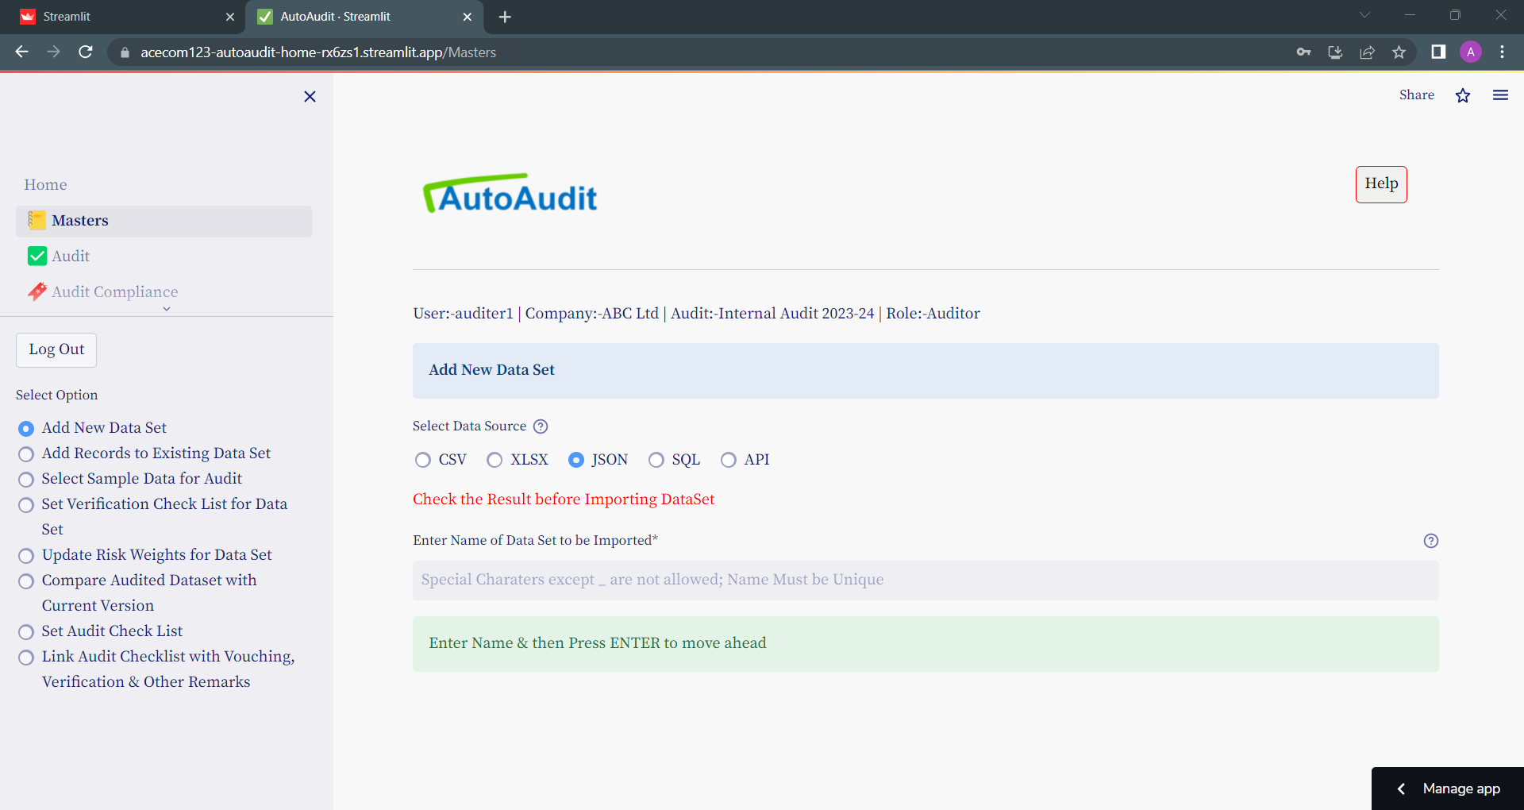

Enter Name of Data Set to be Imported & Press ENTER

Following Additional Fields will appear

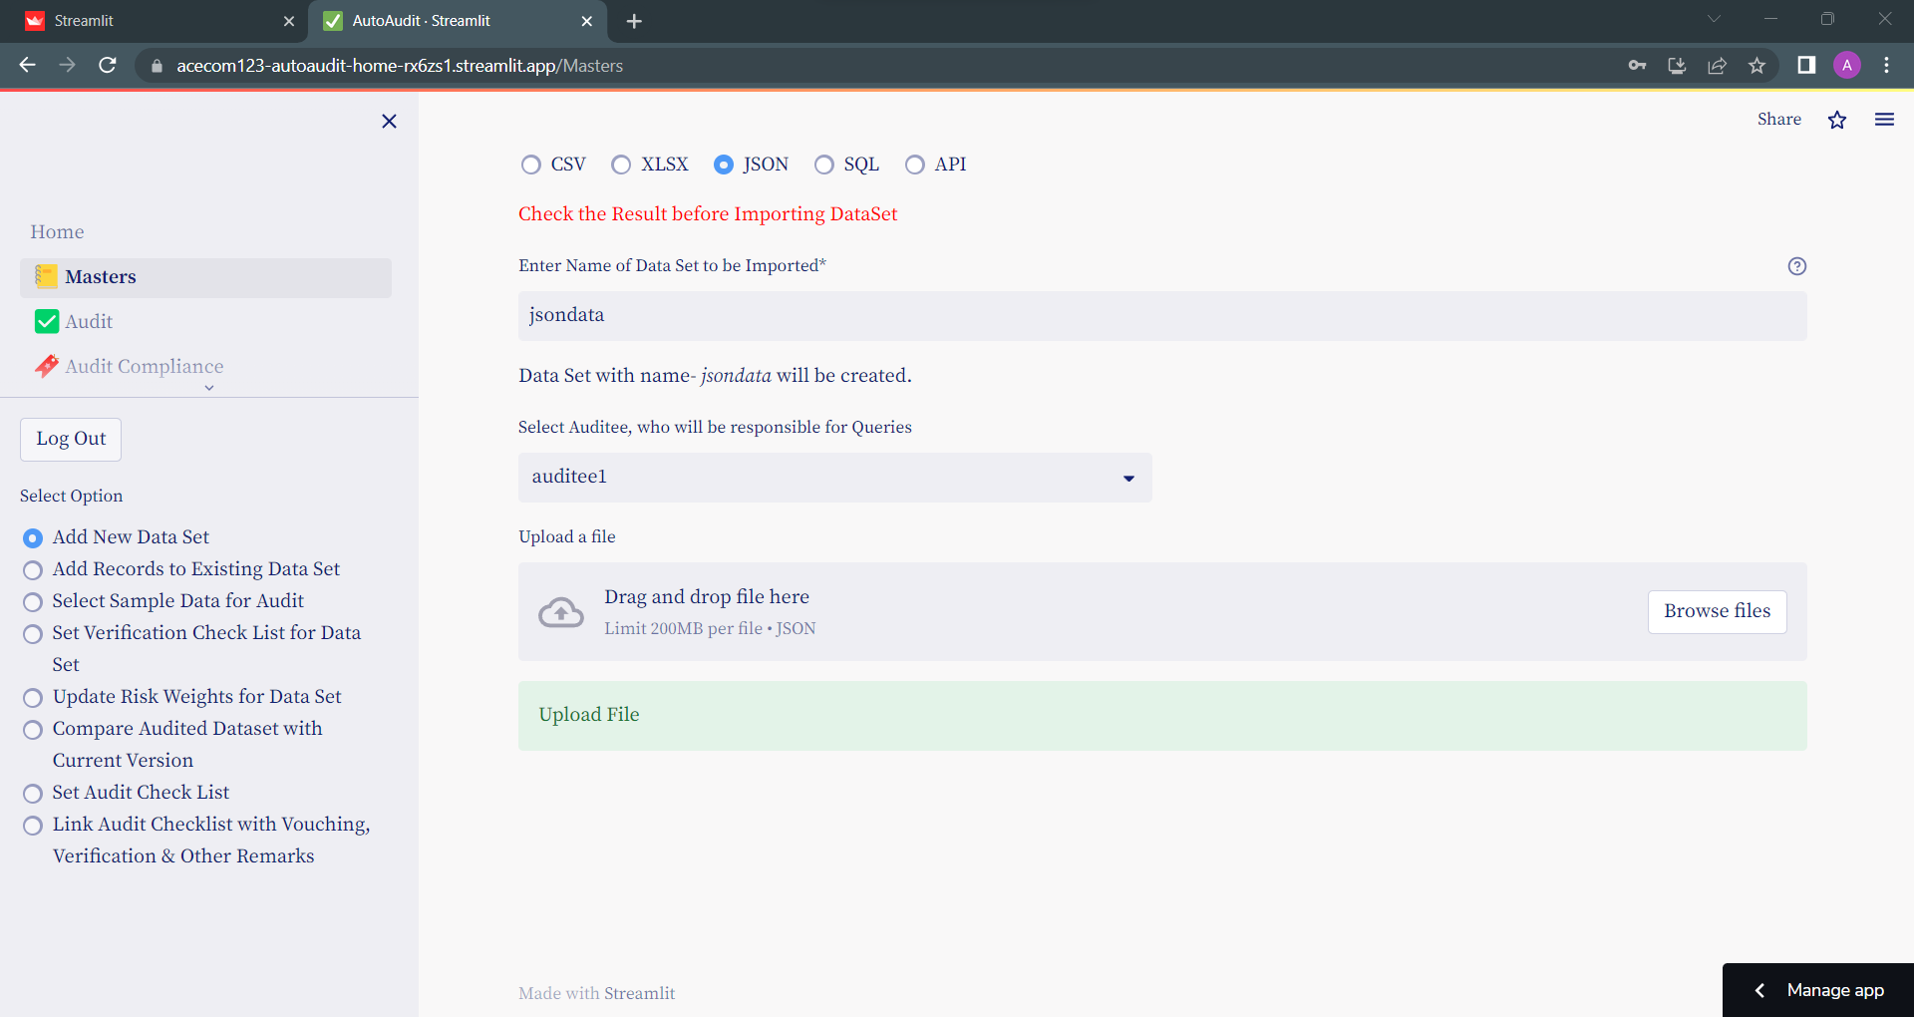

* Select Auditee, who will be responsible for Queries
  + Select Auditee from Drop Down-Select Auditee, who will be responsible for Queries
* To upload JSON file Click of Browse Files & select file to upload
* Preview Data
  + Once file is uploaded you can see Preview of Data & can Alter above Fields get desired output

Check the Result before Importing DataSet

Normal / Simple JSON will look like following

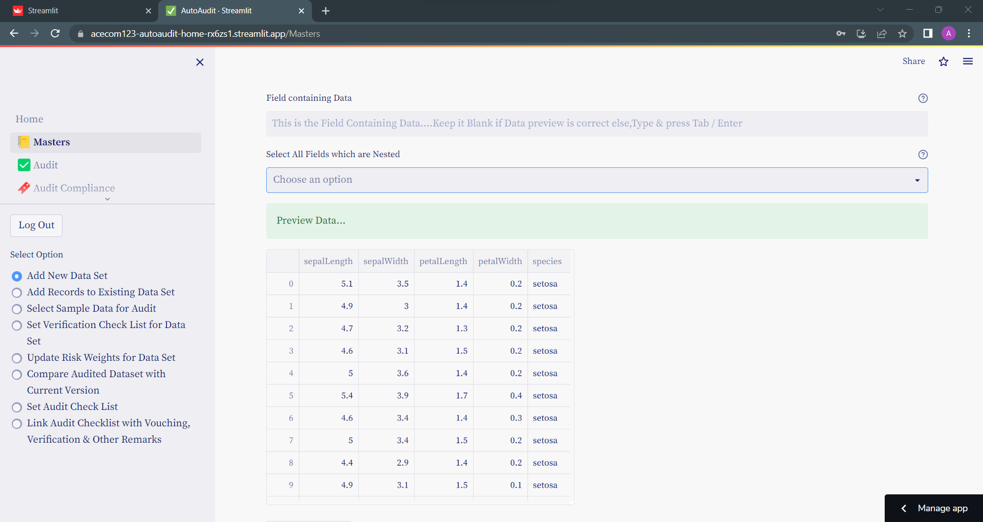

#### Nested / Complex JSON Files

##### Select All Fields which are Nested

In following example we can see Nested Fields-

The fields where you can see –[object Object] are nested fields

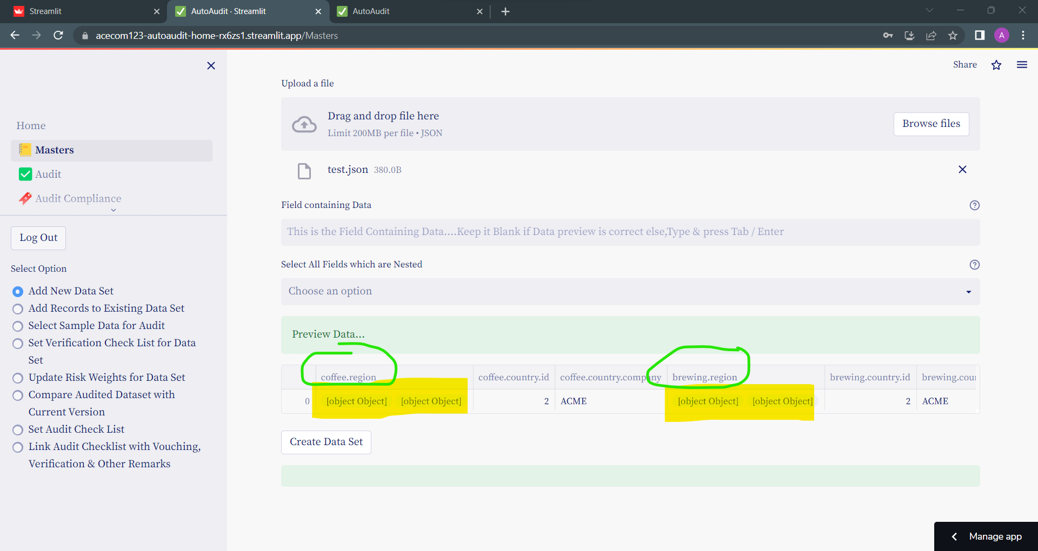

Add theses fields in - **Select All Fields which are Nested**

and you can see the output is showing all Nested Data

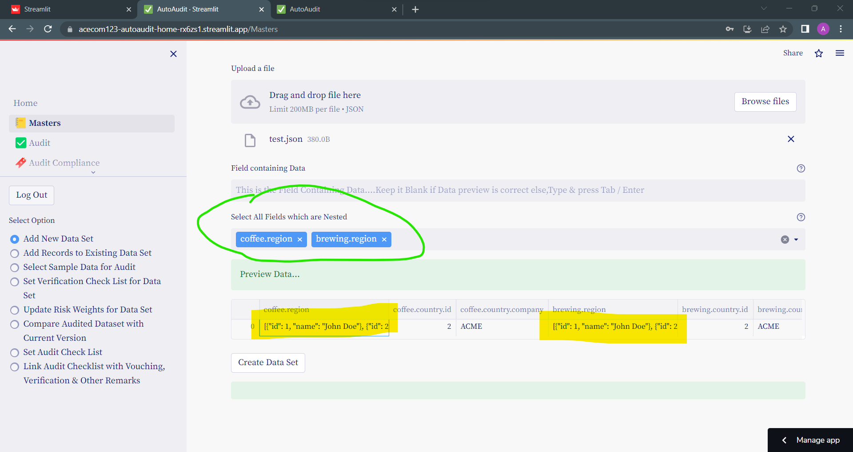

##### Field containing Data

In this example, we can see Three is column **data,** which contains list of –[object Object].

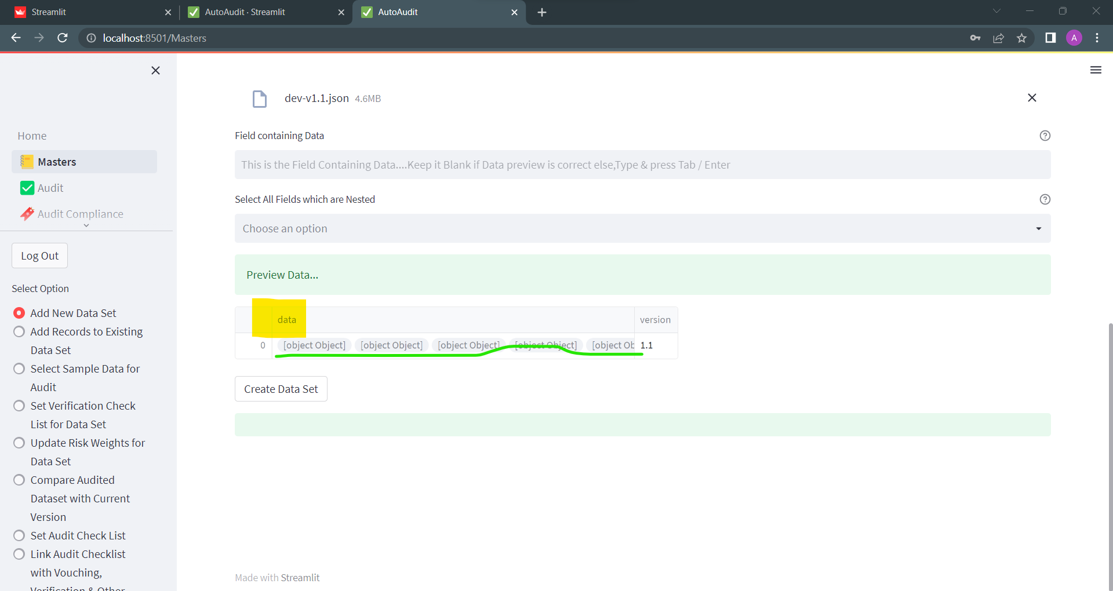

Type that column name in -**Fields Containing Data** & press ENTER

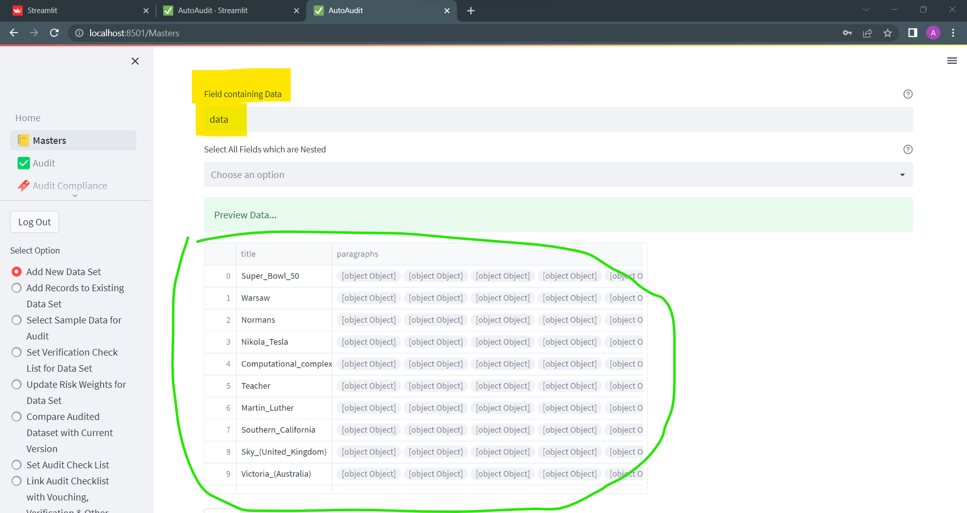

Now there is a column- paragraphs - which contains list of –[object Object].

So we will select this column in **Select All Fields which are Nested**

To get final output

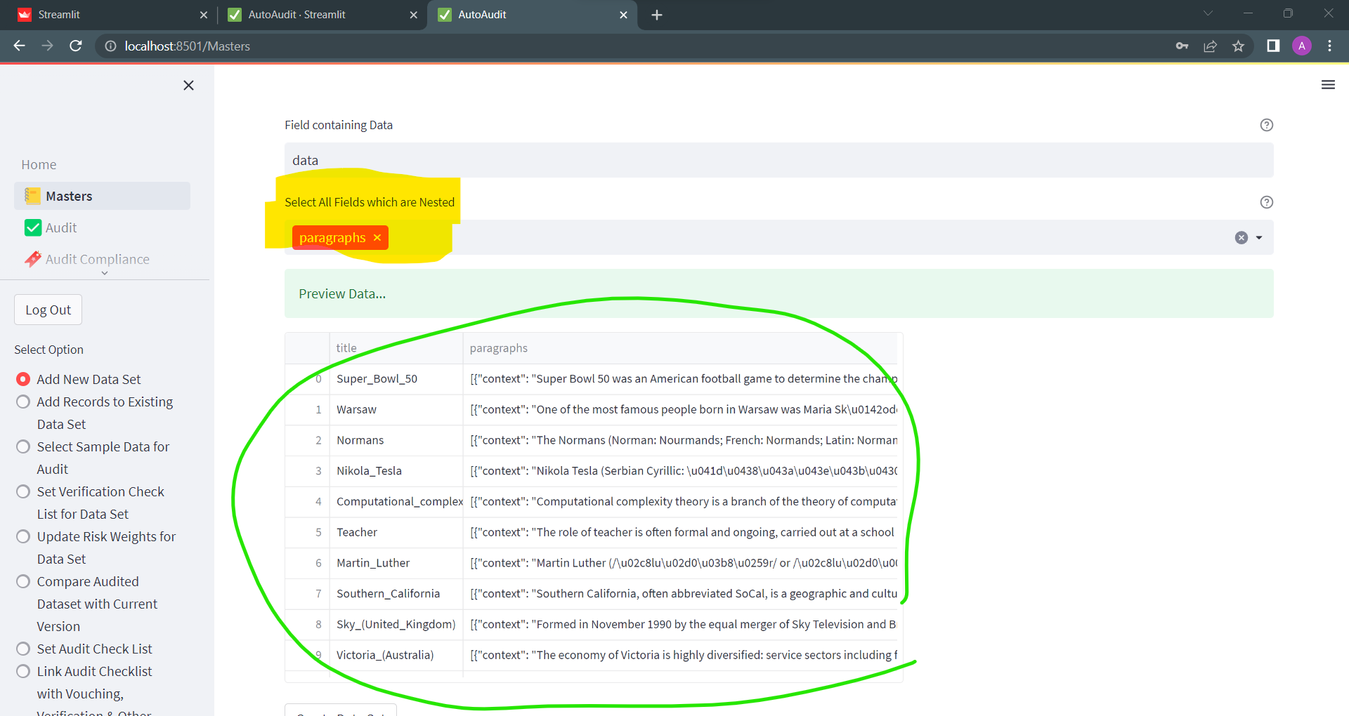

### Import Data from SQL

To import data from SQL: Go to menu **Masters** and then select option button- **Add new dataset**

Under Select Data Source- select option button- **SQL**

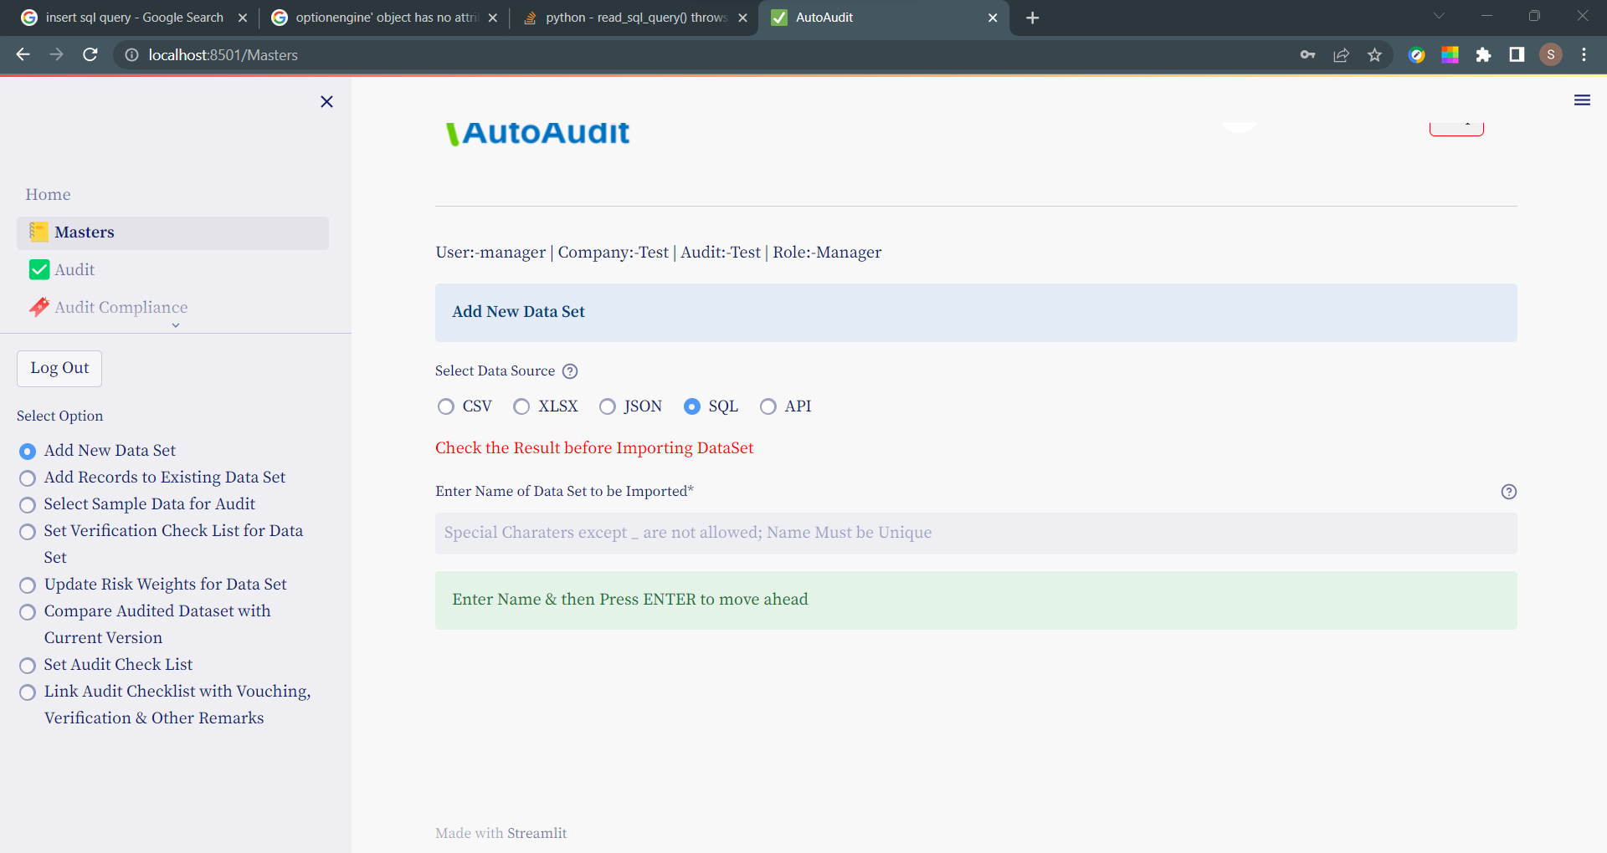

Enter Name of Data Set to be Imported & Press ENTER

Following Additional Fields will appear

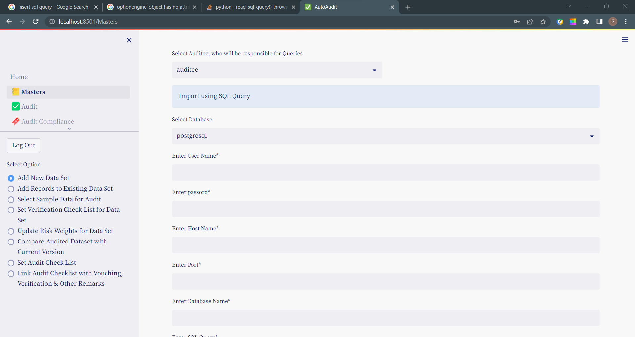

* Select Auditee, who will be responsible for Queries
  + Select Auditee from Drop Down-Select Auditee, who will be responsible for Queries

Enter Following fields relating to import from SQL:

* Select Database (from Dropdown)
* User Name*
* password*
* Host Name*
* Port*
* Database Name*
* SQL Query*

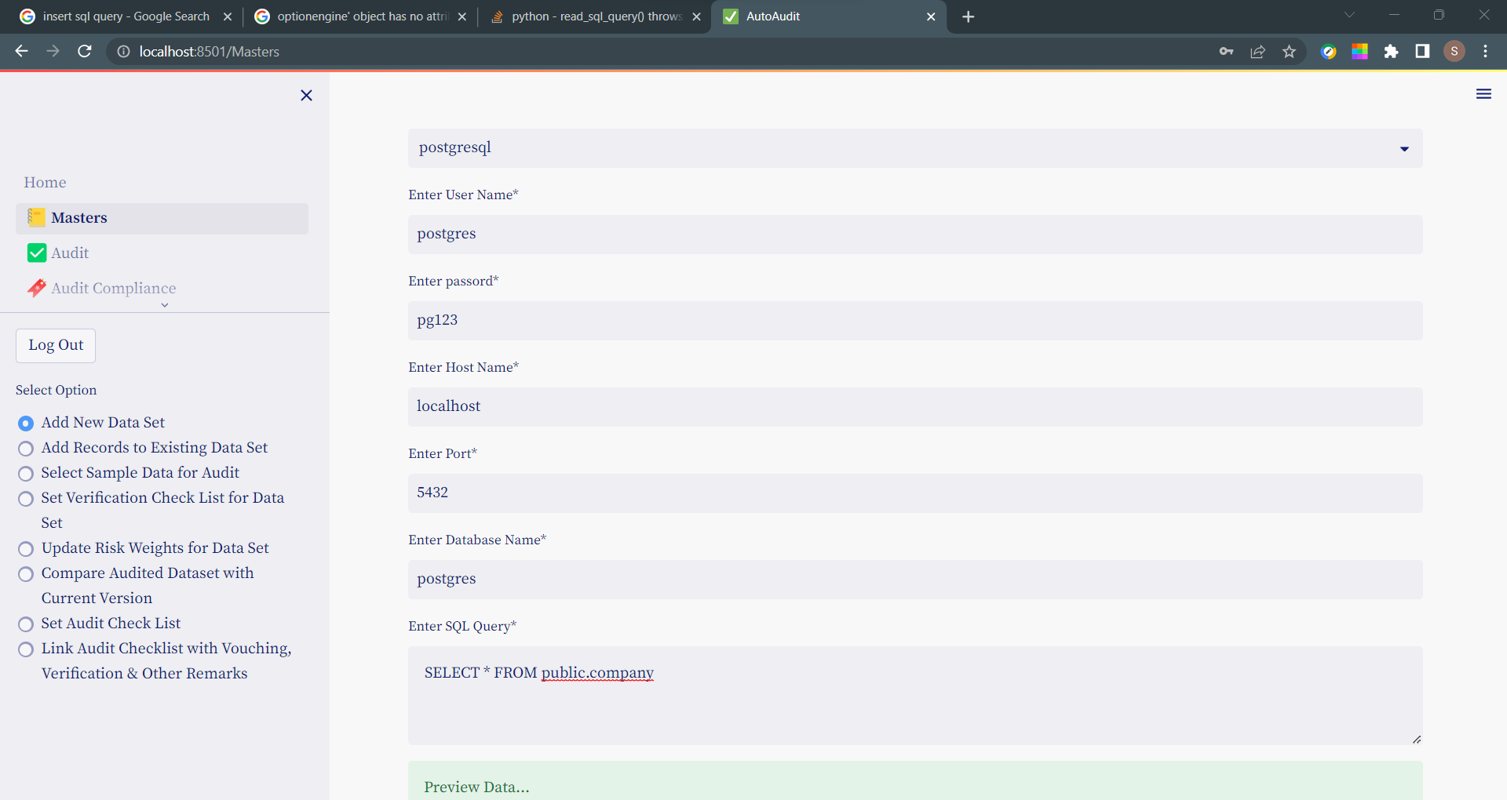

Press CTRL+ENTER or TAB to see the Preview of Data

If the Data is correct- Press **Create Data Set** to import

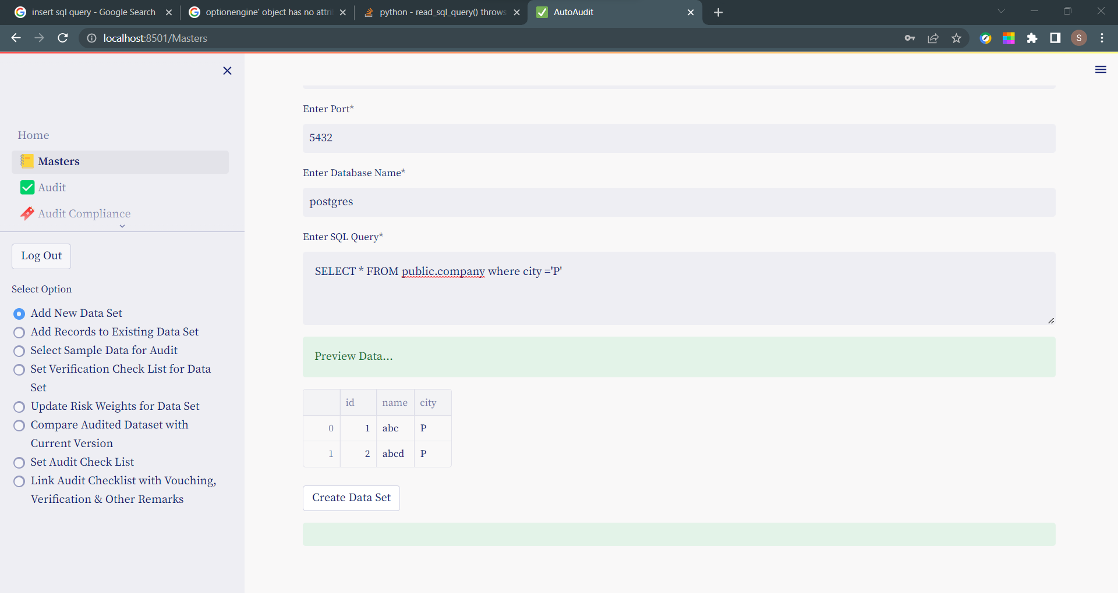

### Import Data using API

To import data from SQL: Go to menu **Masters** and then select option button- **Add new dataset**

Under Select Data Source- select option button- **API**

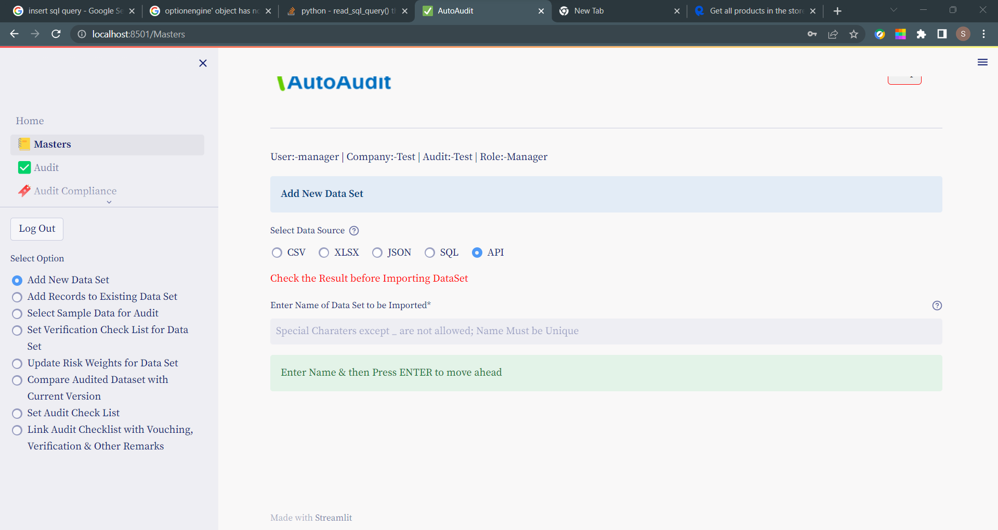

Enter Name of Data Set to be Imported & Press ENTER

Following Additional Fields will appear

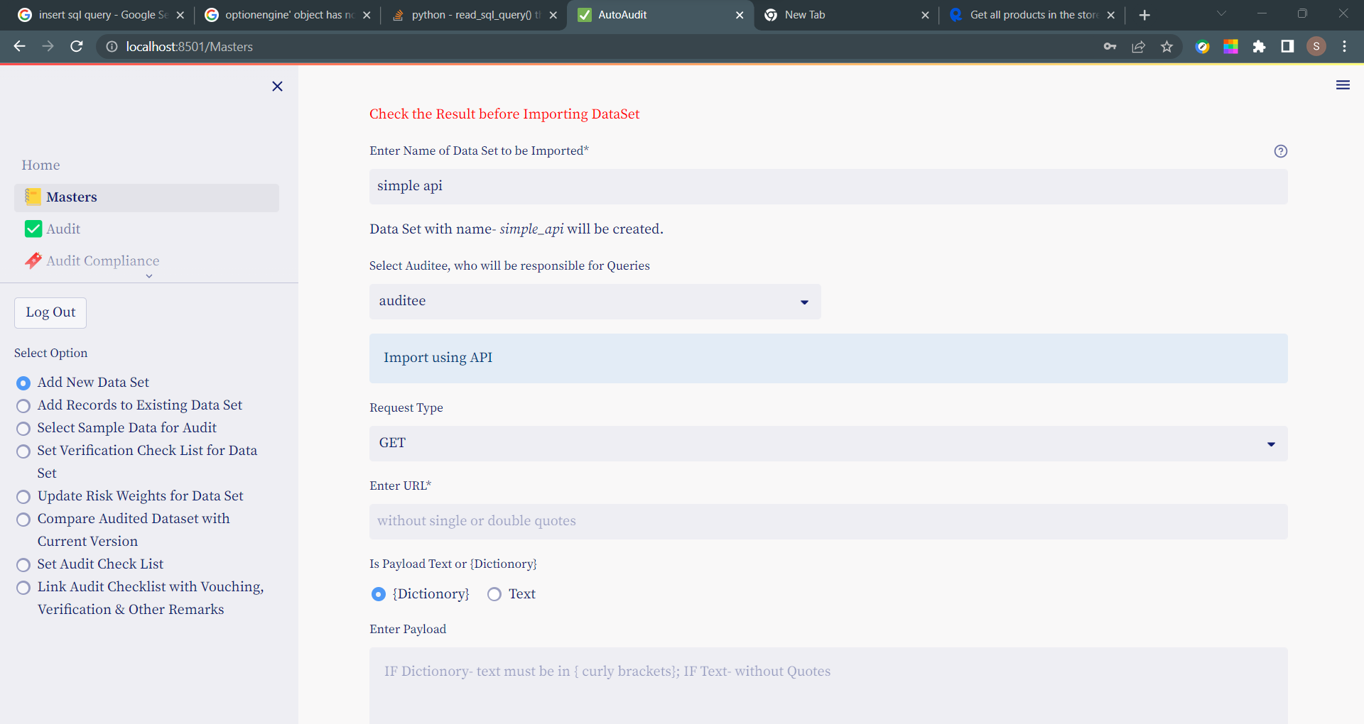

* Select Auditee, who will be responsible for Queries
  + Select Auditee from Drop Down-Select Auditee, who will be responsible for Queries

Enter Following fields relating to import from API:

* Select Request Type (from Dropdown)
* URL*
* Payload (Is Payload Text or {Dictionary})
* Headers

Let’s see few examples as under

1. Simple API without Payload & Headers(Here Payload & Headers- are Blank)

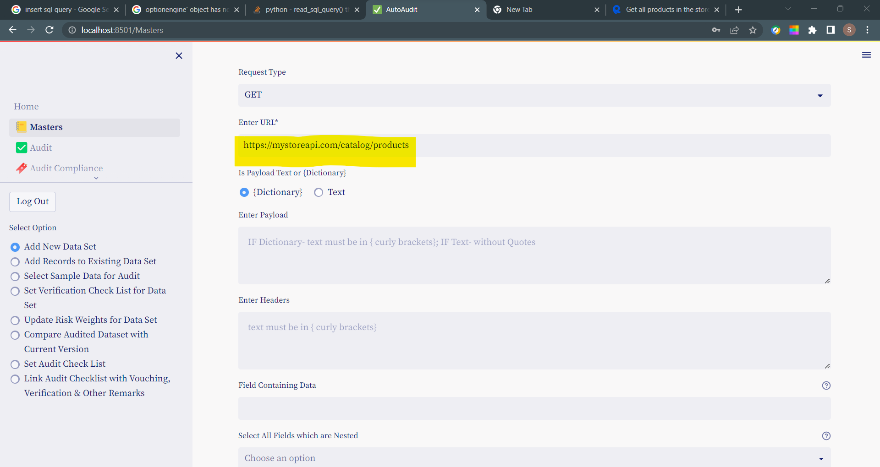

URL should include query parameters if any- Eg-

https://mystoreapi.com/catalog/products?limit=4

Once you press TAB / ENTER you can see Data Preview below like :

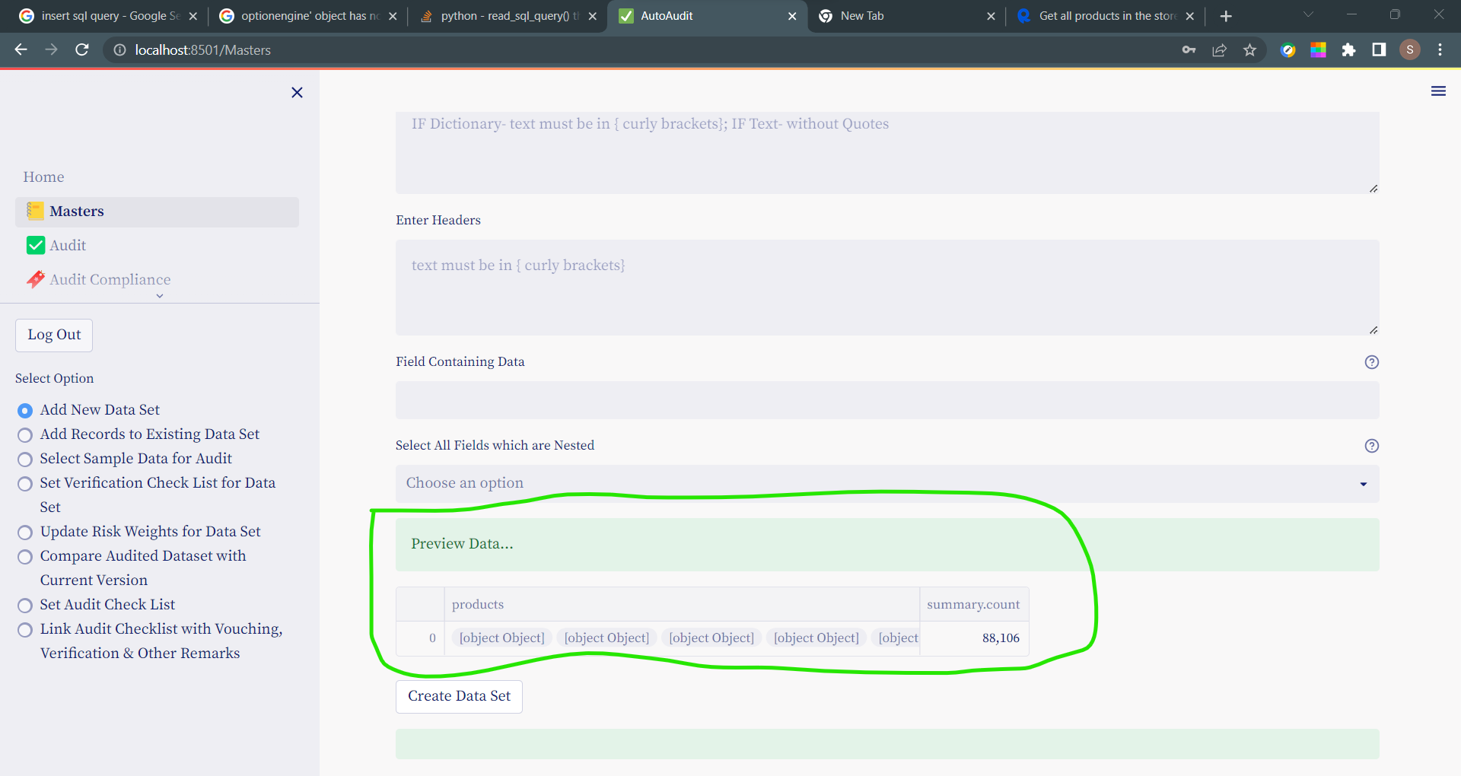

As the API output is JSON , same steps as we follow for JSON import are applicable for - **Fields Containing Data & Select All Fields which are Nested**

Eg

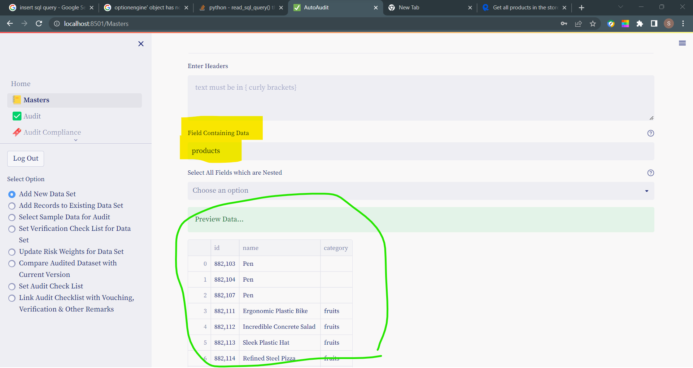

1. API with Payload & Headers

Example of payload in {Dictionory} –

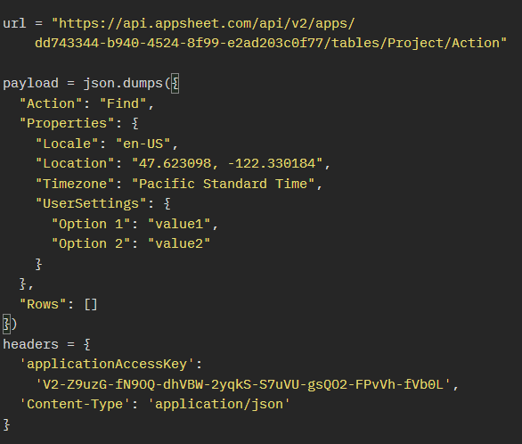

Here we will enters these details as follows-

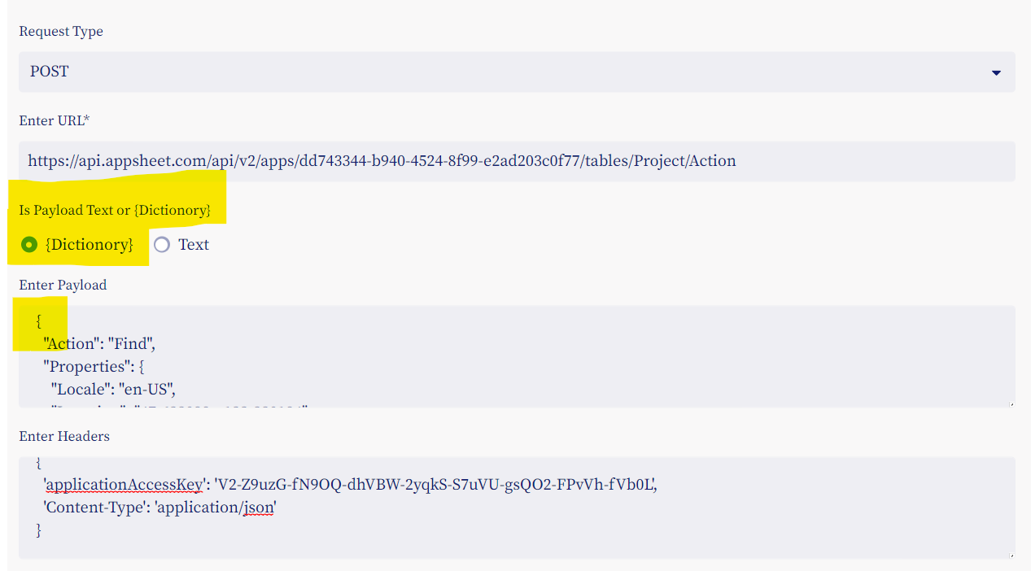

Note-

1. Payload is in { } so we selected - {Dictionory}
2. We have enter payload starting from – { & ending with } without json.dumps({

payload = json.dumps({

  "Action": "Find",

  "Properties": {

    "Locale": "en-US",

    "Location": "47.623098, -122.330184",

    "Timezone": "Pacific Standard Time",

    "UserSettings": {

      "Option 1": "value1",

      "Option 2": "value2"

    }

  },

  "Rows": []

})

Example of Payload in TEXT

Here payload is not in { } so use TEXT option

url = "https://yahoo-finance97.p.rapidapi.com/stock-info?payload=symbol=AAPL"

payload = "symbol=AAPL"

headers = {

  'content-type': 'application/x-www-form-urlencoded',

  'X-RapidAPI-Key': '51ea81802cmshb6acb25bfab3dfbp1ae37fjsne71fb996f472',

  'X-RapidAPI-Host': 'yahoo-finance97.p.rapidapi.com'

}

Here we will enter details as under-

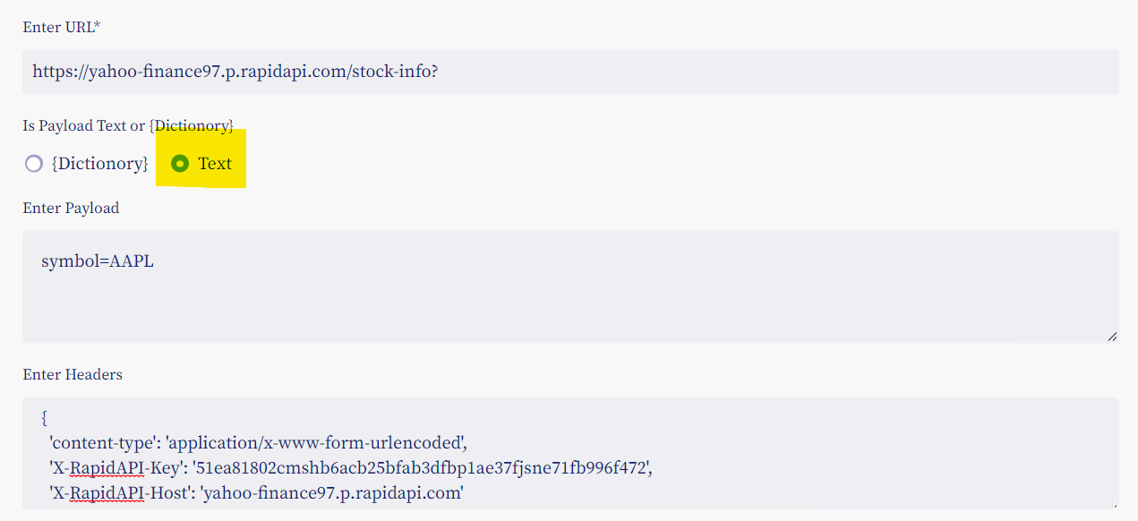

### Import for TALLY ERP

* To import any data or reports from Tally ERP, use **Export to EXCEL** option.
* Any data or report should be in columnar format, if the report is not in columnar format export the same using F8 Columnar Option in Tally ERP if available.
* In the following example We will see How to export purchase register in detail format.
* Select Purchase Register /Ledger & Press F8- Columnar

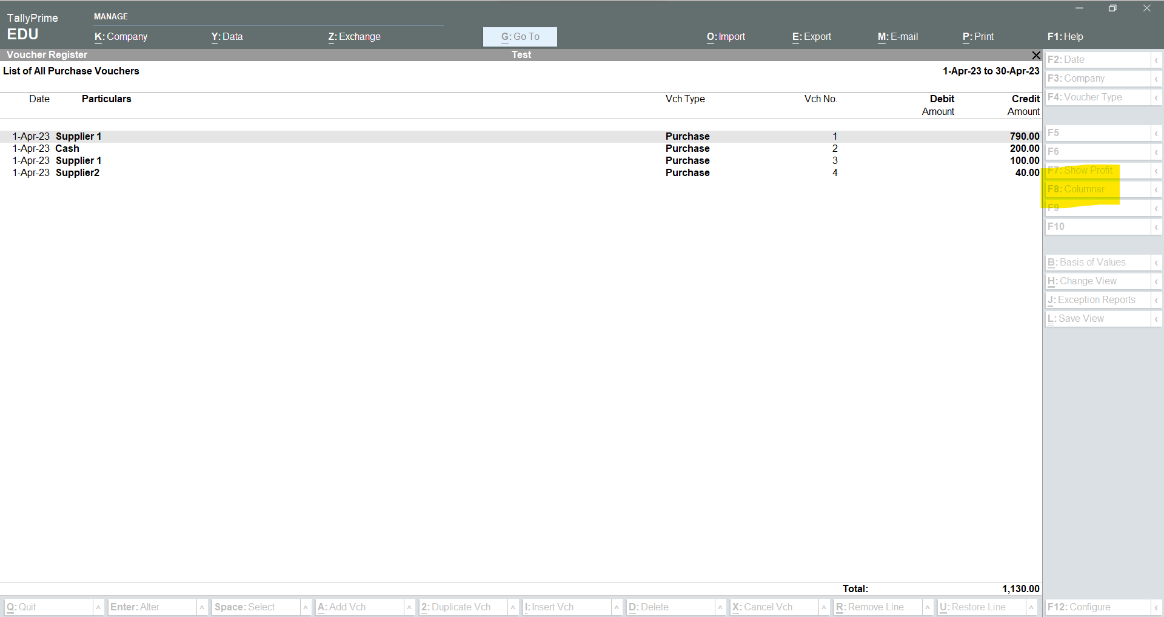

Set the value for – **Show ledger amounts with Dr/Cr- to NO**

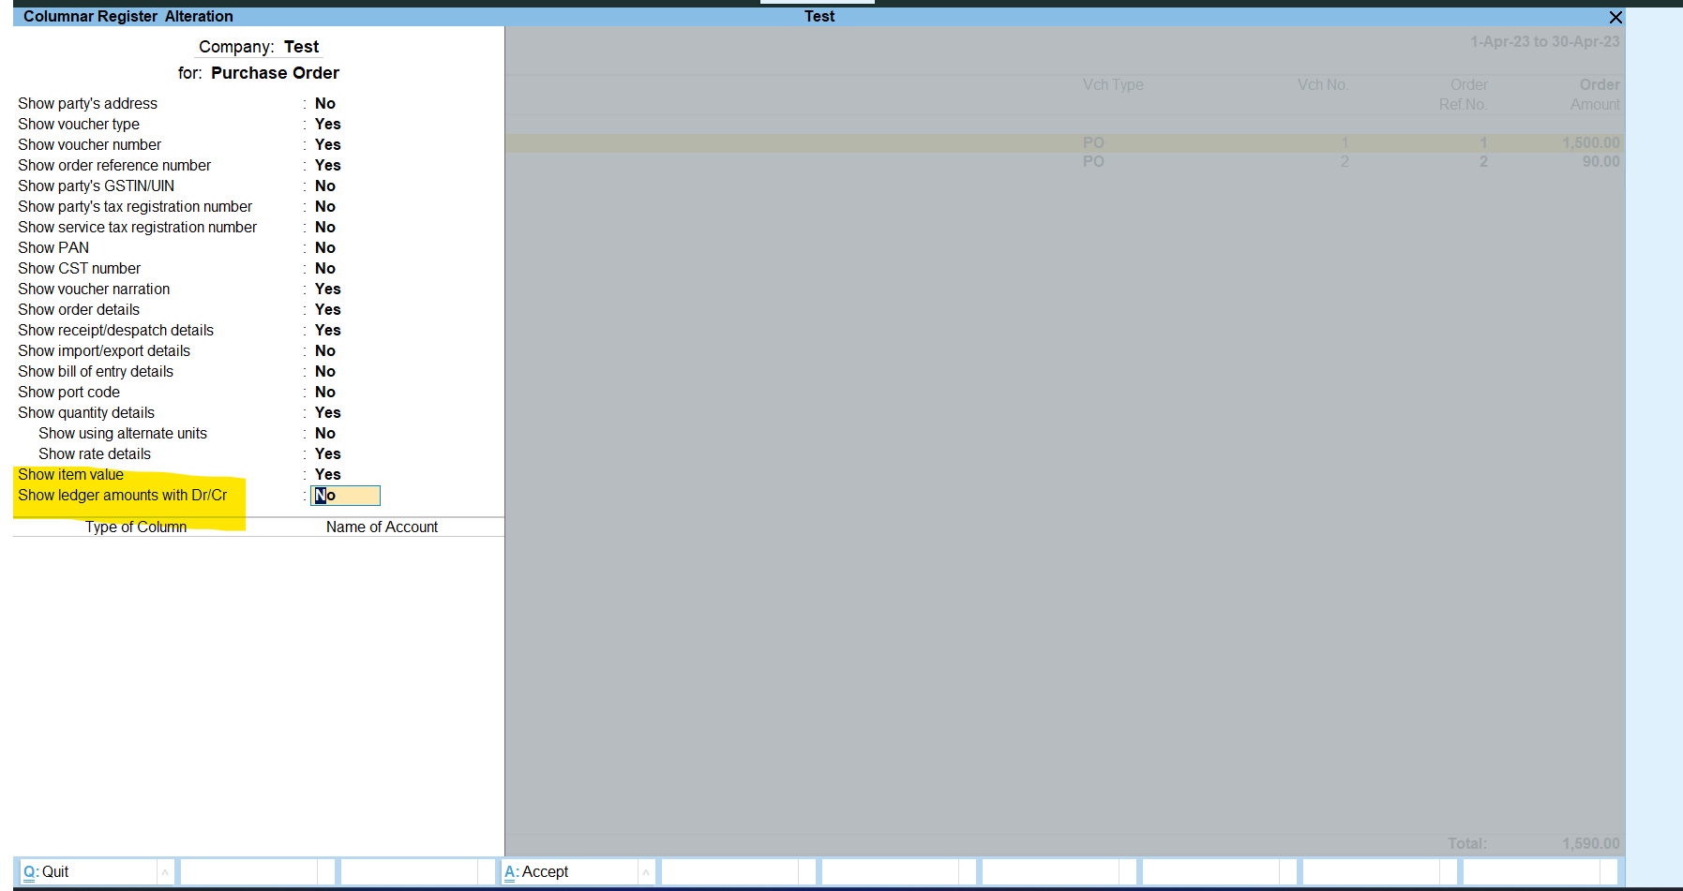

Press CTRL+A to save & export

Click on **Export**

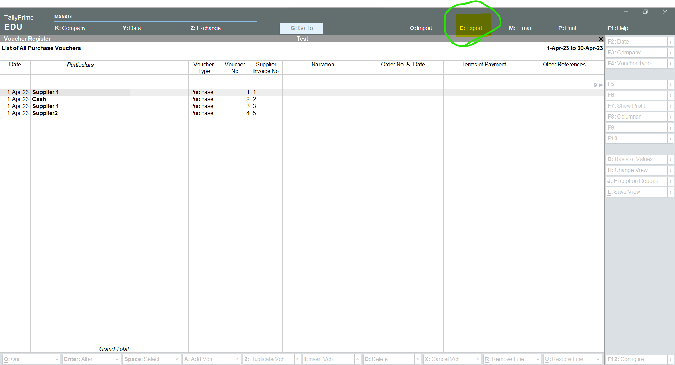

Select Current (CTRL+E)

& Click on Configure

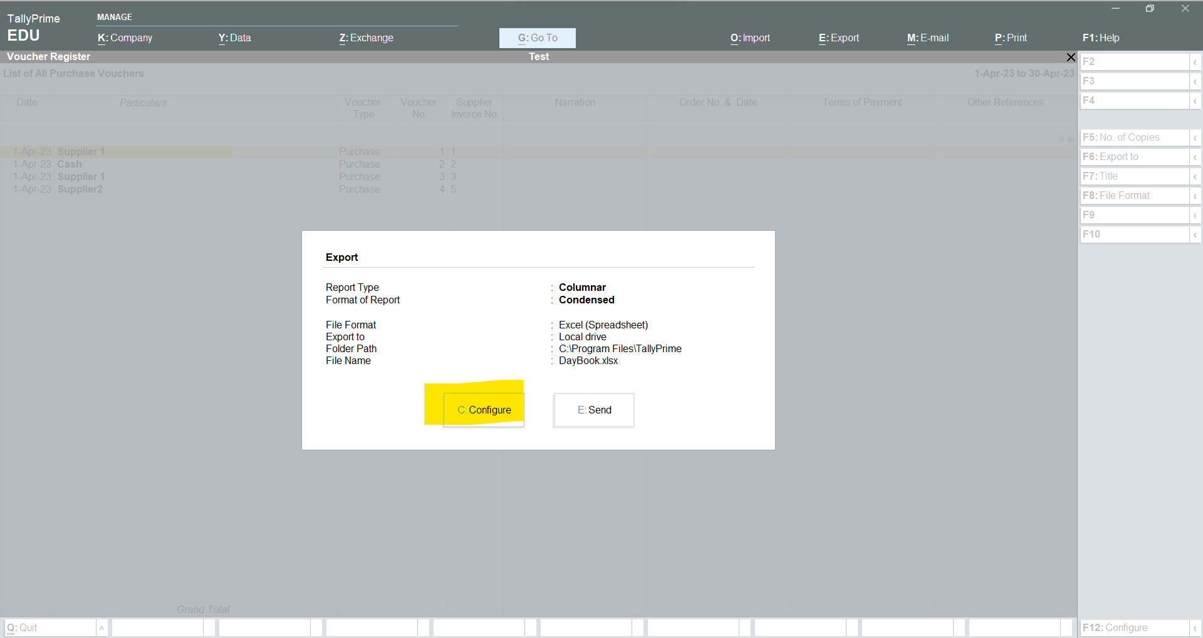

Select Detail (if you want all details)

Finally click on Send to export report in Excel

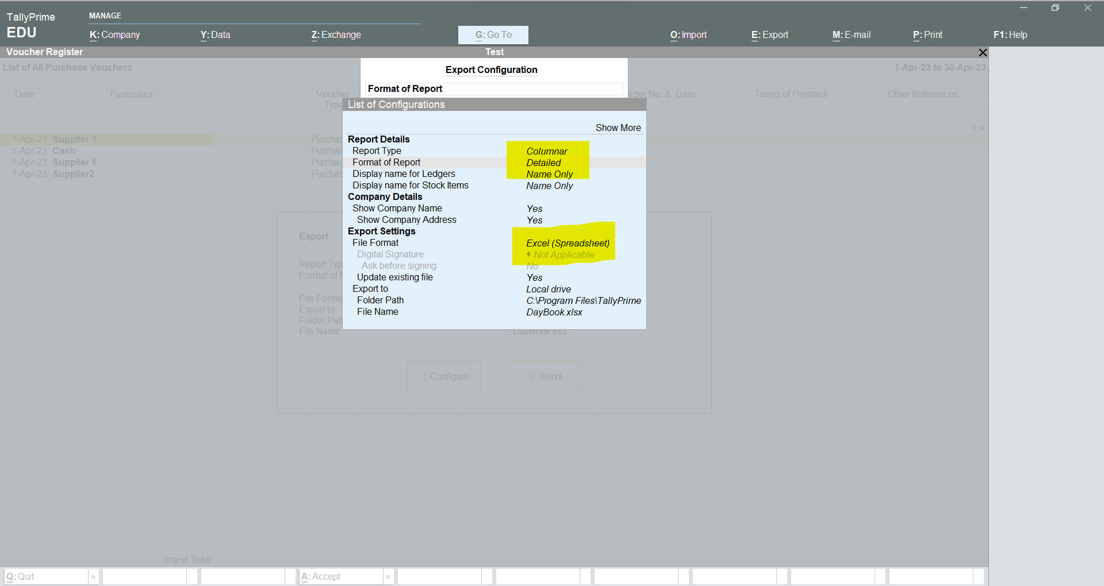

The report will look like-

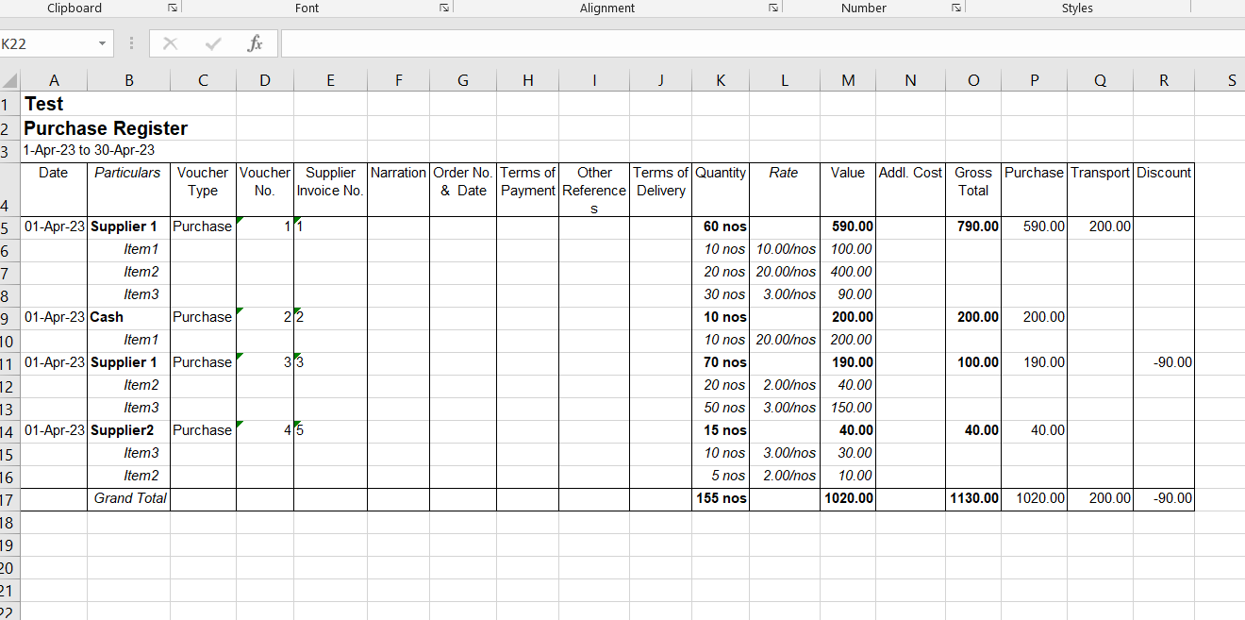

In AutoAudit import this excel file

In Simple Option the Data will look like-

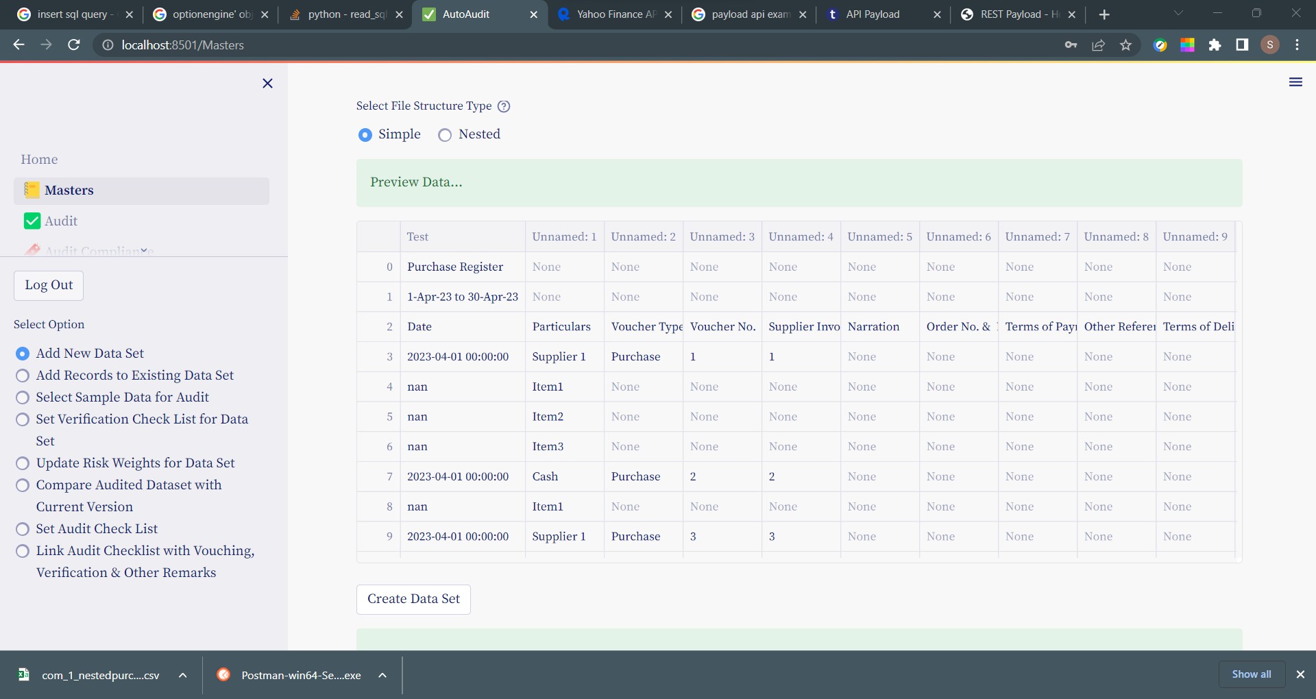

If you want all details for each Purchase transaction in single line, use **Nested** option

Deselect (Remove) the fields- Particulars, Quantity, Rate, Value as **Child fields**.

So for each row these fields are shown in 1 Column called **Child-Data**

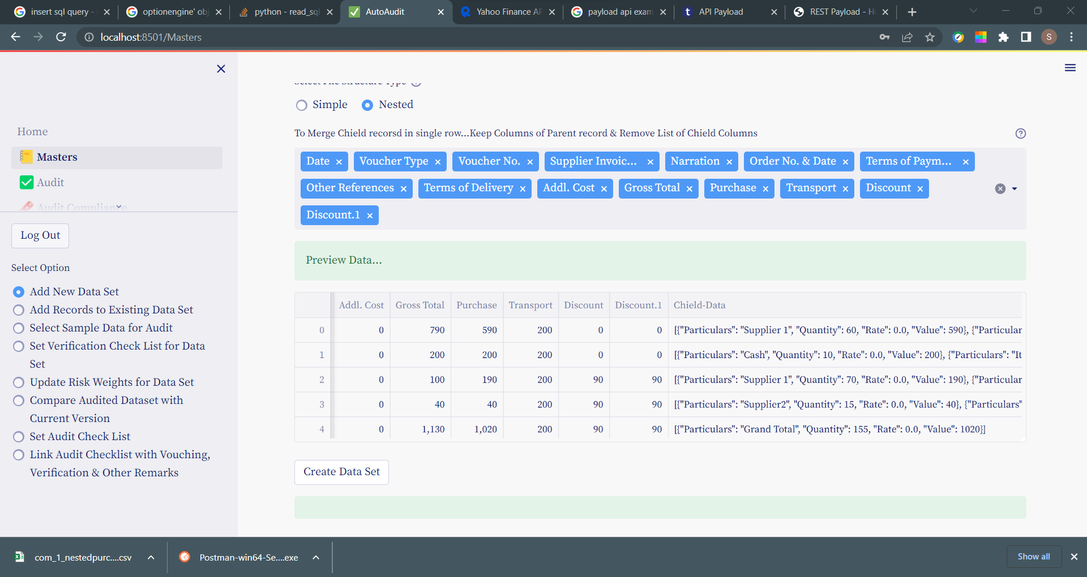

Finally click on Create Dataset to import.

## **Add data to Existing Data Set**

* After importing data for auditing, We can add data to existing data set.
* This is typically useful in concurrent or ongoing audits.
* Say for example you have imported sales data for quarter 1, Now for next quarter you want to import & add data in the existing data set.
* In such cases you can use this option.
* The data structure including column names number of columns etc should be exactly same to that of existing data set.
* Data can be imported in various formats & modes- like csv, xlsx ,JSON,api, sql.
* To add data for to Existing dataset:

Go to menu **Masters** and then select option button- **Add Records to Existing Data Set**

* First select the dataset name in which you want to add the records
* Then select the types for format of data to be imported.
* Existing data set will be shown on the left-hand side

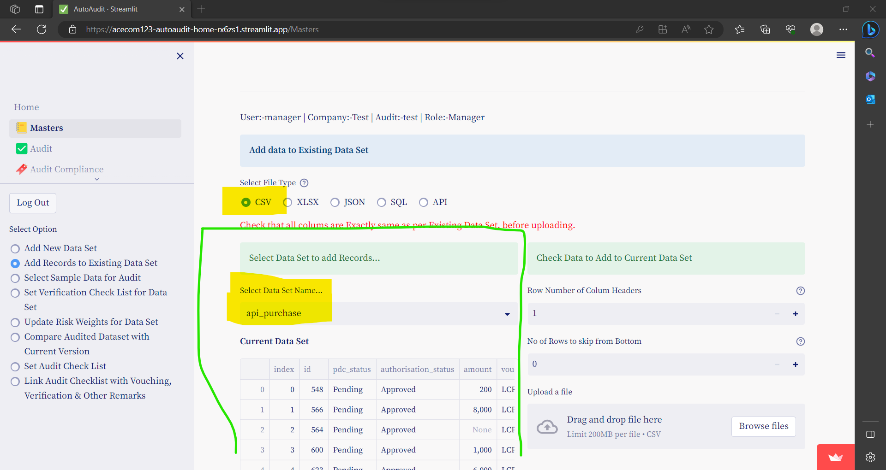

* On the right hand side there are options to add data to this existing data set.
* The options are exactly same as in case of import of data.
* If data structure is not exactly same then error message is shown

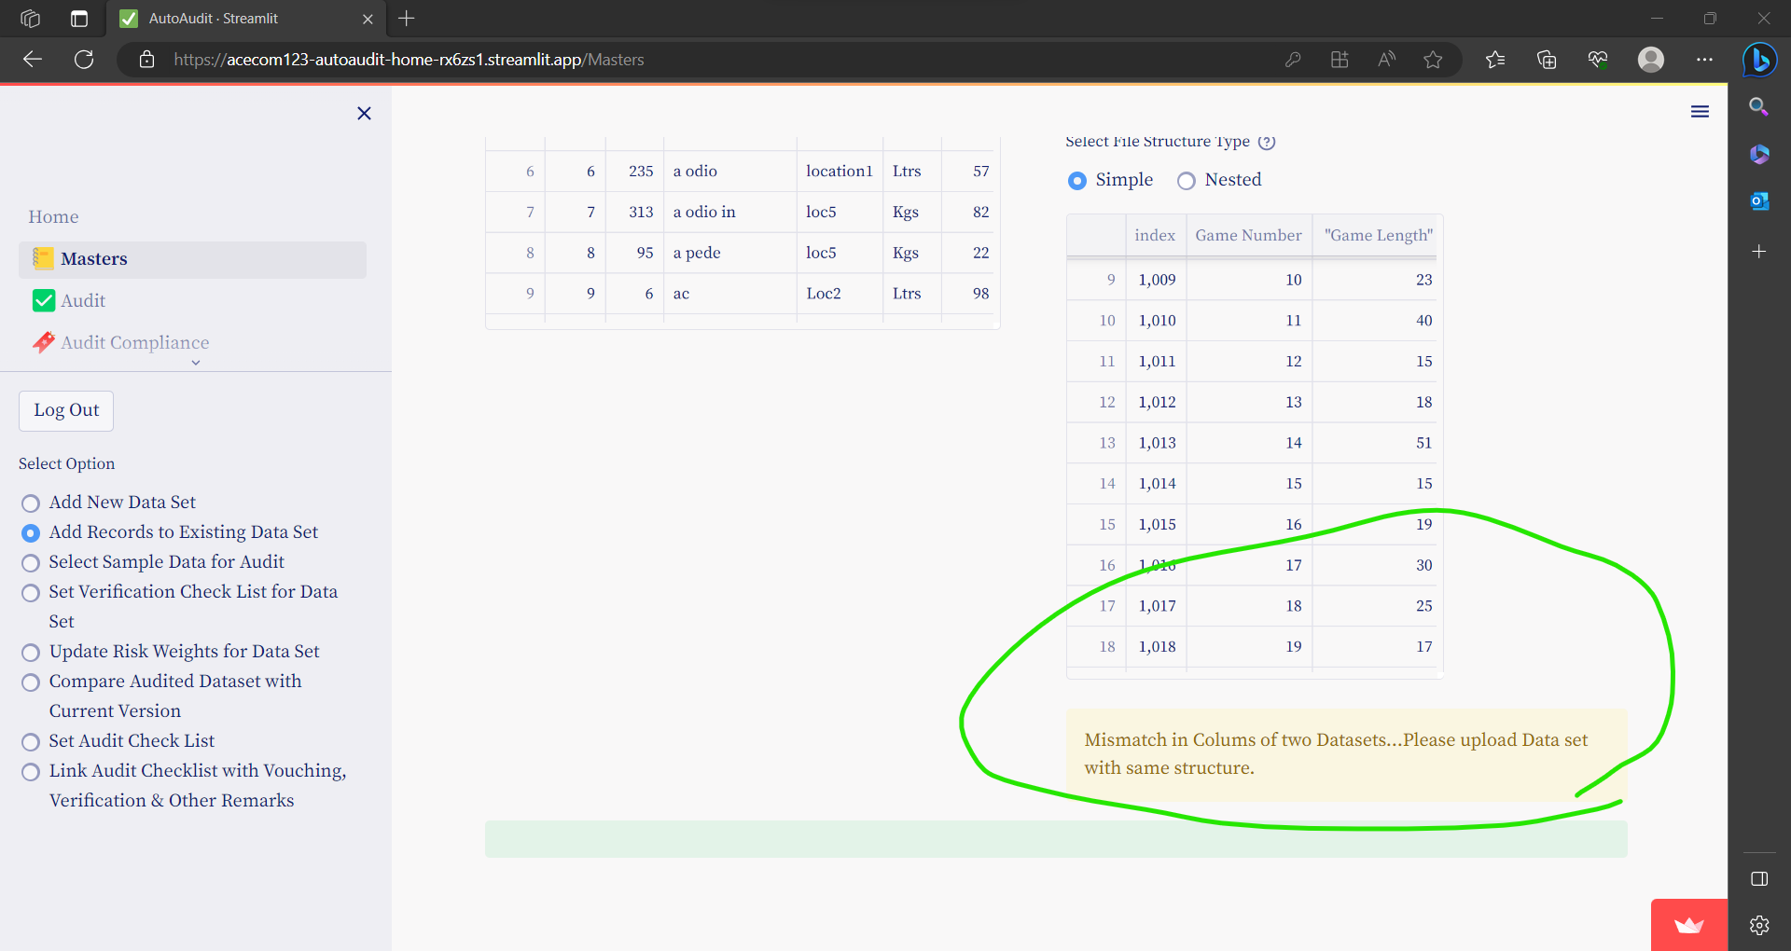

* Finally click on **Append to Dataset**

## **Select Sample Data for Audit**

By default data imported is not available for audit.

From data imported you have to select sample Data for audit.

To add Sample data for Auditing:

Go to menu **Masters** and then select option button- **Select Sample Data for Audit**

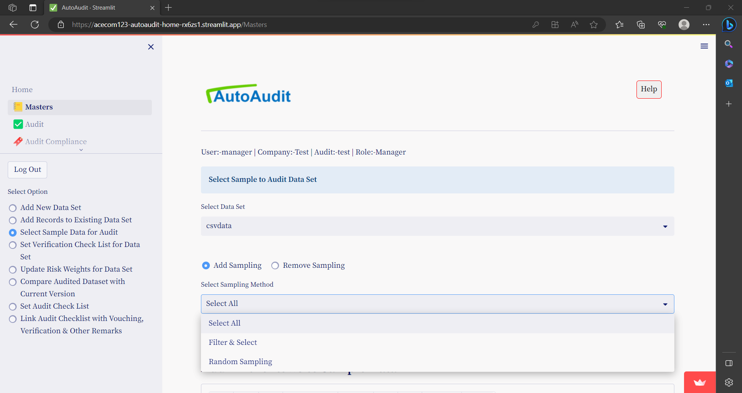

There are three options for selecting sample data:-

1. Select entire / All data set for sampling
2. Filter and select specific data for sampling
3. Select Random data for sampling

### Select entire / All data set for sampling

* Select the Dataset Name & select- **Select All**  option under Select Sampling Method.
* Click on Add **All to Sample Data**

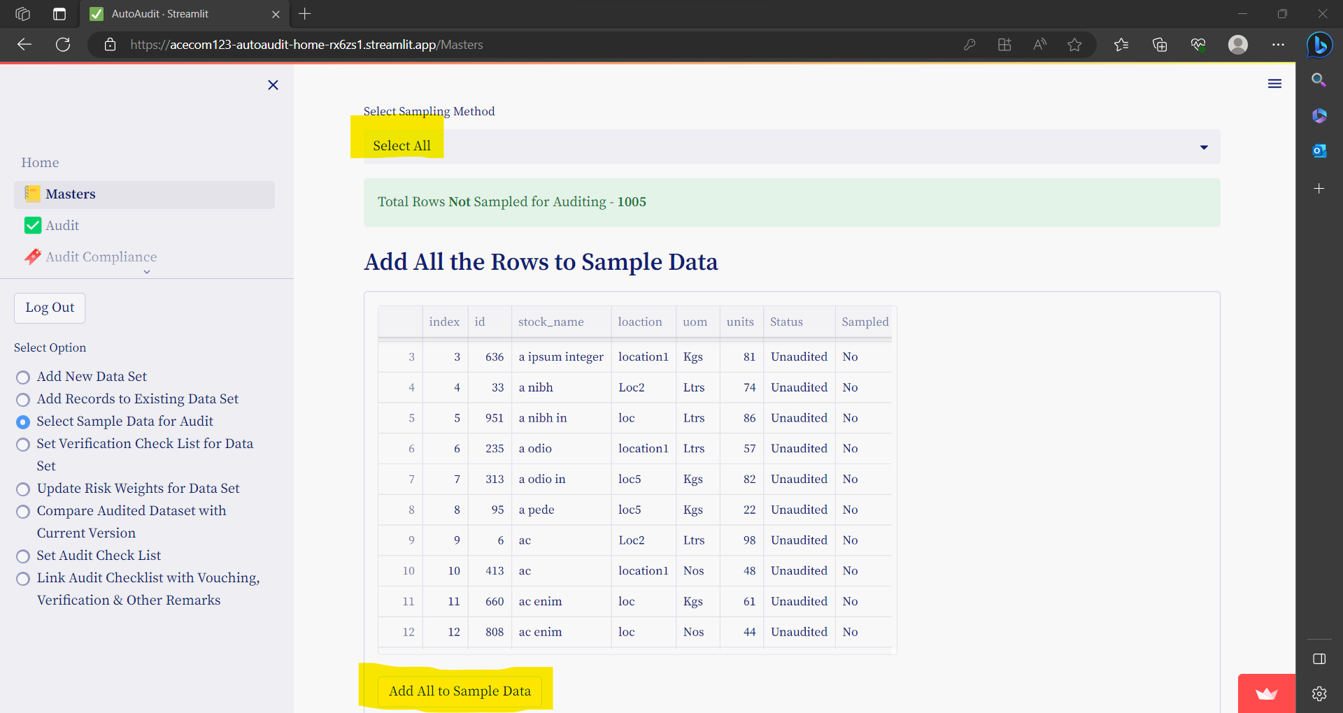

### Filter and select specific data for sampling

* Select the Dataset Name & select- **Filter & Select**  option under Select Sampling Method.
* Click on Column Name & Select Filtering Options to select data

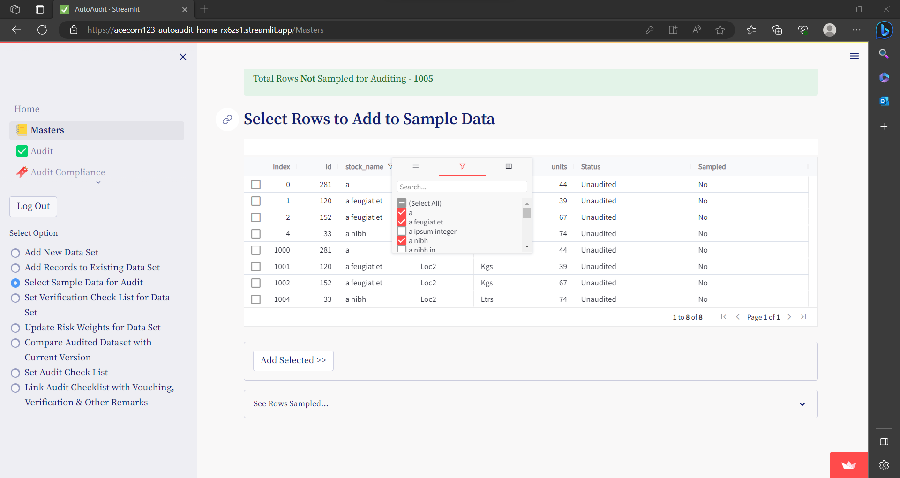

Check the Rows to add in Sample Data & the click on **Add Selected**

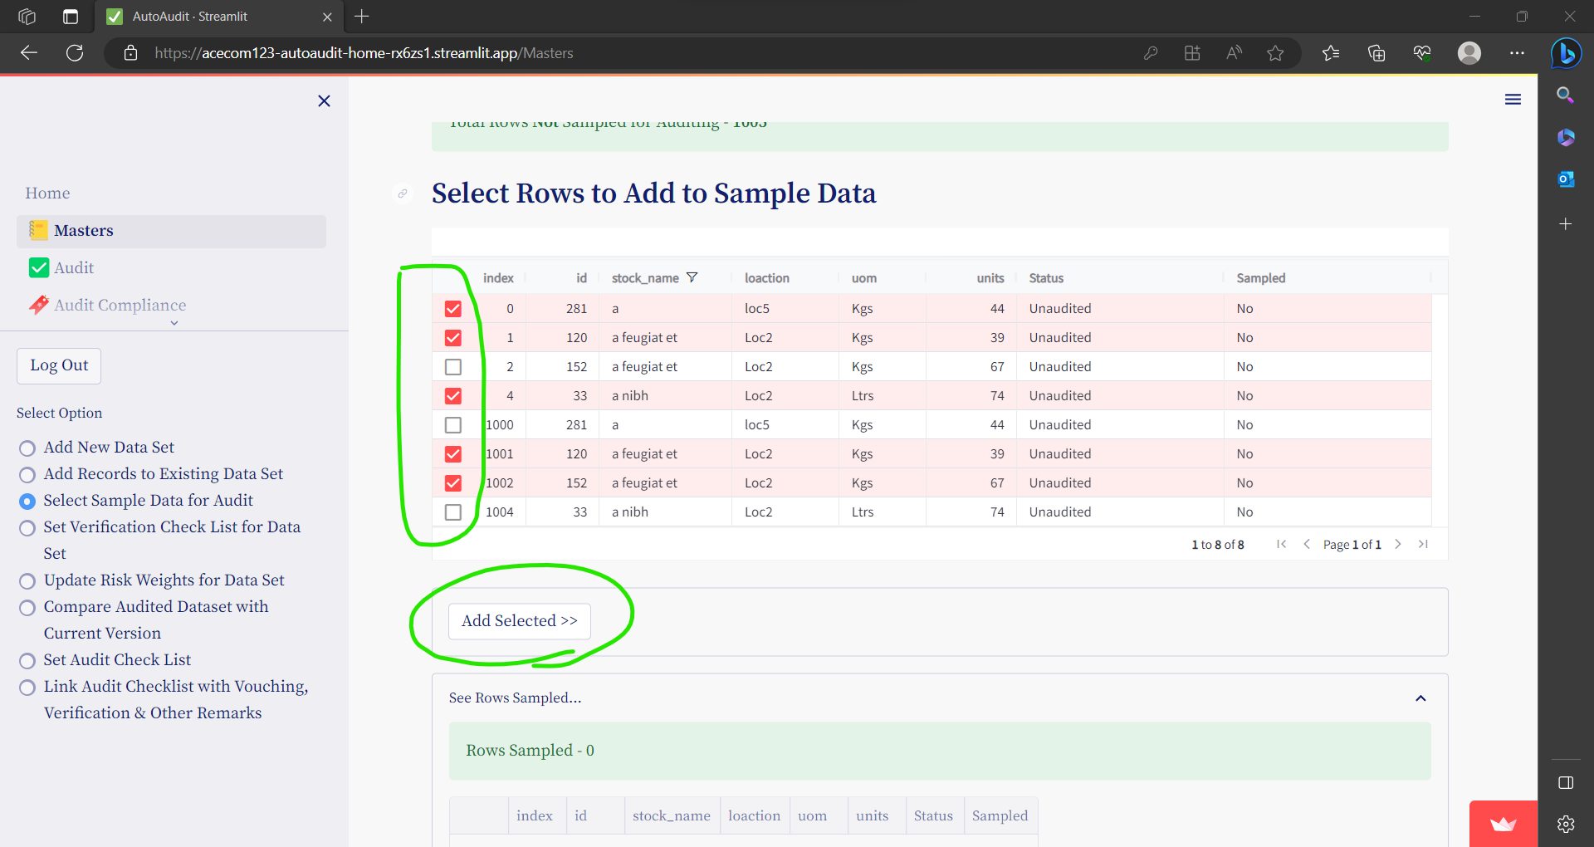

### Select Random data for sampling

* Select the Dataset Name & select- Select **Random Sampling** under Select Sampling Method.
* There are two methods of random sampling available-

Select random number of Rows or select percentage (%)of Rowes

Under Select Sampling Method- Select any of the option.

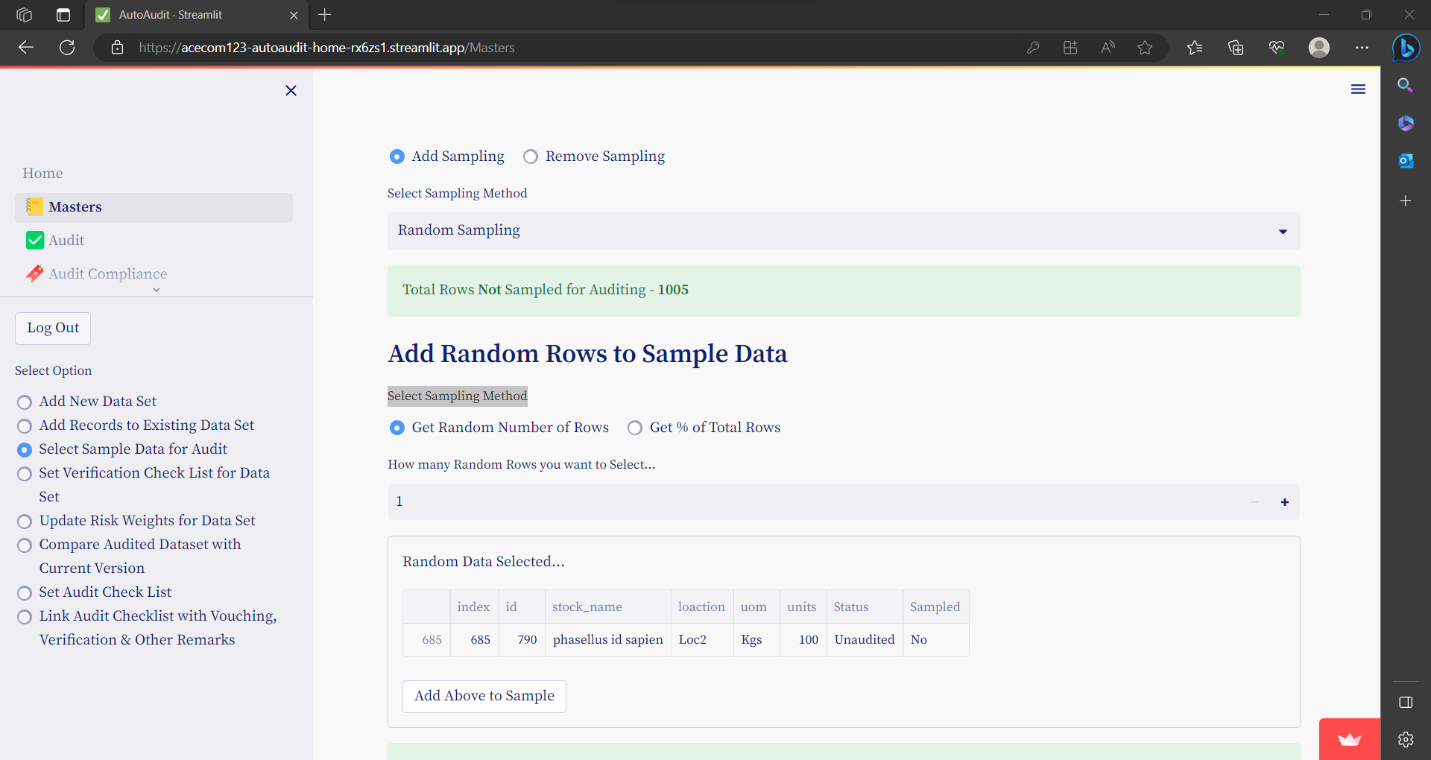

**Option1- Select random number of Rows**

* Just enter Number of rows to select at Random & Press ENTER
* Click on **Add above to Sample**

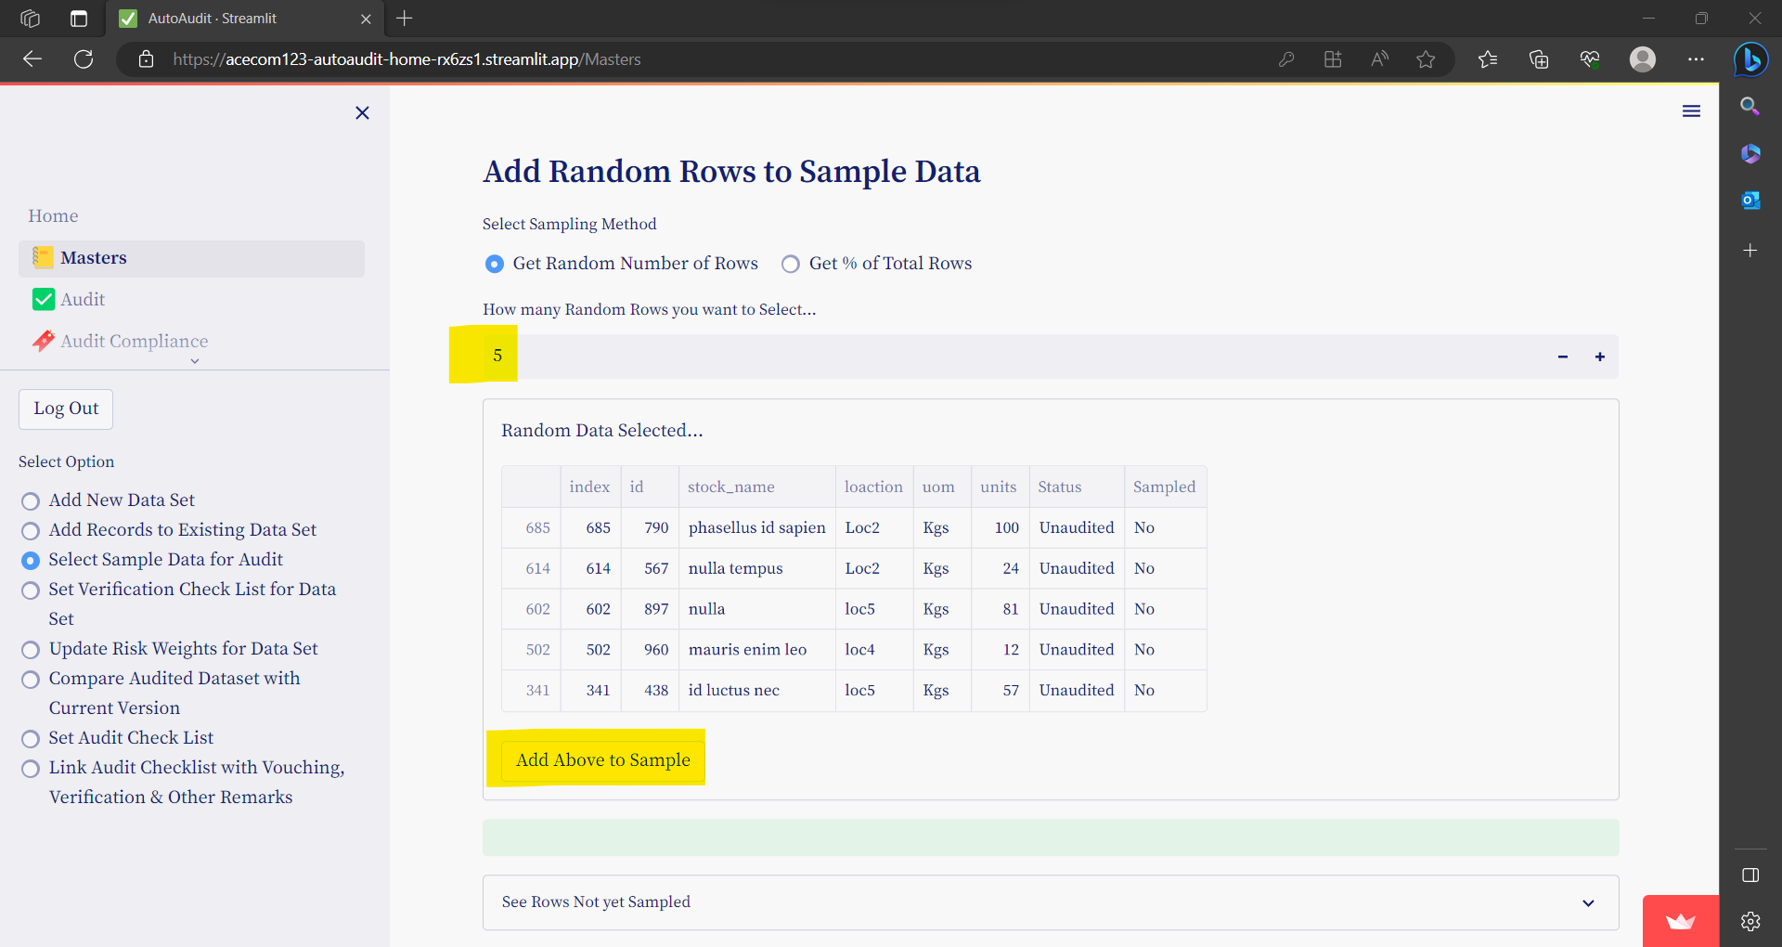

**Option 2- Select random number of Rows**

* Just enter %of rows to select at Random & Press ENTER
* Click on **Add above to Sample**

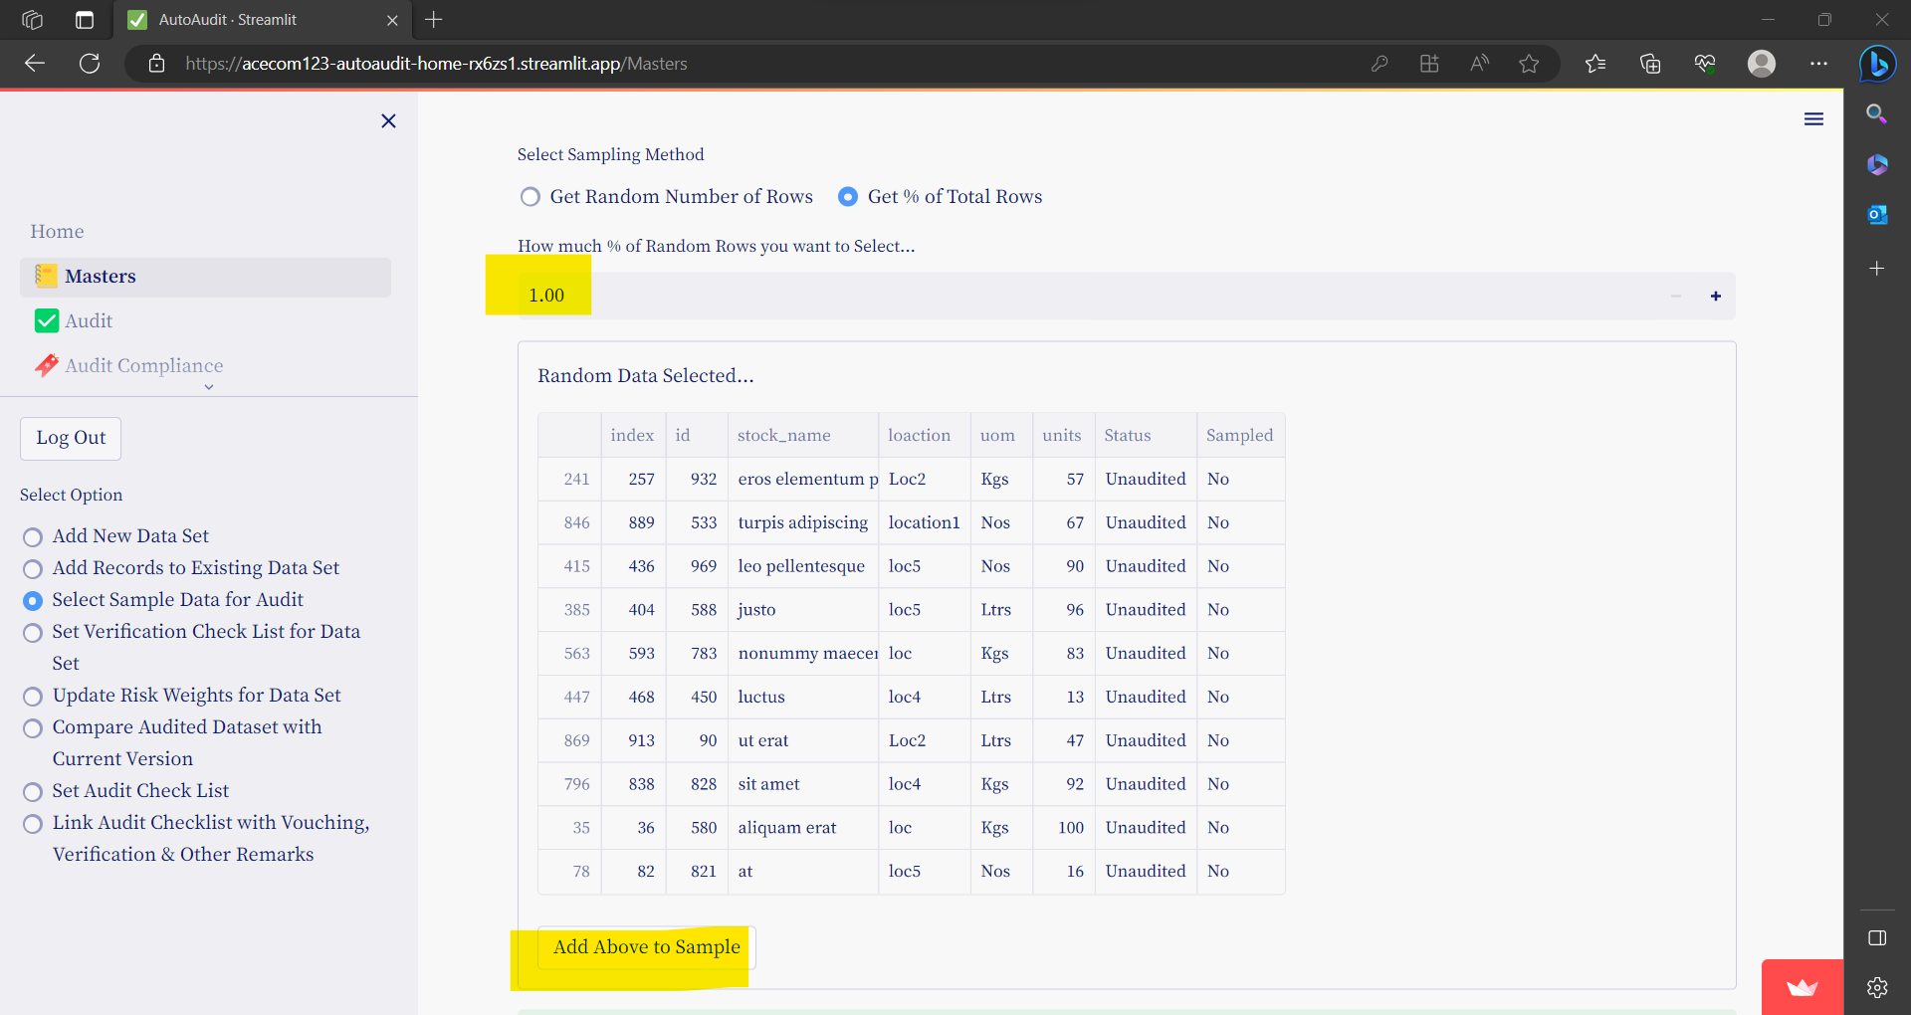

## **Compare Audited Dataset with Current Version of Dataset**

This option is useful to verify - if after auditing the data is changed or not.

Go to menu **Masters** and then select option button- **Compare Audited Dataset with Current Version of Dataset**

* Select data set
* Upload Current Version of Dataset
* Check...Data Structure is Exactly same, with same column names
* Click on **Compare Data Set**

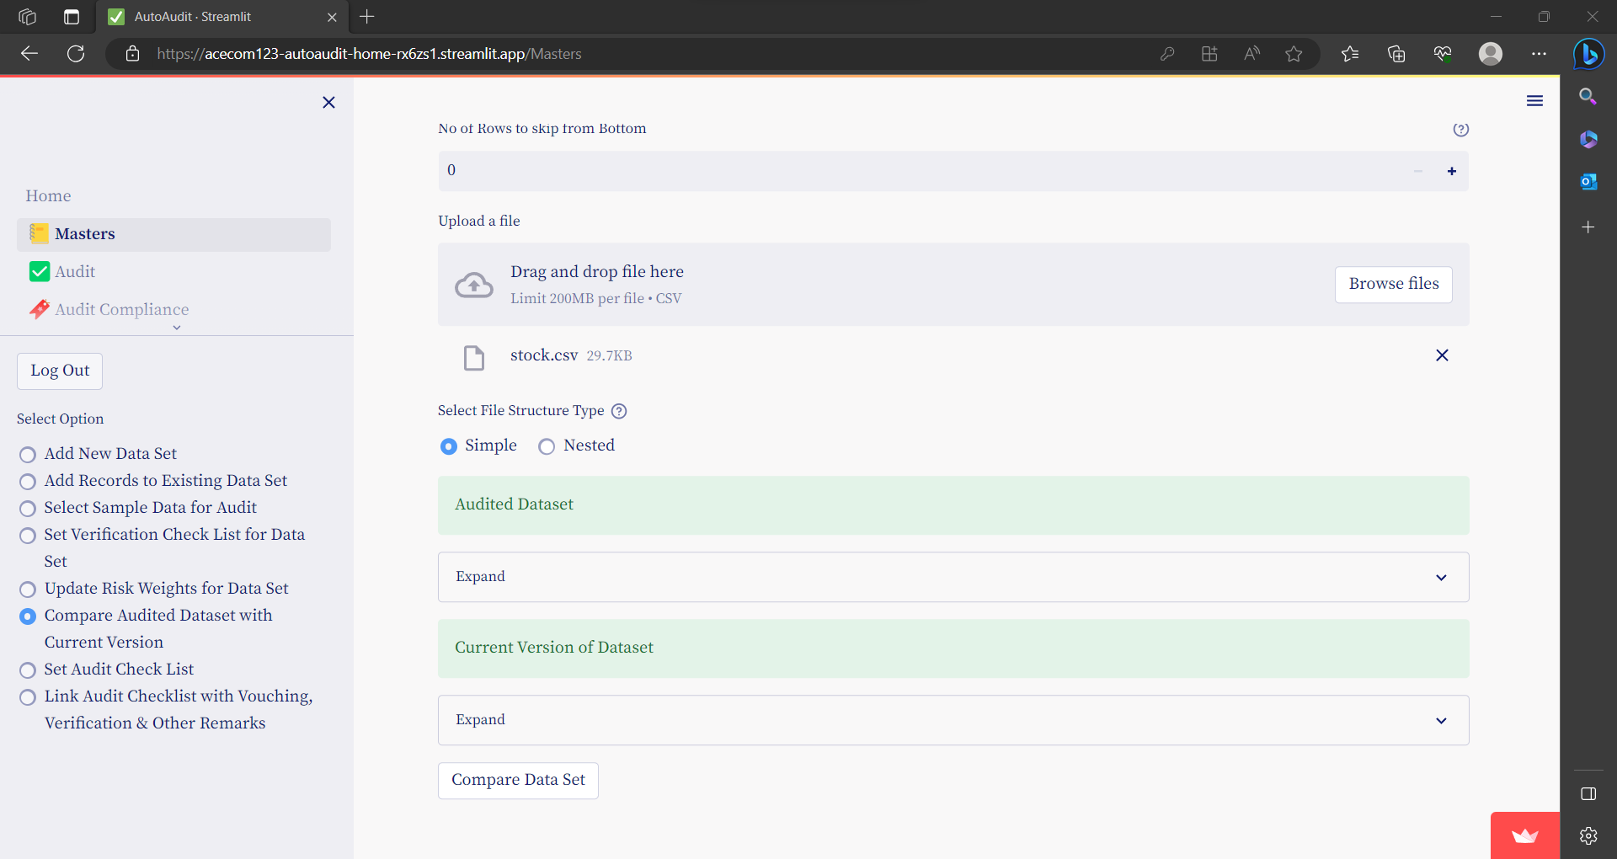

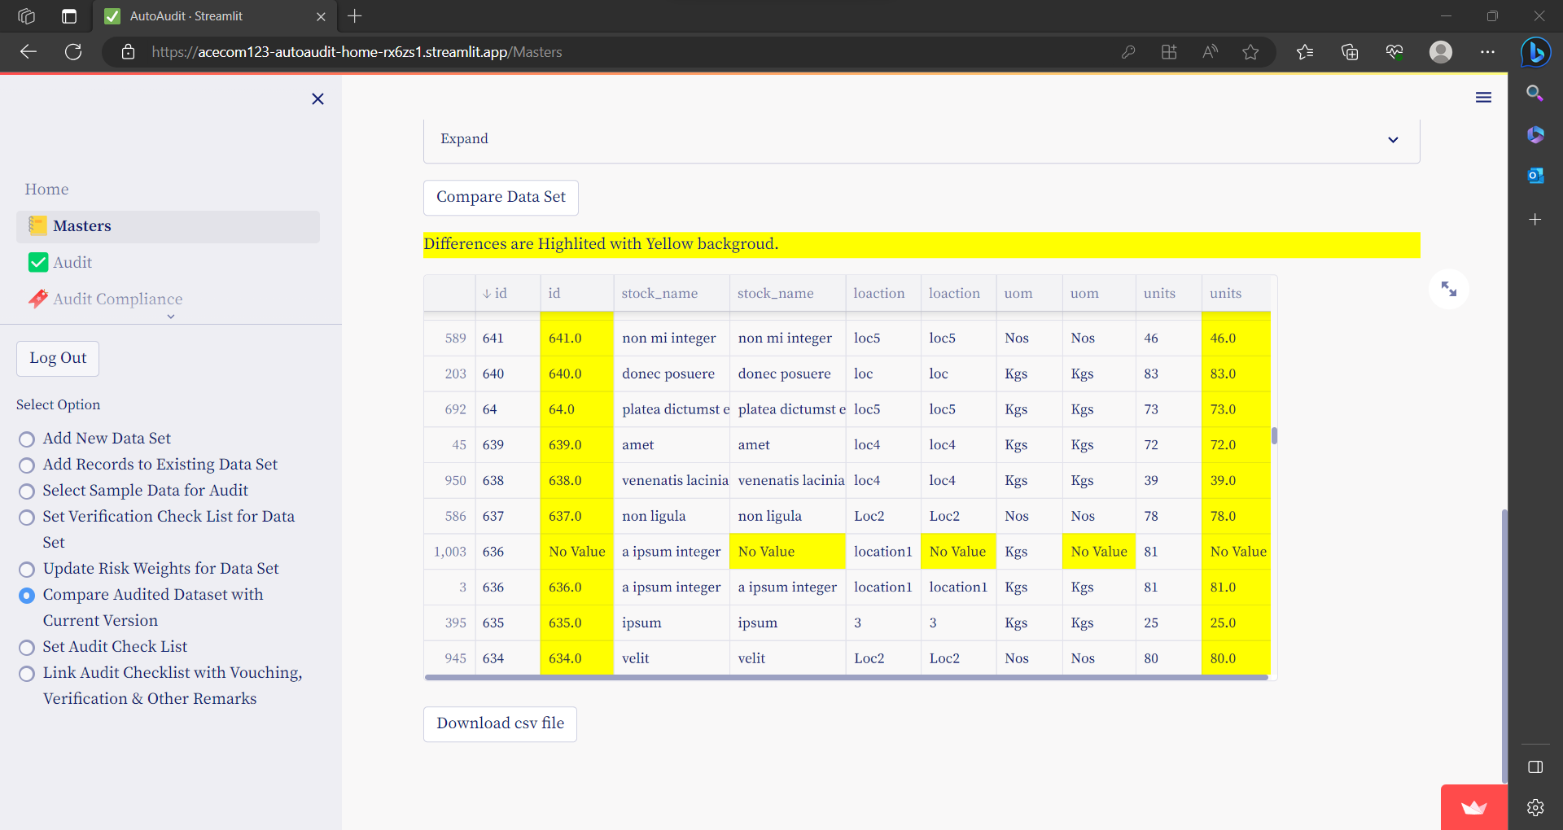

Differences are Highlighted with Yellow background.

* To download this report Click on **Download CSV file**

## **Set Audit Verification Check List**

Go to menu **Masters** and then select option button- **Set Audit Verification Check List**

* In this option you can set verification check list for selected data set.
* e.g. For every transaction of expense paid you want to verify whether the expenses properly approved or not. In this case verification checklist is weather-**expense is properly approved.**
* If Answer to this question is positive or yes then there is no auditory; otherwise if answer to this question is negative or no then, automatically audit query is generated.
* Also for each verification checklist you can assign risk weight.

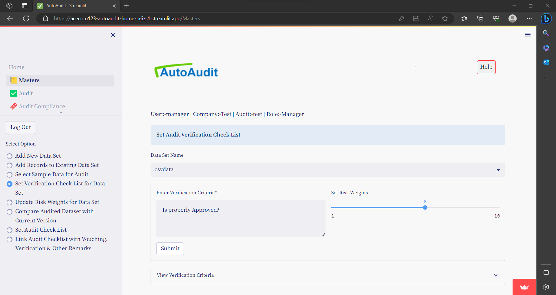

You can see list of checklist by clicking on **View Verification Criteria**

Once checklist is added you cannot modify or delete checklist.

## **Update Vouching & Verification Risk Weights**

Go to menu **Masters** and then select option button- **Update Vouching & Verification Risk Weights**

* Risk-weight between 0 to 10 is allocated to all the vouching and verification criteria’s.
* For all the vouching criteria risk weight of 1 each allotted by default.
* You can view and change the risk weights associated with the data set vouching and verification.

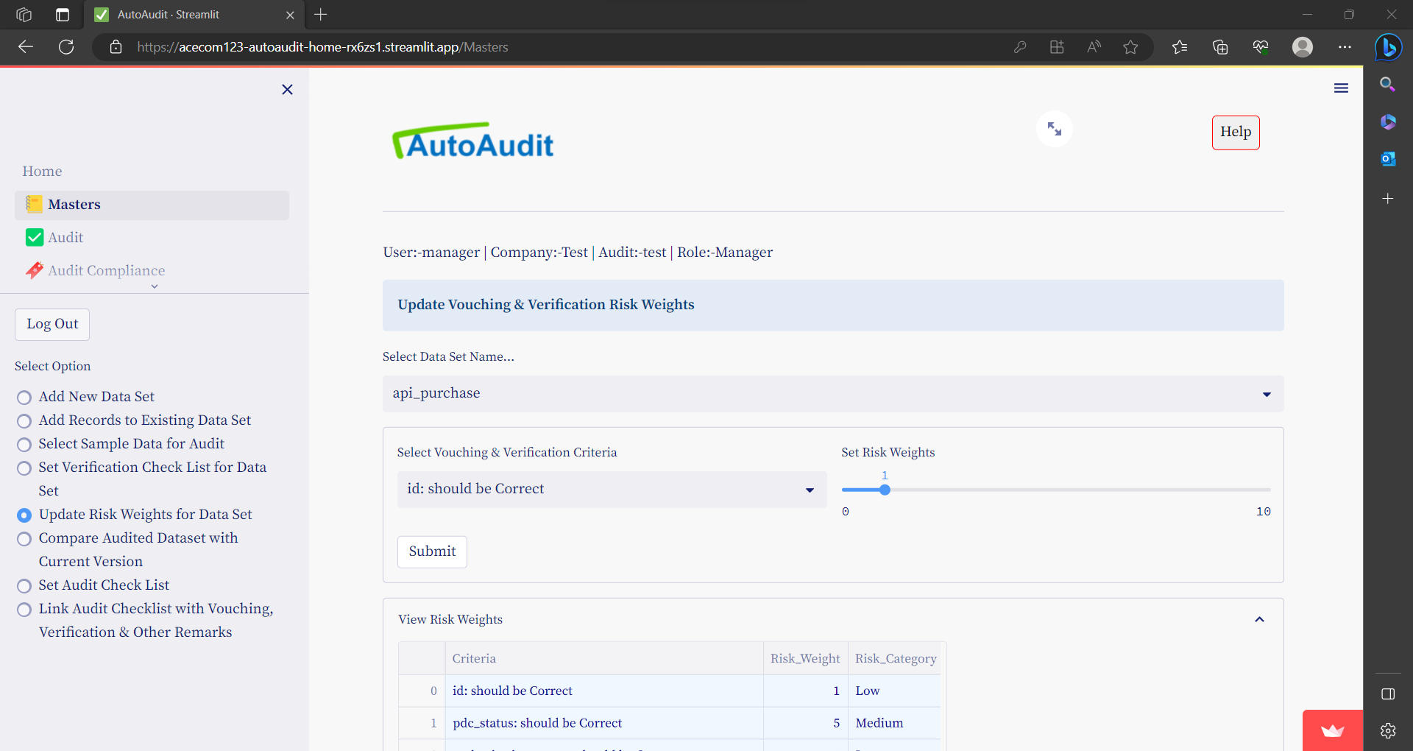

## **Set Check List for Audit**

* You can set checklist for the selected audit.
* Audit checklist is list of audit Criteria’s or audit objectives.
* Based on this checklist audit report is automatically generated.

Go to menu **Masters** and then select option button- **Set Checklist for Audit**

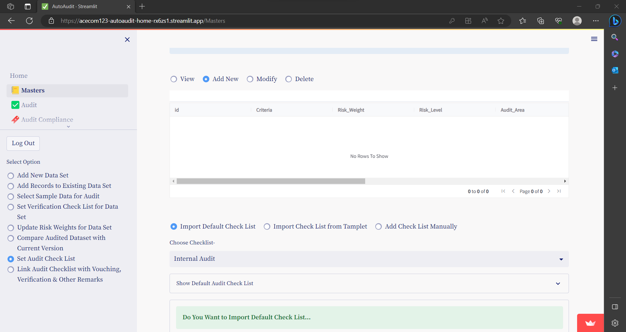

You have 3 options to add Audit Checklist-

1. Import Default Checklist
2. Import using Templet
3. Add Manually

Let us see how to add checklist in each option

### Import Default Checklist

select option button- Import Default Check List

choose the type from drop down options- Choose Checklist-

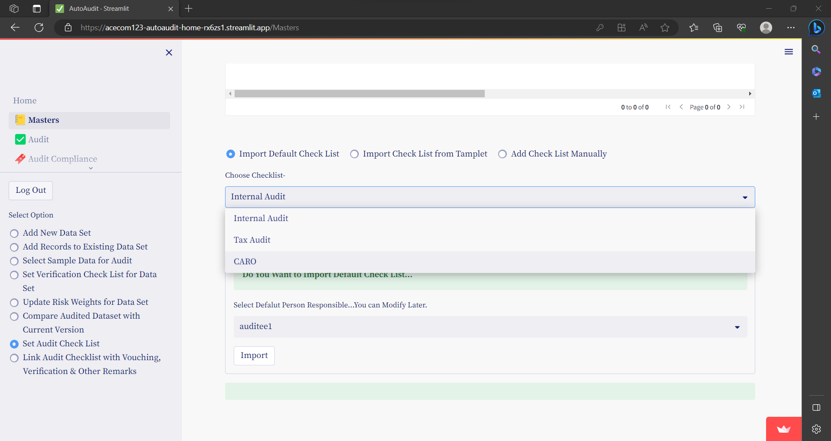

You can see the default checklist before importing

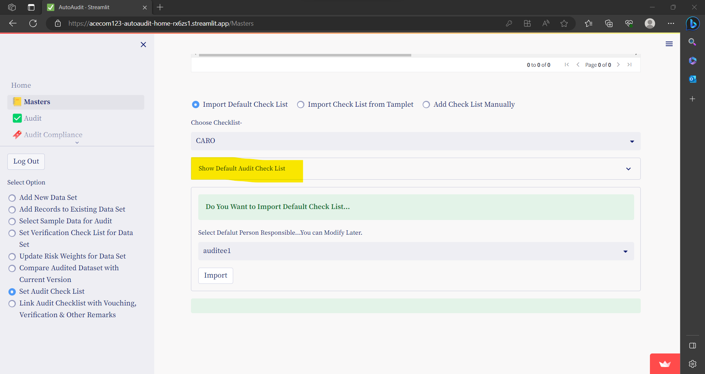

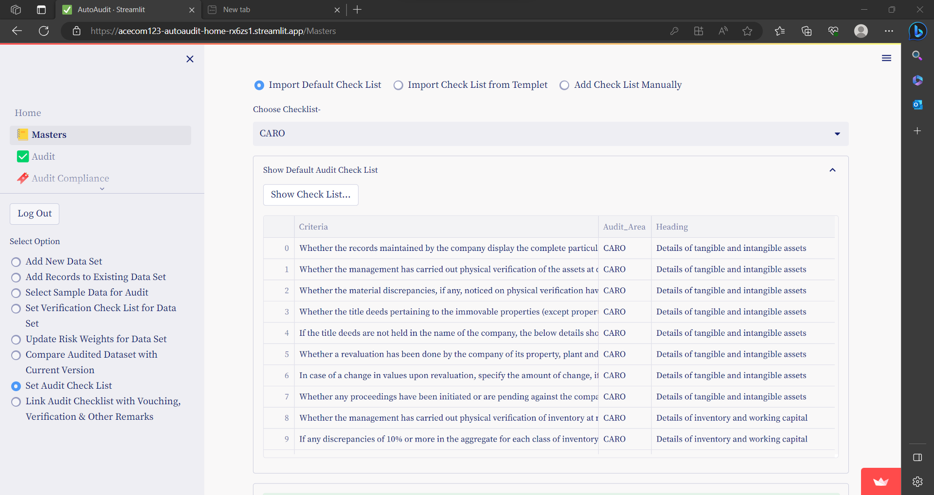

To import default checklist click on **Import**

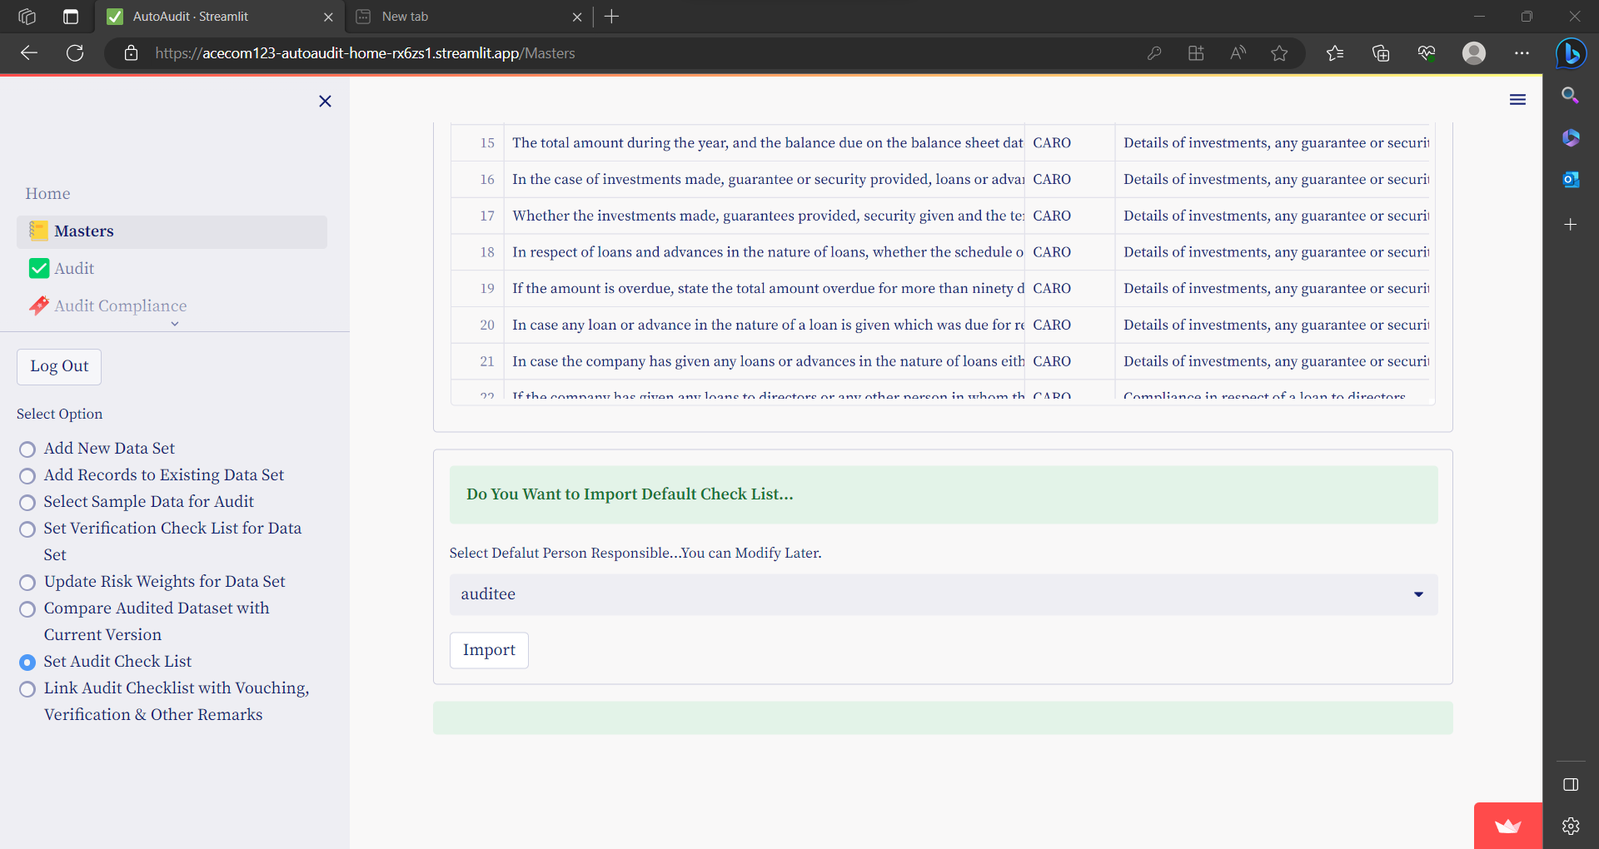

* For each Audit- Checklist / Criteria should be Unique, otherwise error is raised

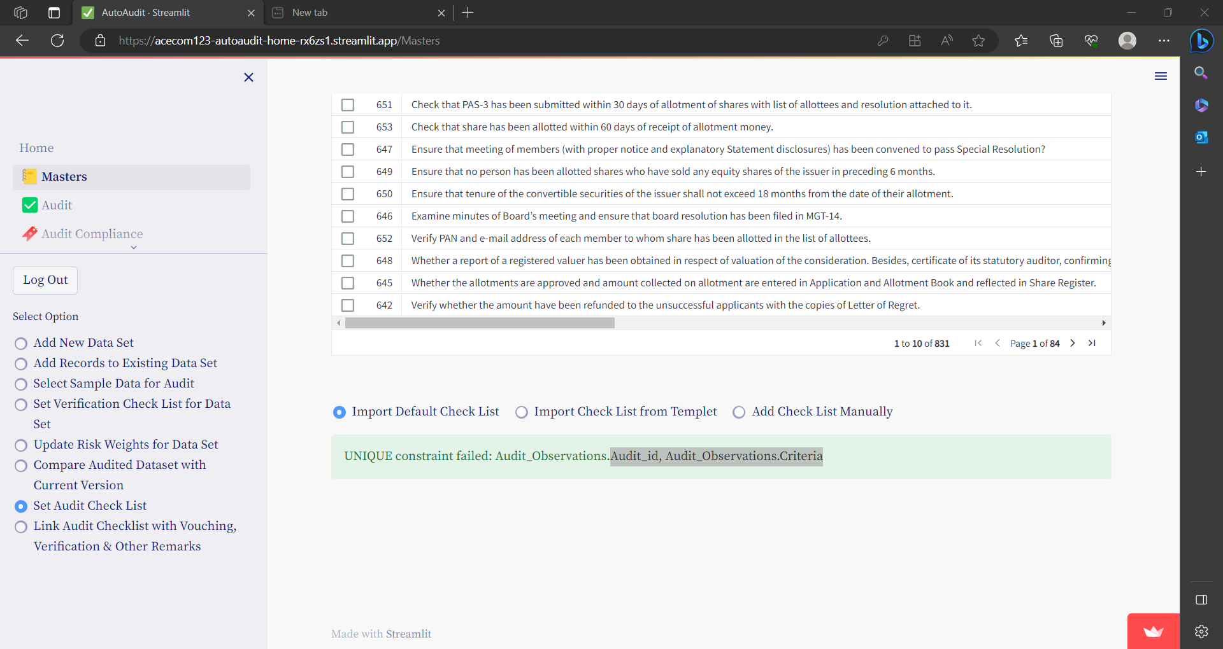

* By default risk weight is 1 for all the criteria’s.

### Import using Templet

select option button- Import Check List from Templet

* You can download templet by clicking on **Download Templet** button

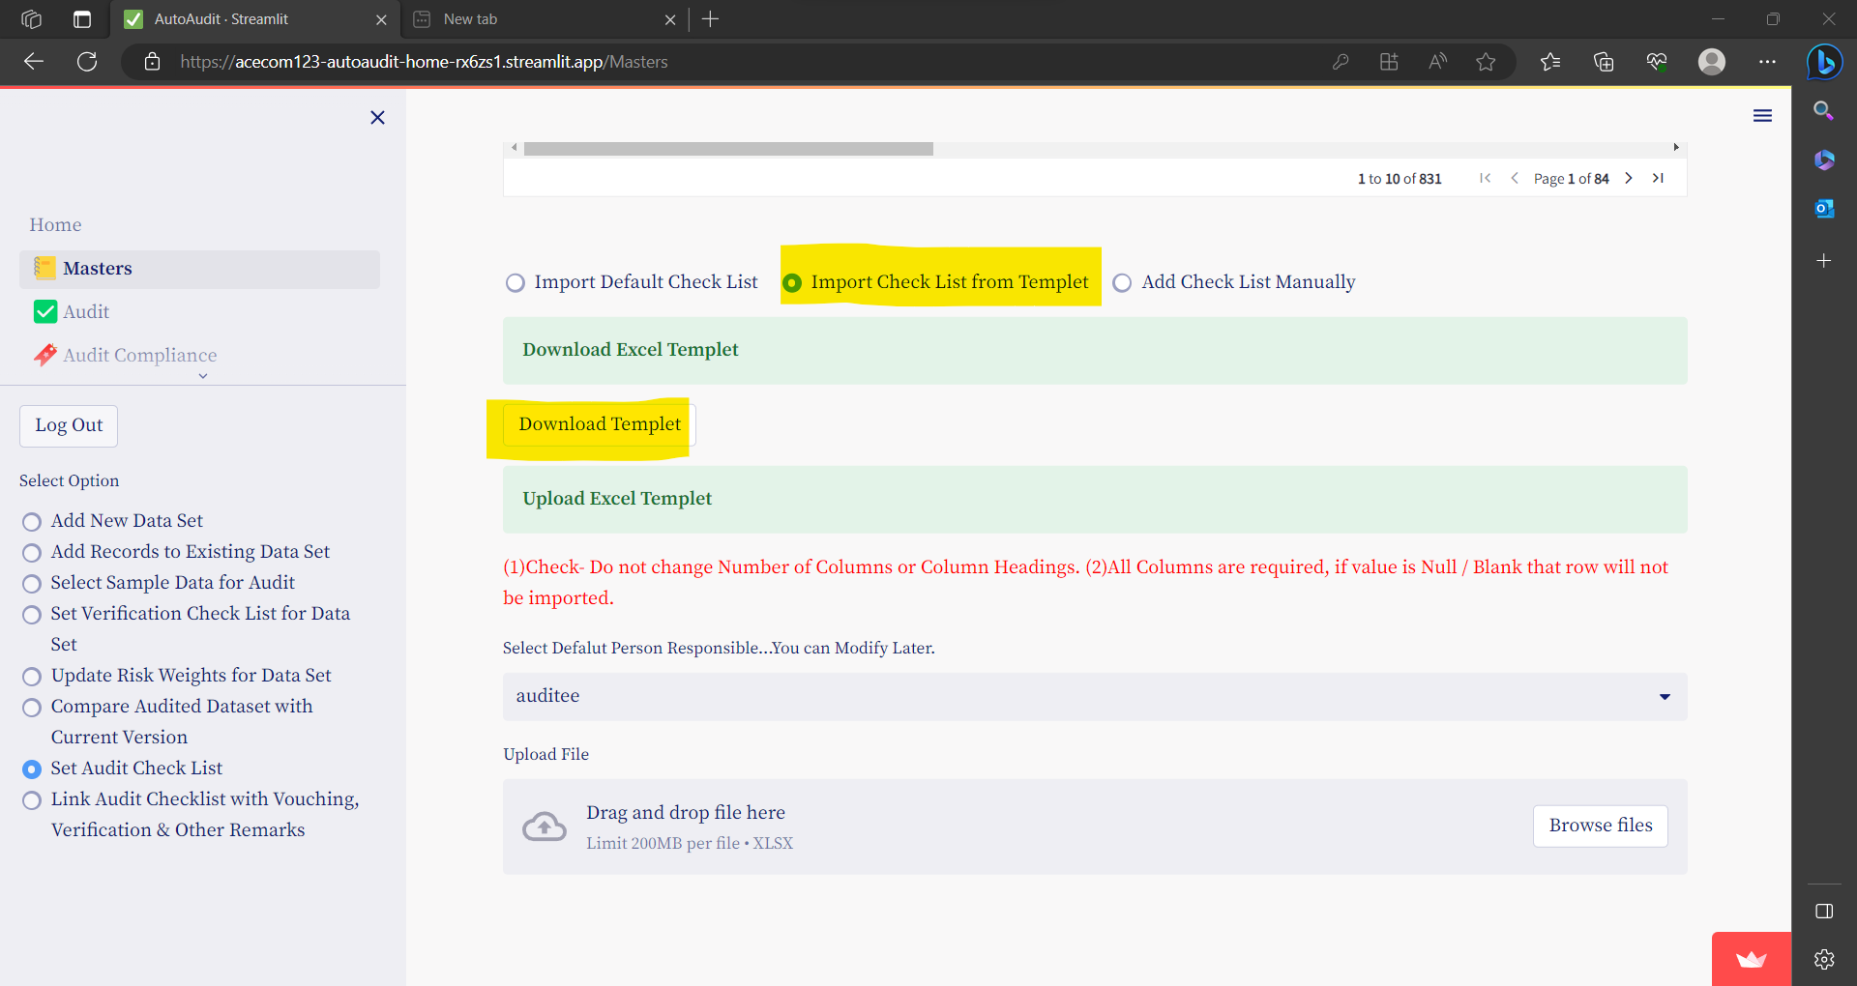

* Fill-up the templet & Upload the file

(1)Check- Do not change Number of Columns or Column Headings. (2)All Columns are required, if value is Null / Blank that row will not be imported.

* By default risk weight is 1 for all the criteria’s.

### Add Manually

select option button- Add Check List Manually

* To add checklist / criteria manually click on Add Check List Manually
* Fill up all the fields & click on **Submit** to save

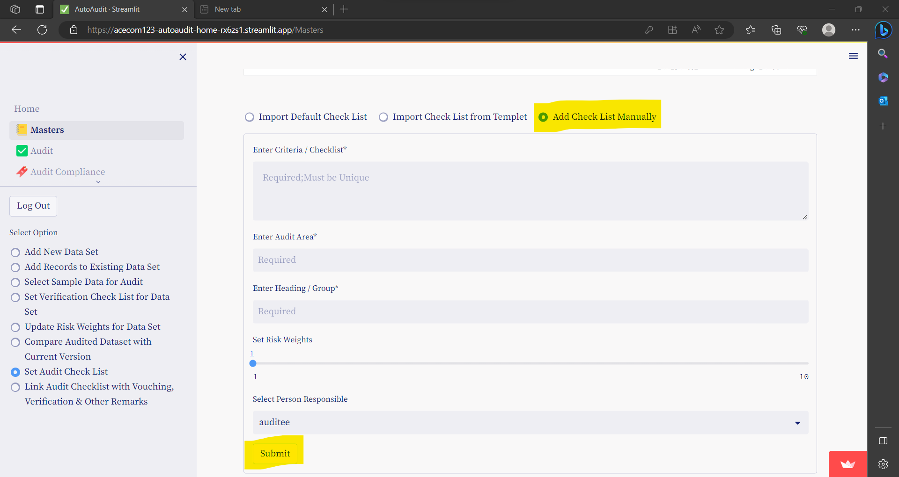

## **Link Audit Checklist with Vouching, Verification & Other Remarks**

This option is used to link Audit checklist with 1 or multiple Audit queries (ie Vouching & Verification Remarks)

1. Select the Criteria

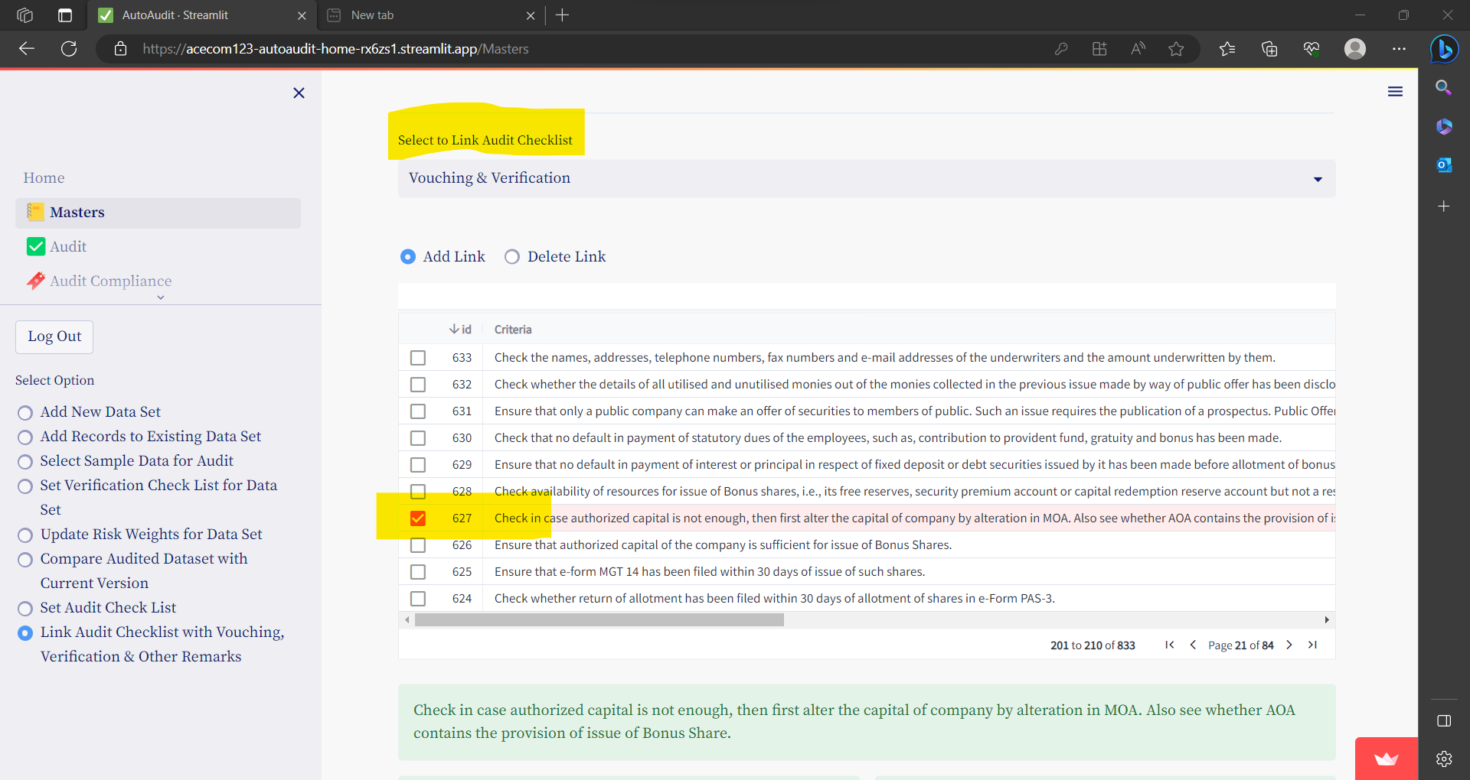

1. Select Vouching & Verification Criteria’s to Link to above Checklist Item

You can sort / filter Vouching & Verification Criteria’s DataSetName

Click on Add Selected to Link.

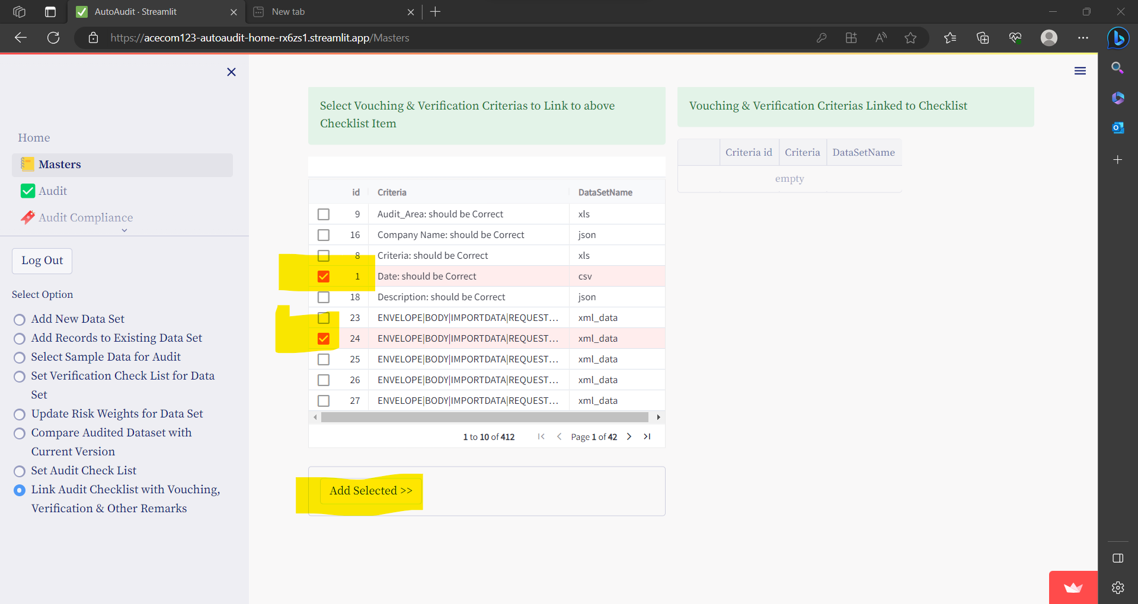

Once added it is shown in the table -on right side

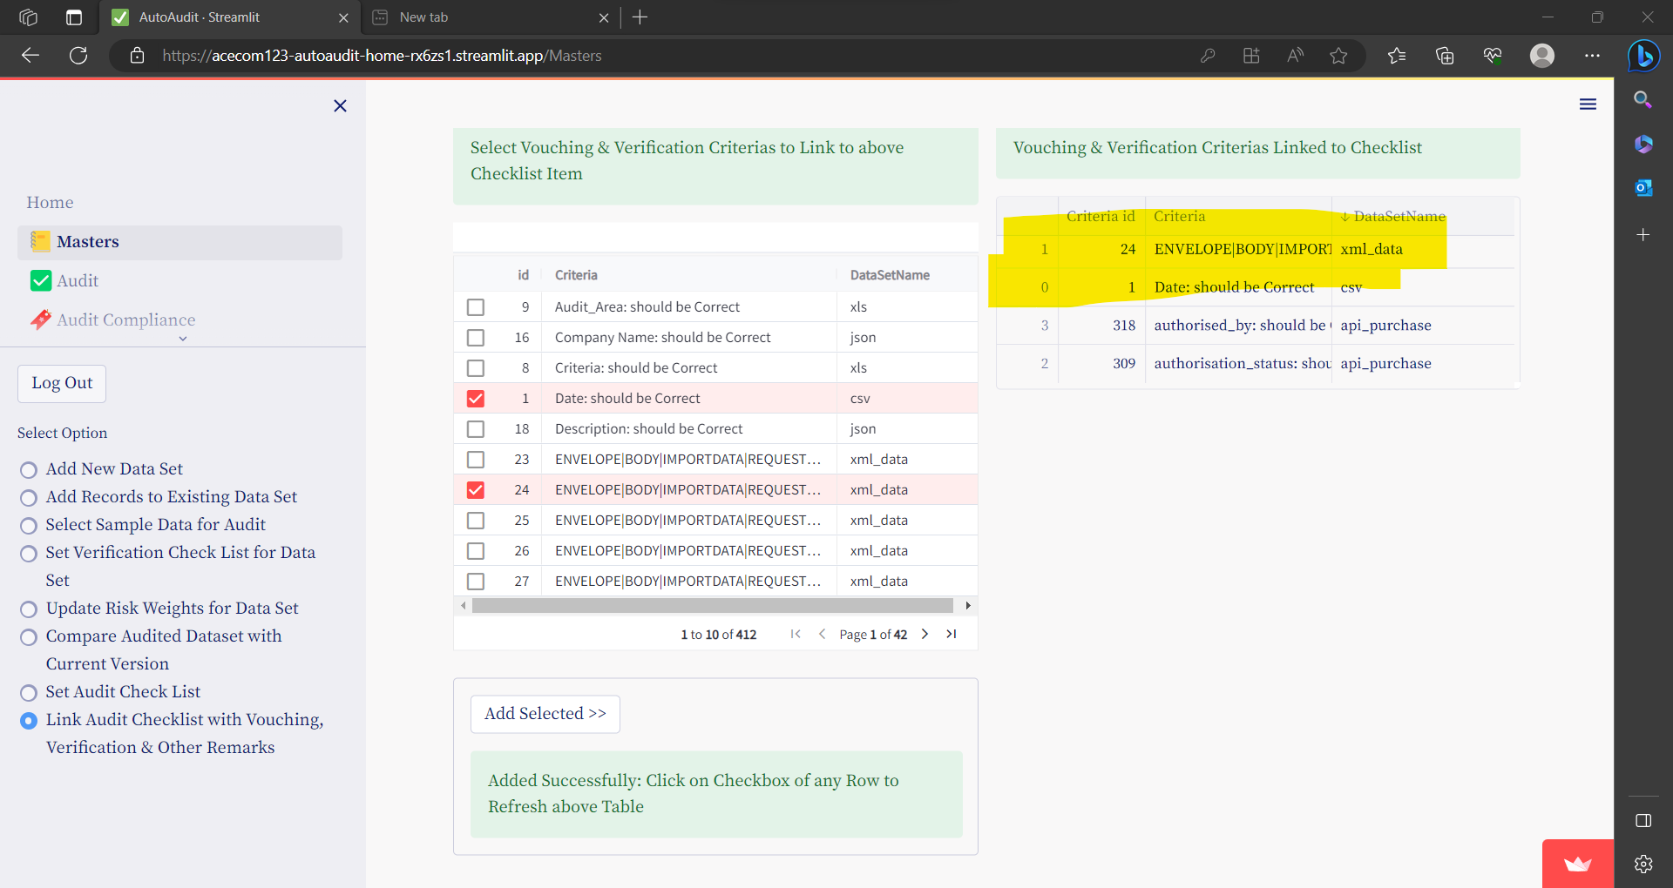

# **AUDIT**

## **Vouching Verification & Review & Other Remarks**

Under this option you can record Audit Findings / Queries, Based on various Auditing Techniques / Procedures for each Data Set.

First select Data Set to Audit.

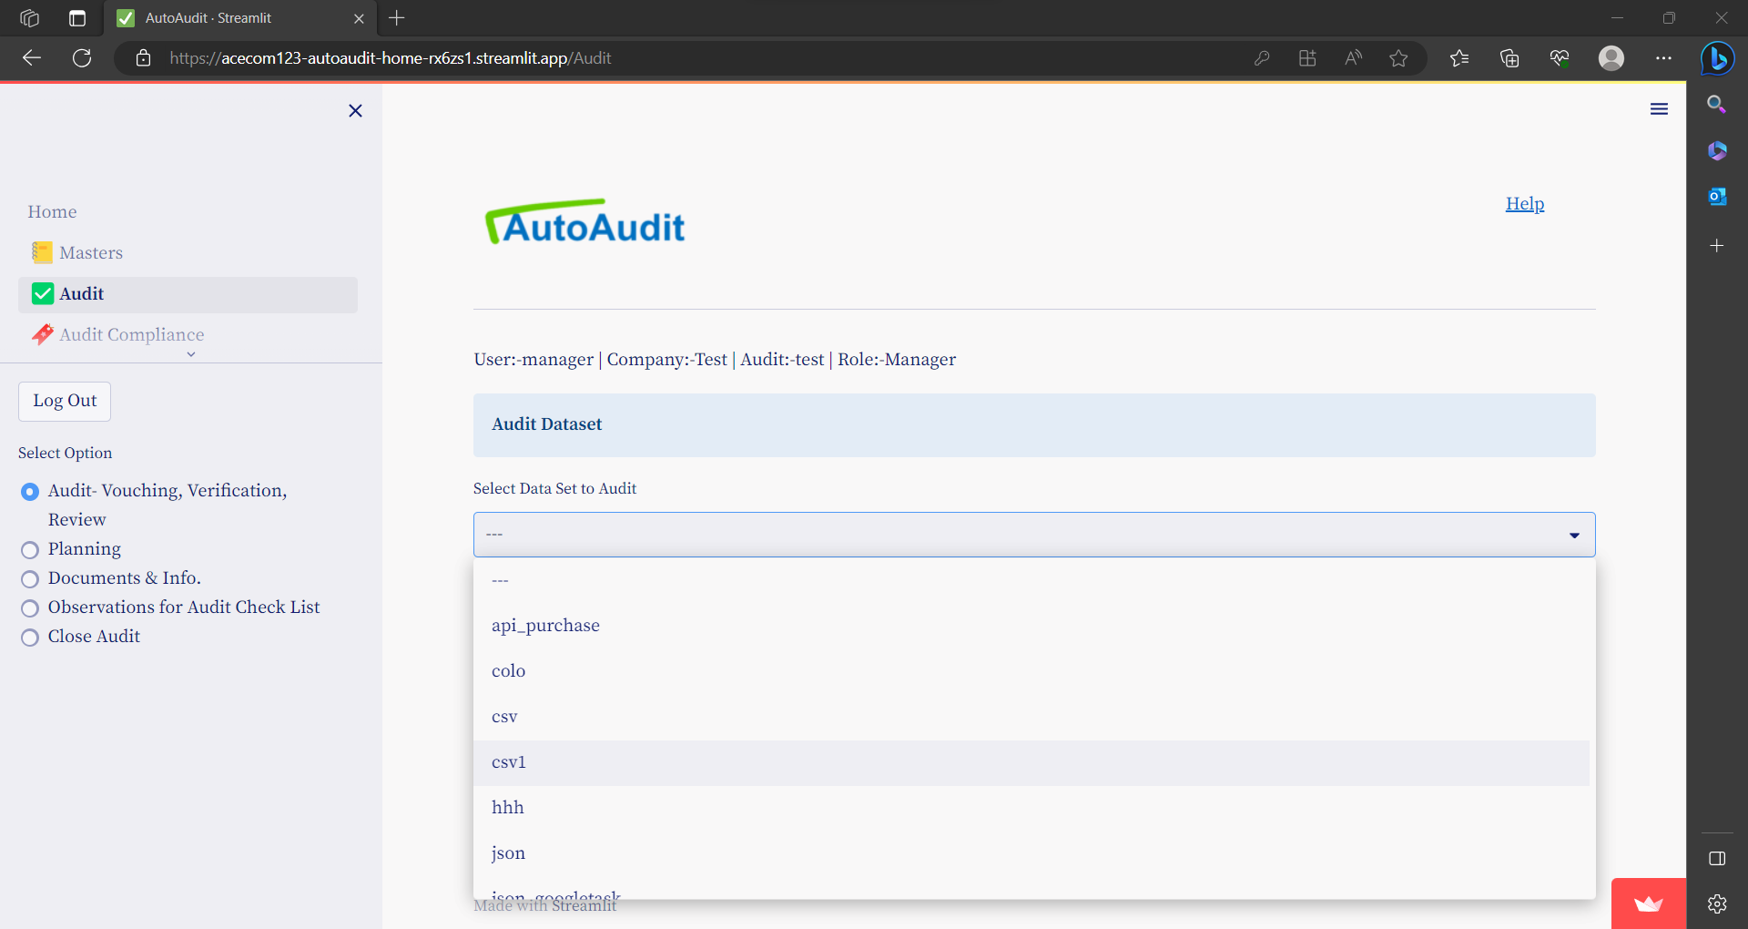

For any selected Data set Audit Findings / Queries are grouped in 2 categories-

1. Vouching & Verification
2. Analytical Review & Other Remarks

Vouching & Verification

* Vouching- is checking of accuracy of each line item of Data Set

e.g. In Vouching of Sales Register- we check If sales Amount, Name of party etc are correct or not.

* Verification- is checking of internal checks & controls related for each line item of Data Set.

e.g. In Verification of Sales Register- we check -If -sales Invoice is Signed or not, If Sales Prices are approved Price List, If Discount is as per policy or not.

**There Audit Findings/ Queries are for each item of Data Set e.g. each Sales Transaction of Sales Register.**

Analytical Review & Other Reviews

Audit Findings / Queries based on Analytical review or Other Review or Observations are entered here.

**There Audit Findings/ Queries are for entire Data Set e.g. Month on month payroll has increased by 40%**

### Entering Vouching & Verification Findings/ Queries

* Select Data set Name.
* Select option- Vouching & Verification

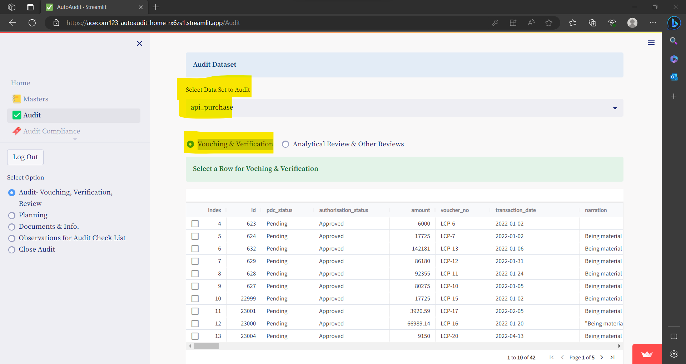

* Now entire Data Set is displayed with Selection option on extreme right of each row.
* Select the line / Transaction to audit.
* Once selected 2 Boxed are shown under the list for adding Vouching & Verification Findings / Queries.

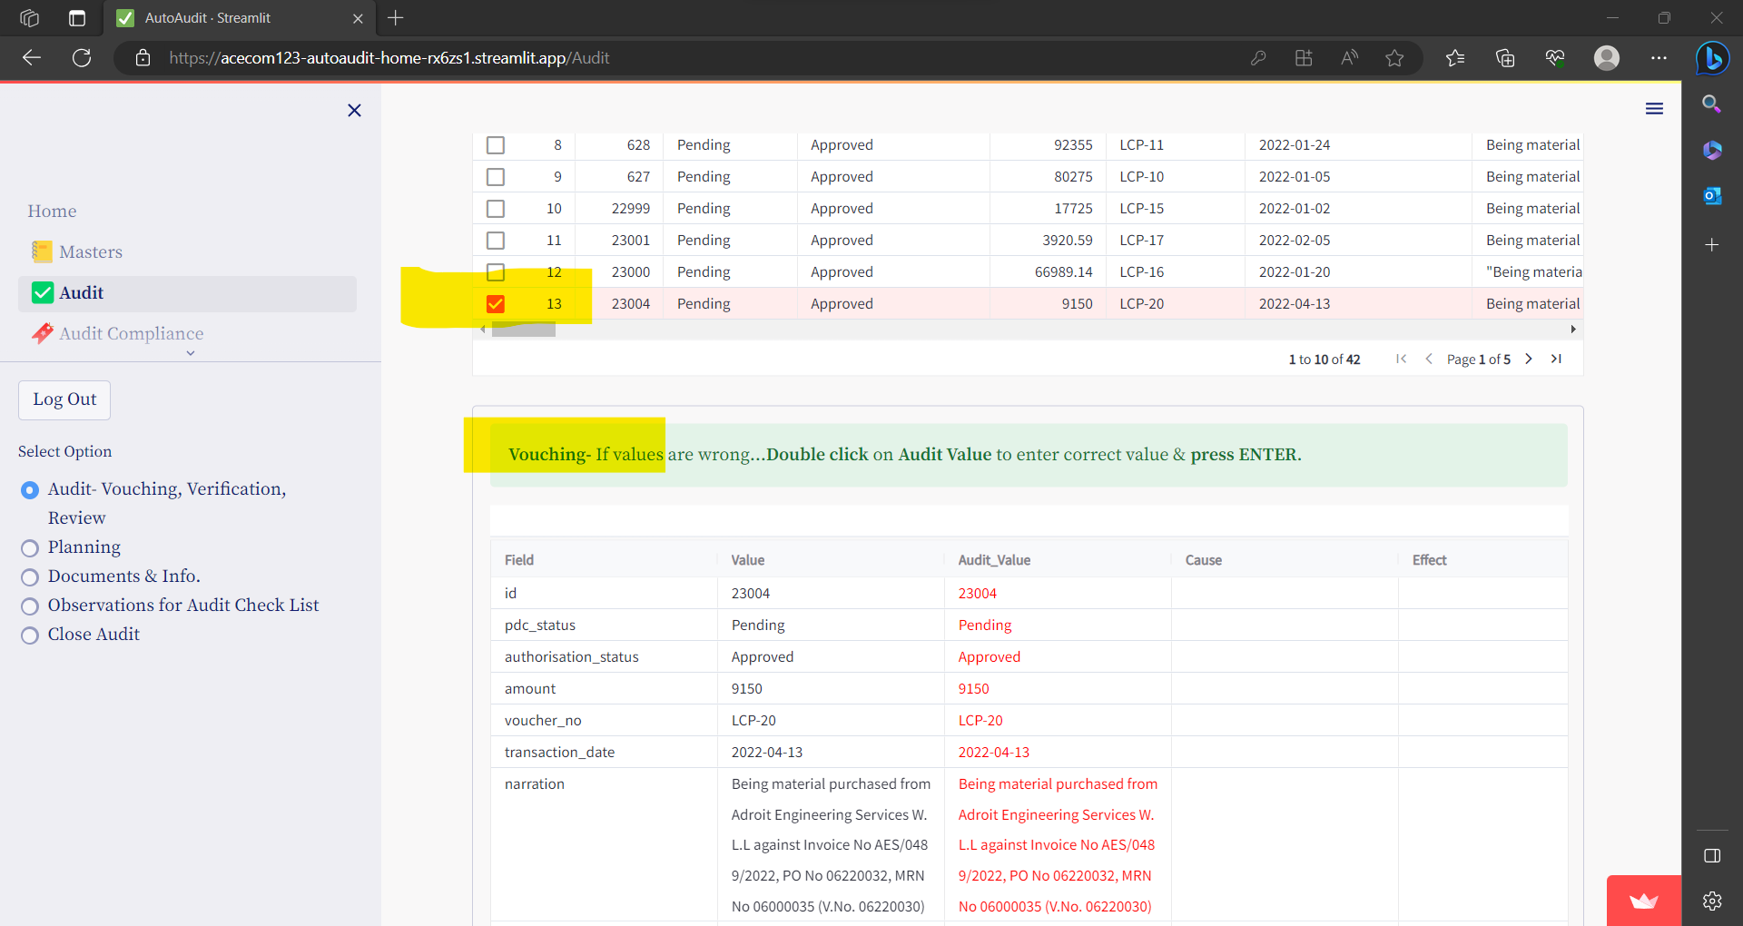

#### For Vouching:

* In the Second Column Value as per Dataset id shown & the same is shown in Third Column **Audited Value** by default.
* If for any field value as per Audit is different, then DoubleClick & enter the Audited value in Third Column **Audited Value.**

e.g. as shown below- Value of amount field is 9150 but as per audit it is 9000

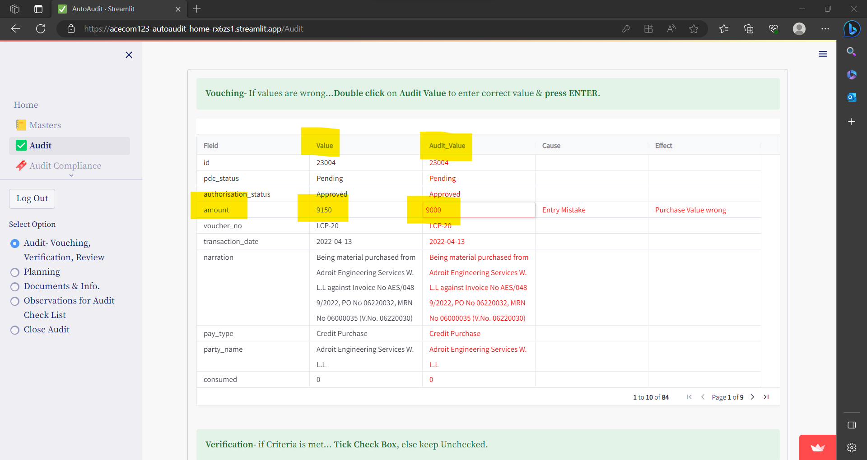

* Also you can mention Cause & Effect of such Query for each line, in respective columns.
* press **ENTER** to Save the Data for selected cell
* **If the Audit Value is different than Value- then Automatically Audit Query is generated for field.**

#### For Verification:

* Verification criteria’s are those which are entered in the **Masters- Set Audit Verification Check List.**
* If the checklist/Criteria is met then Check the Check Box before Verification criteria. But if the checklist/Criteria is NOT met then Check the Check Box before Verification criteria.

e.g. as shown below- for selected transaction the 1st Criteria was met / fulfilled but the second criteria is not met.

So for 1st criteria Check Box is Checked but for 2nd criteria Check Box is NOT Checked.

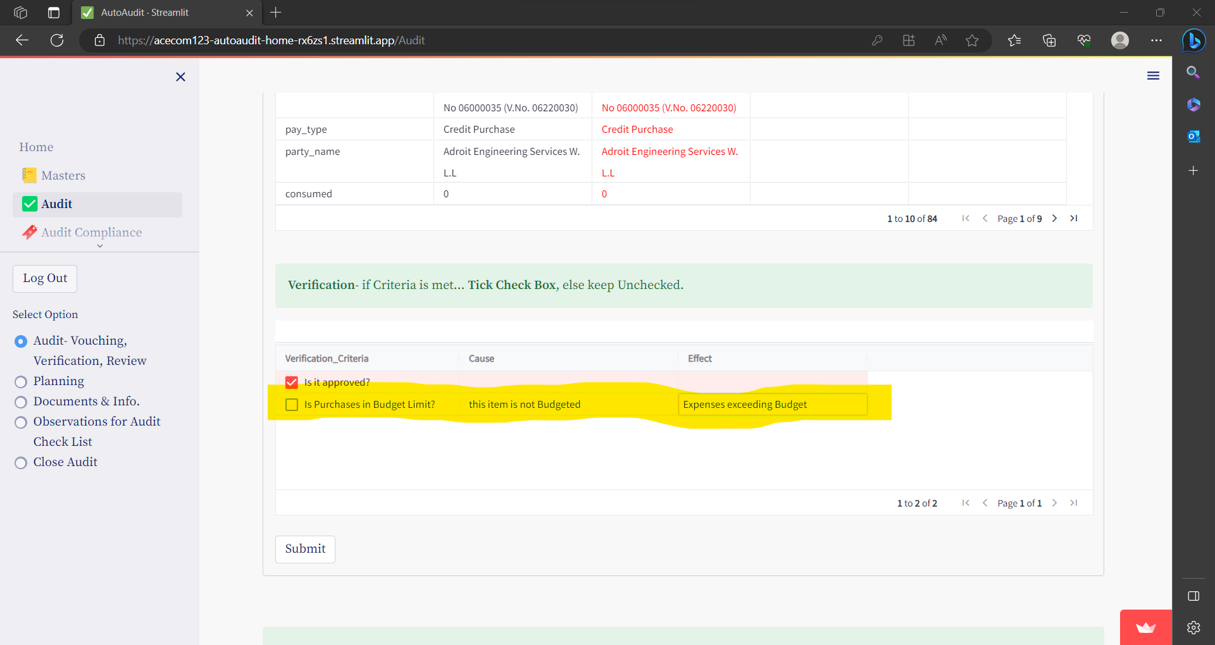

* **If the Criteria is not met the Automatically Audit Query is generated for that.**

### Entering Analytical Review & Other Remarks

* Select Data set Name.
* Select option- Analytical Review & Other Remarks

#### To add Analytical / Other Remarks

Entera all the fields as shown under:-

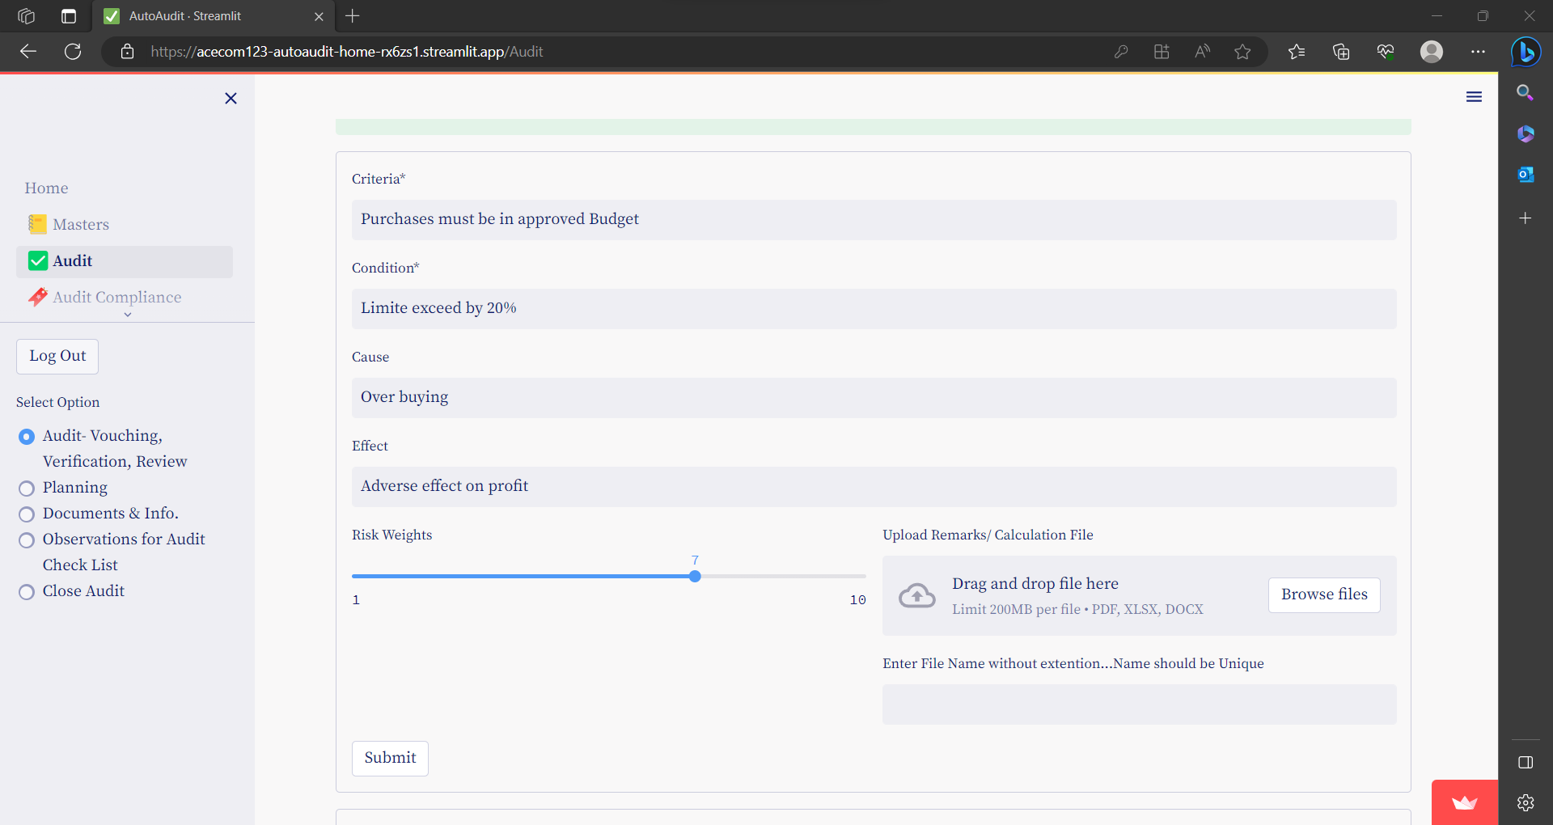

* You can attach supporting files.
* Click on **Submit** to save

#### To View Analytical / Other Remarks –

click on **View Analytical Review & Other Comments**

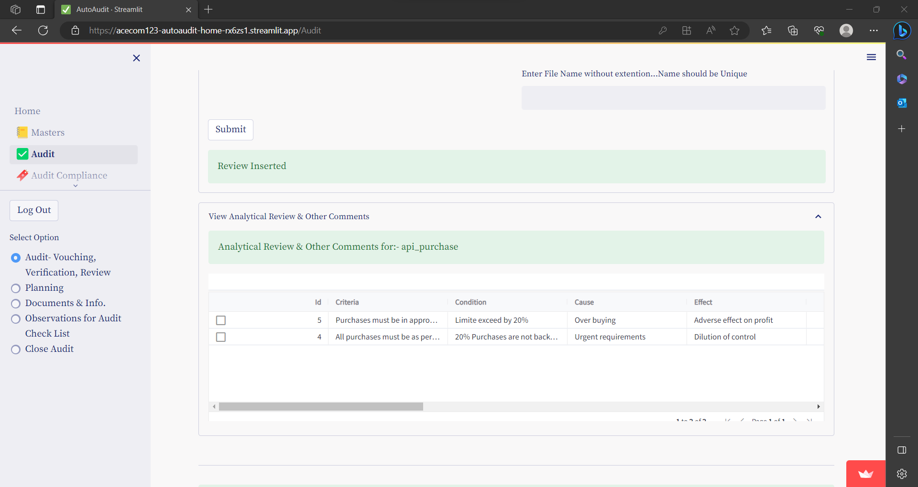

### Analyse Data Set

* Select Data set Name.
* Select option- Analytical Review & Other Remarks

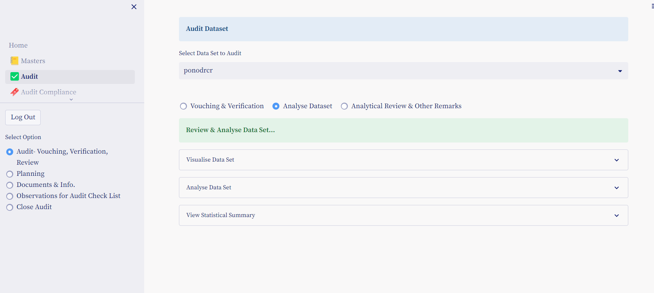

There are 3 Expander options-

1. Visualise Data Set
2. Analyse Data Set
3. View Statistical Summary

#### Visualise Data Set

To generate Charts on Data set click on expander- Visualise Data Set

Numerical fields are listed below the line, if any filed is not shown as Numerical field, the Drag & Drop it from list

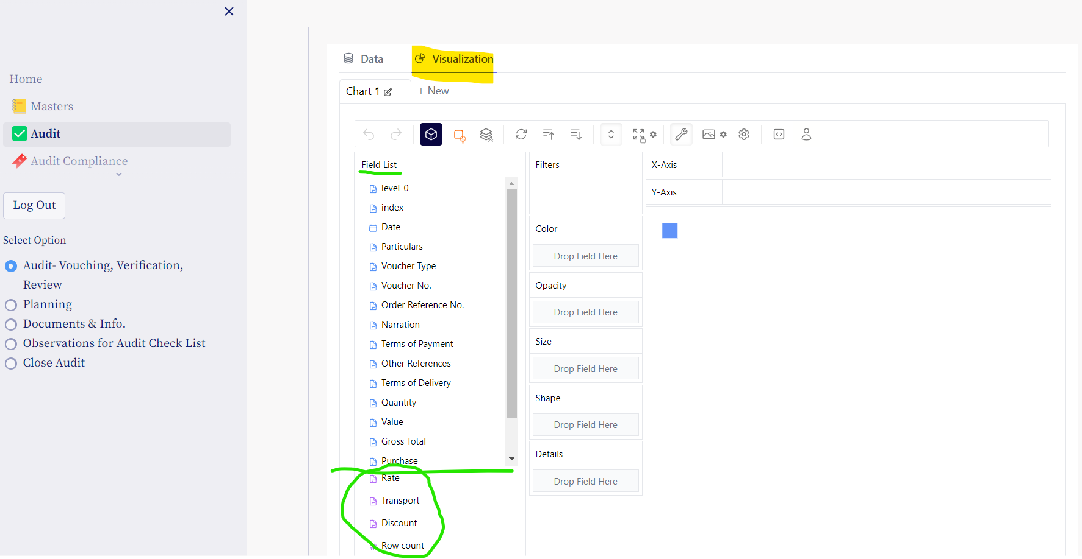

To generate Chart- Drag & Dro Fields to X Axis & Y Axis.

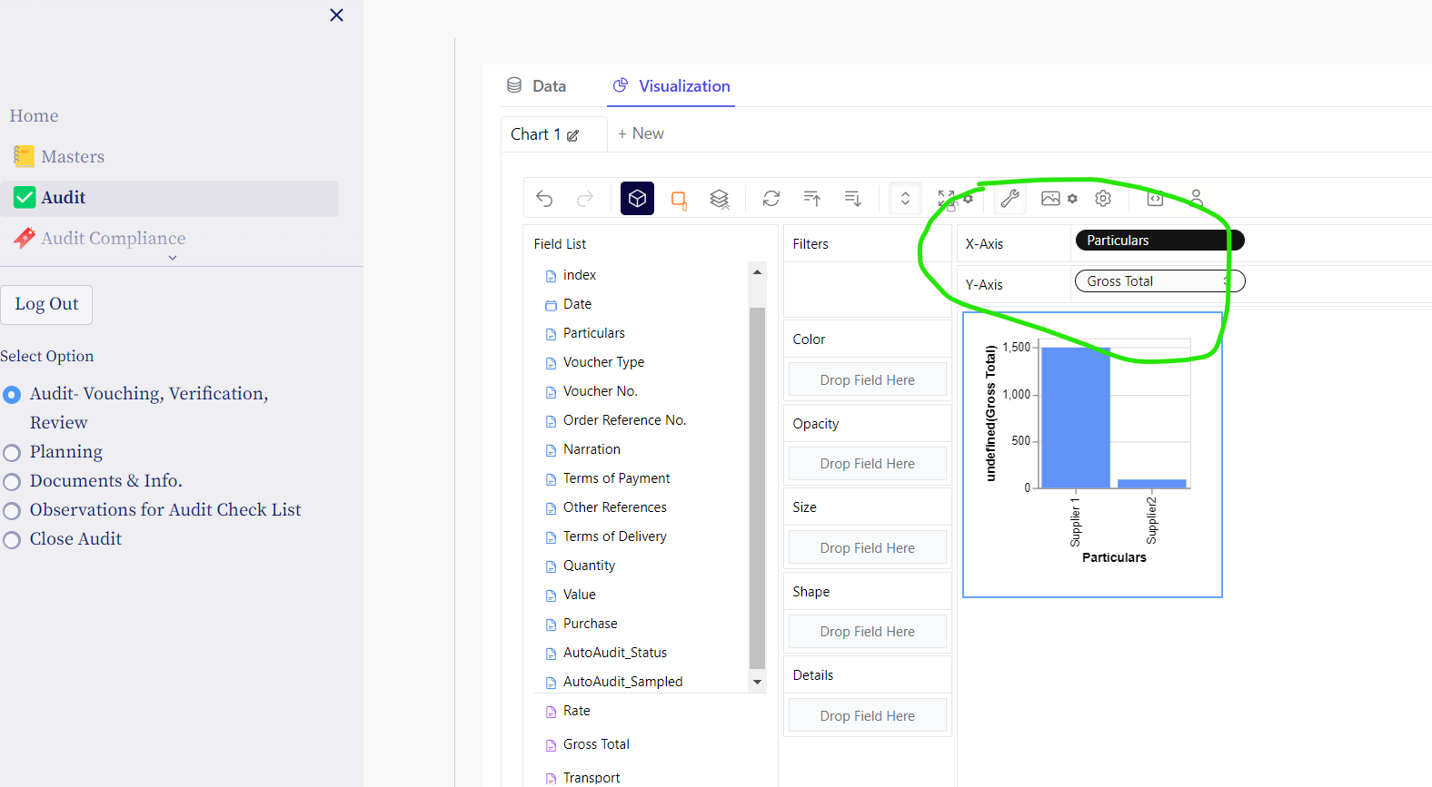

Also you can add Colours, Filters etc, by Drag & Drop of Fields.

You can change Chart type , by clicking on second Icon

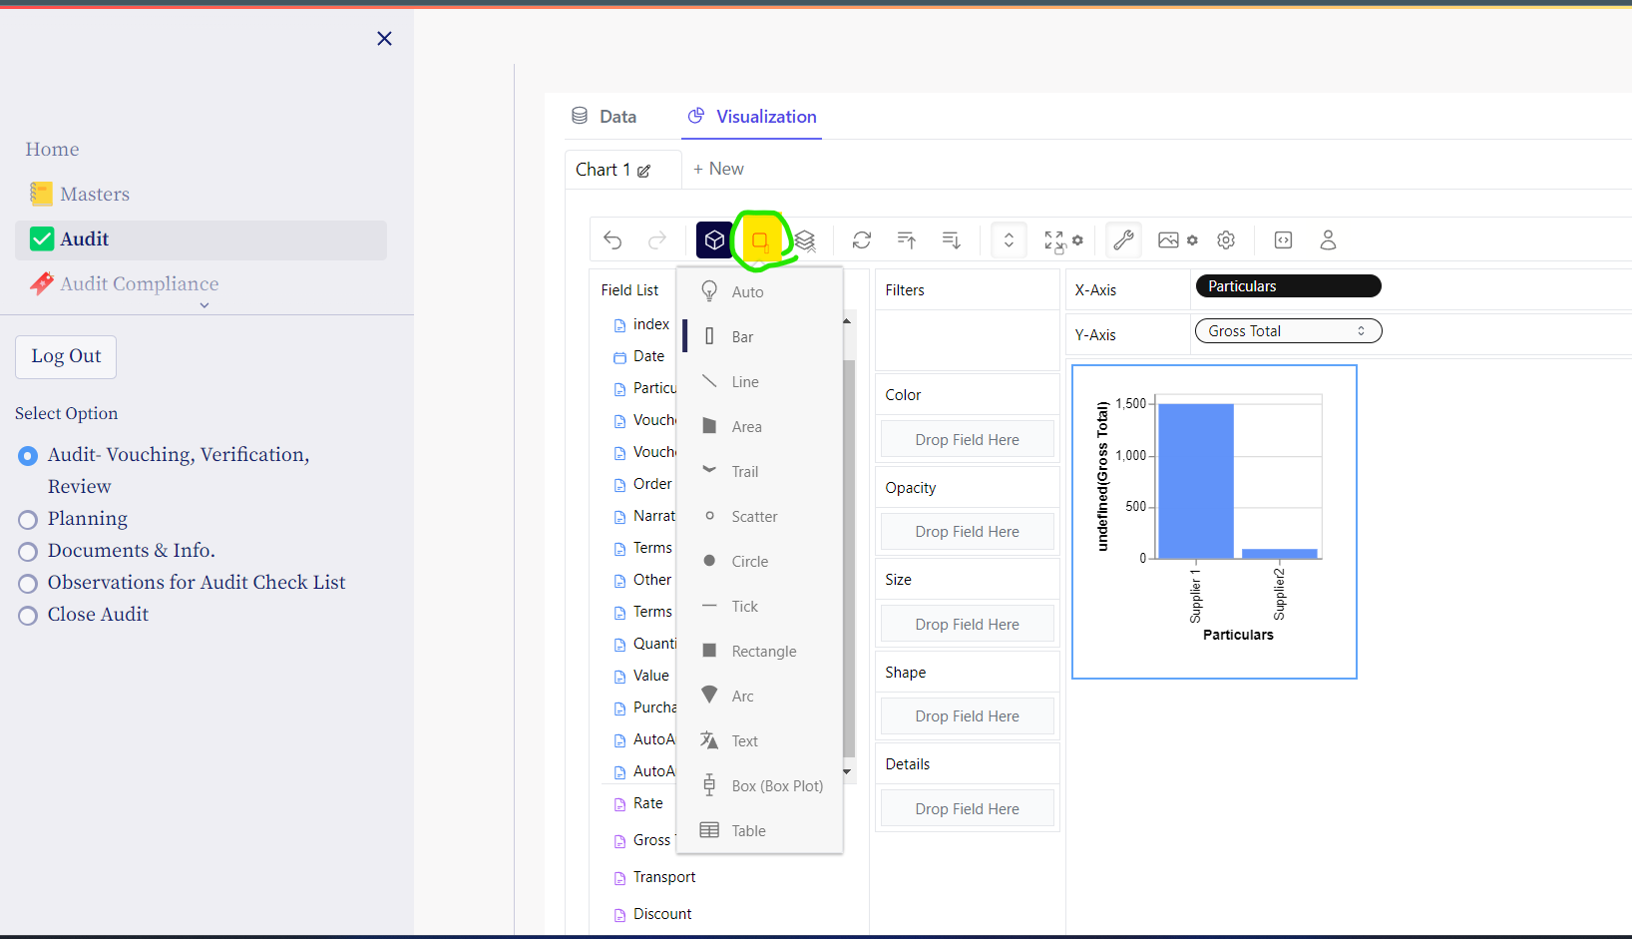

You can export Chat-

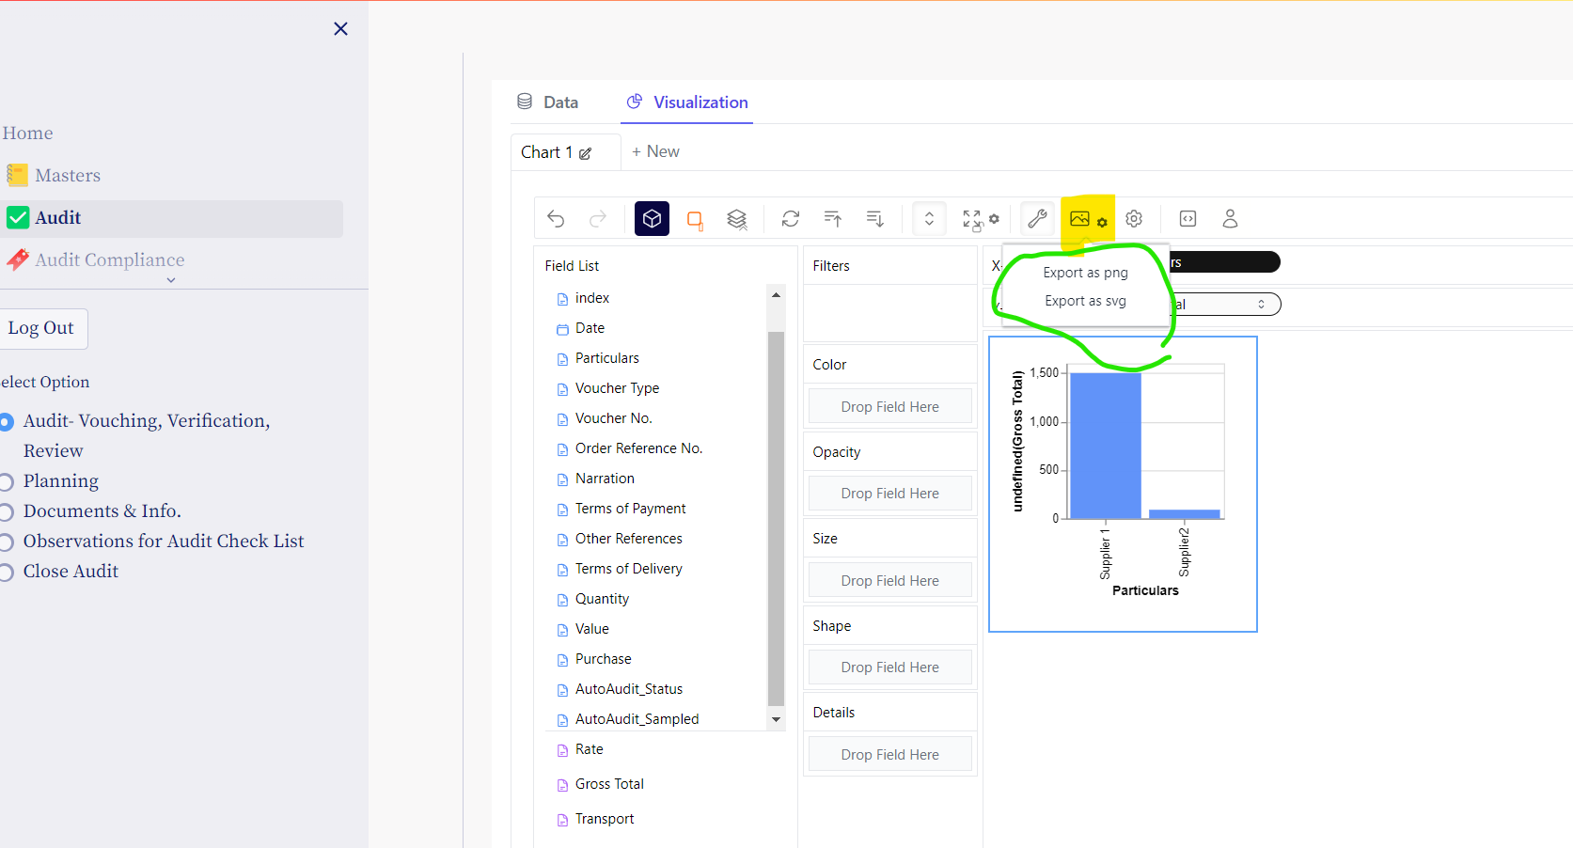

#### Analyse Data Set

* Click Analyse Data to see Dataset & Export to Excel
* To sort / Filter data click on Column headings

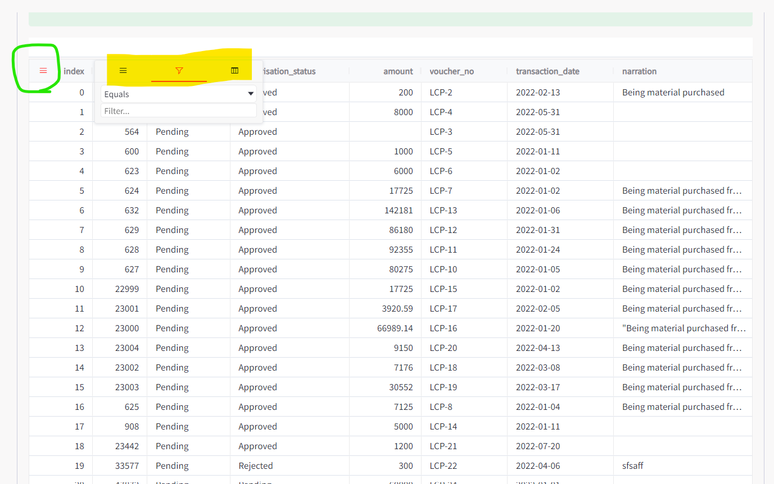

* To Export data to CSV / Excel – Right click on Data

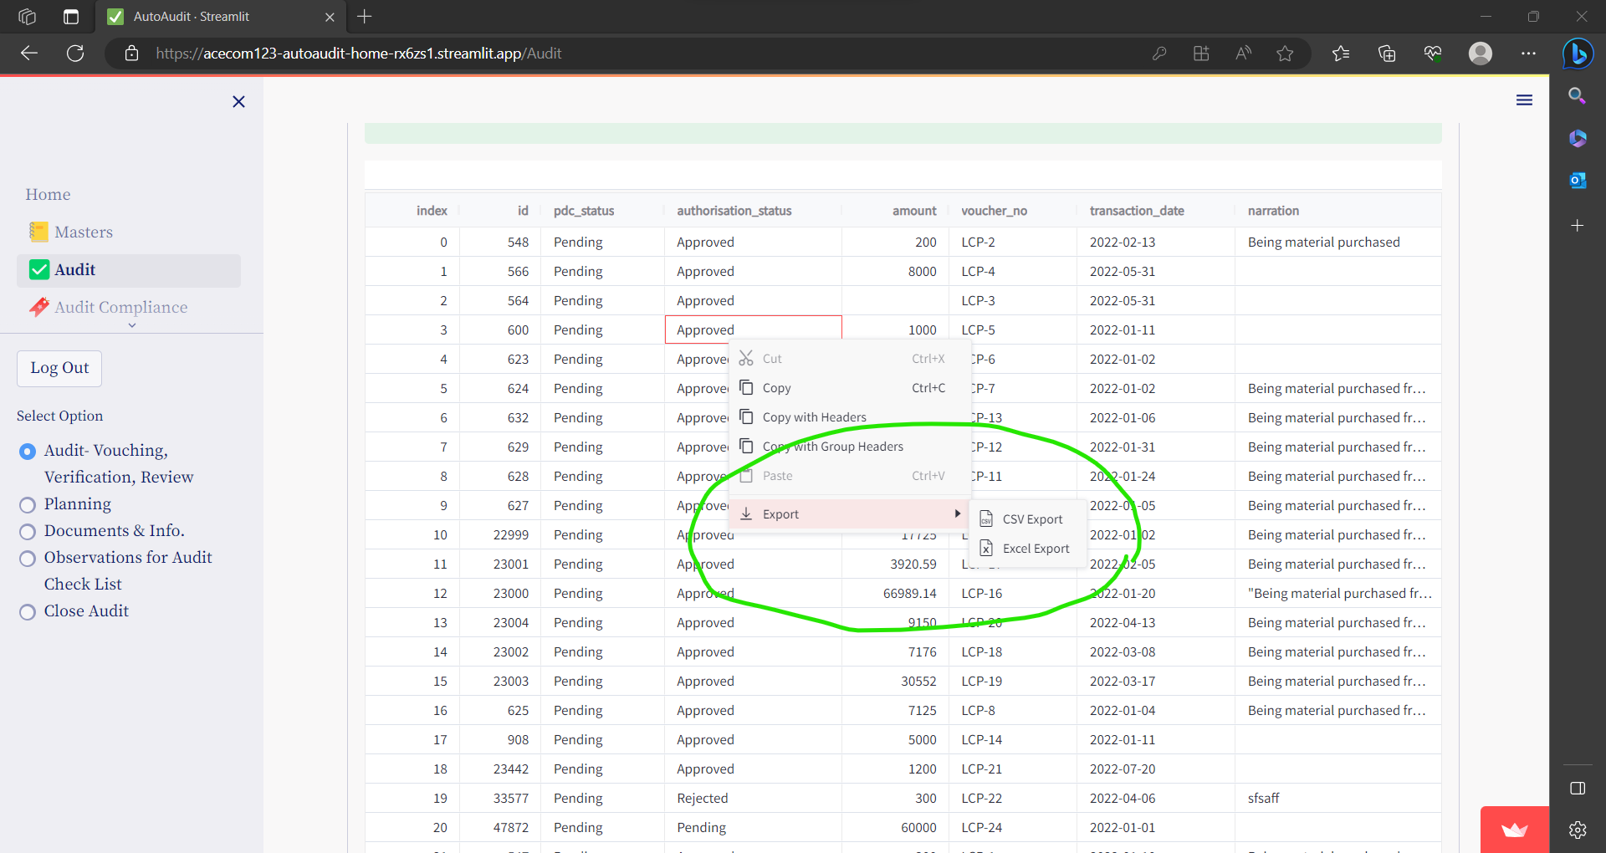

#### View Statistical Summary

To see Statistical Summary - Click on **View Statistical Summary** drop down

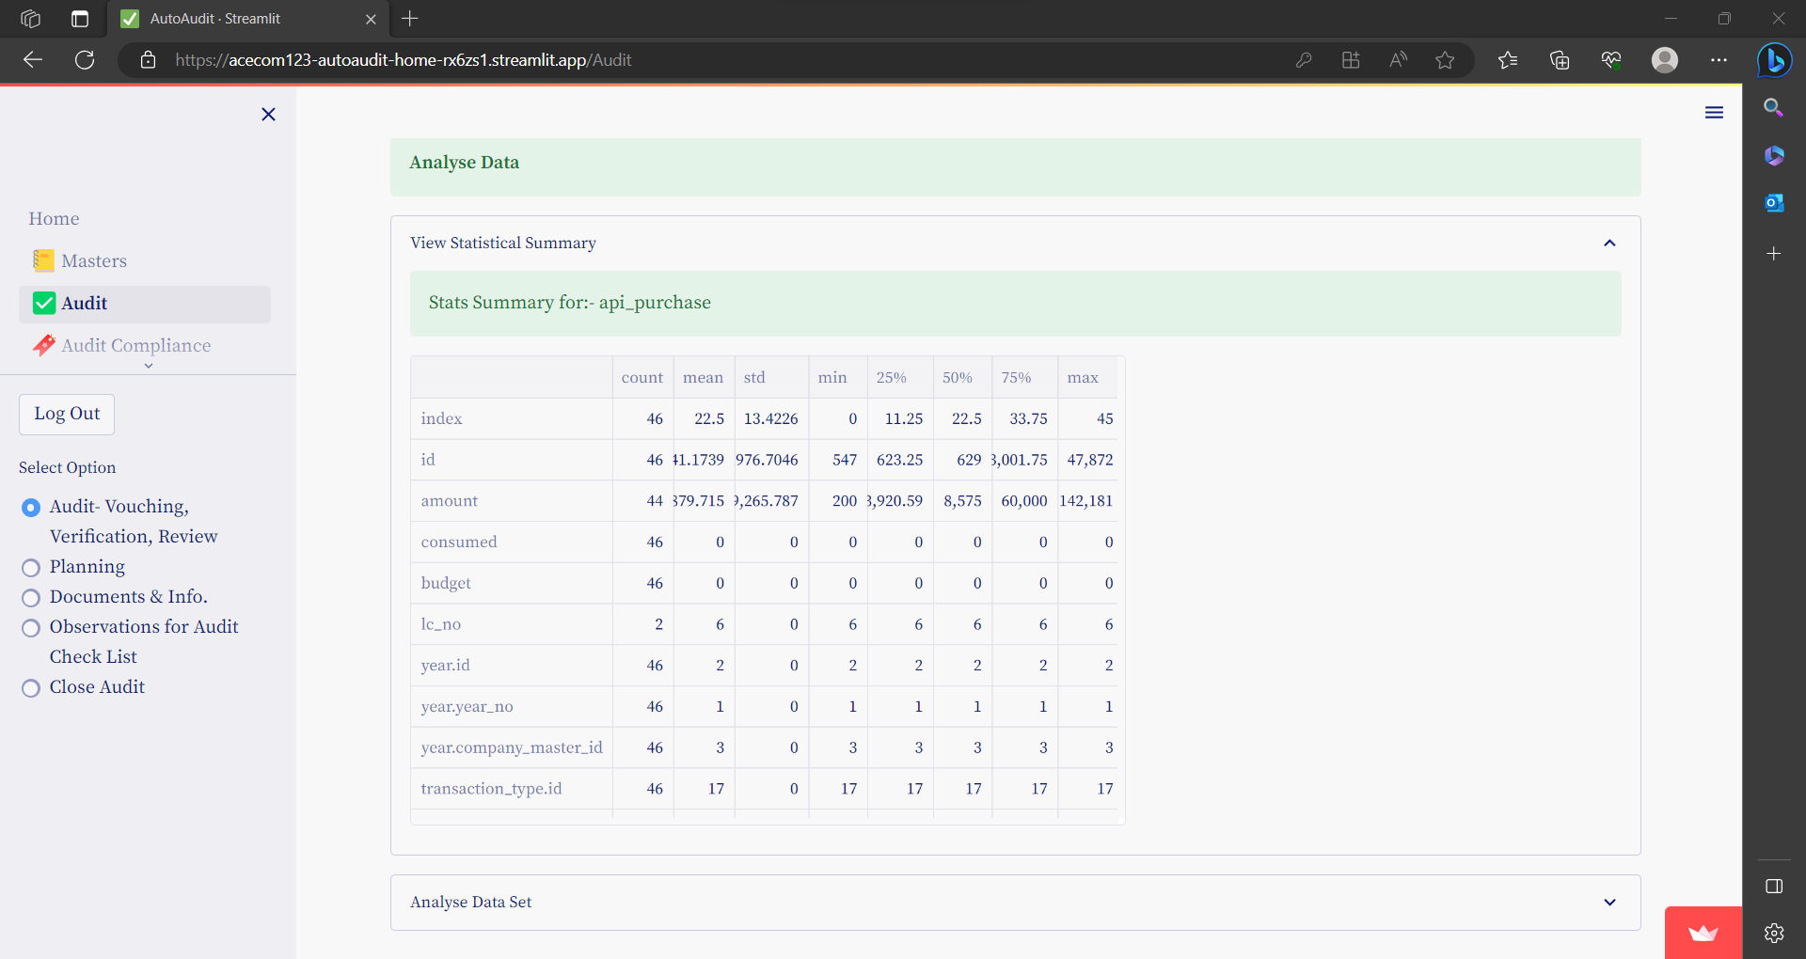

## **Audit Planning & Task Management**

In this option you can Plan & Manage Tasks by users.

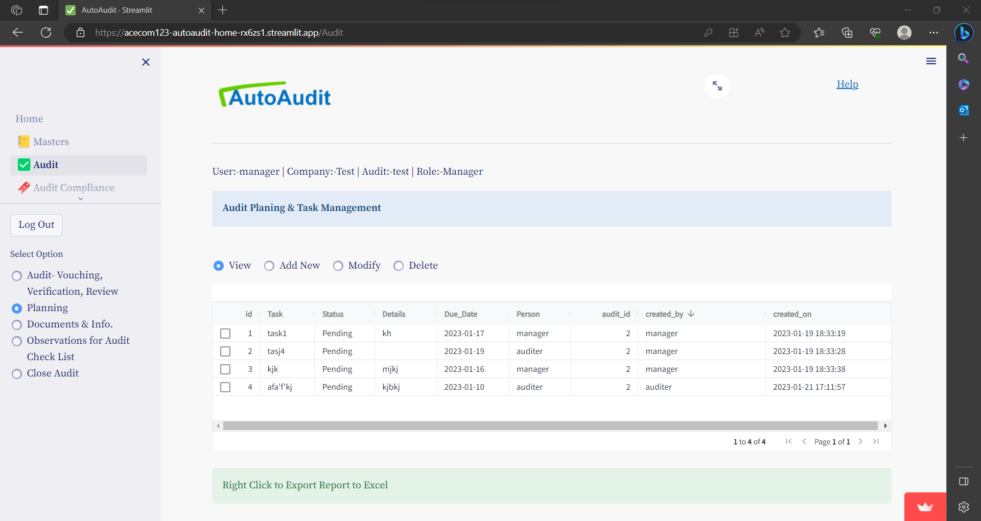

### To Add a Task

Select option Add New

Enter details & click on Submit

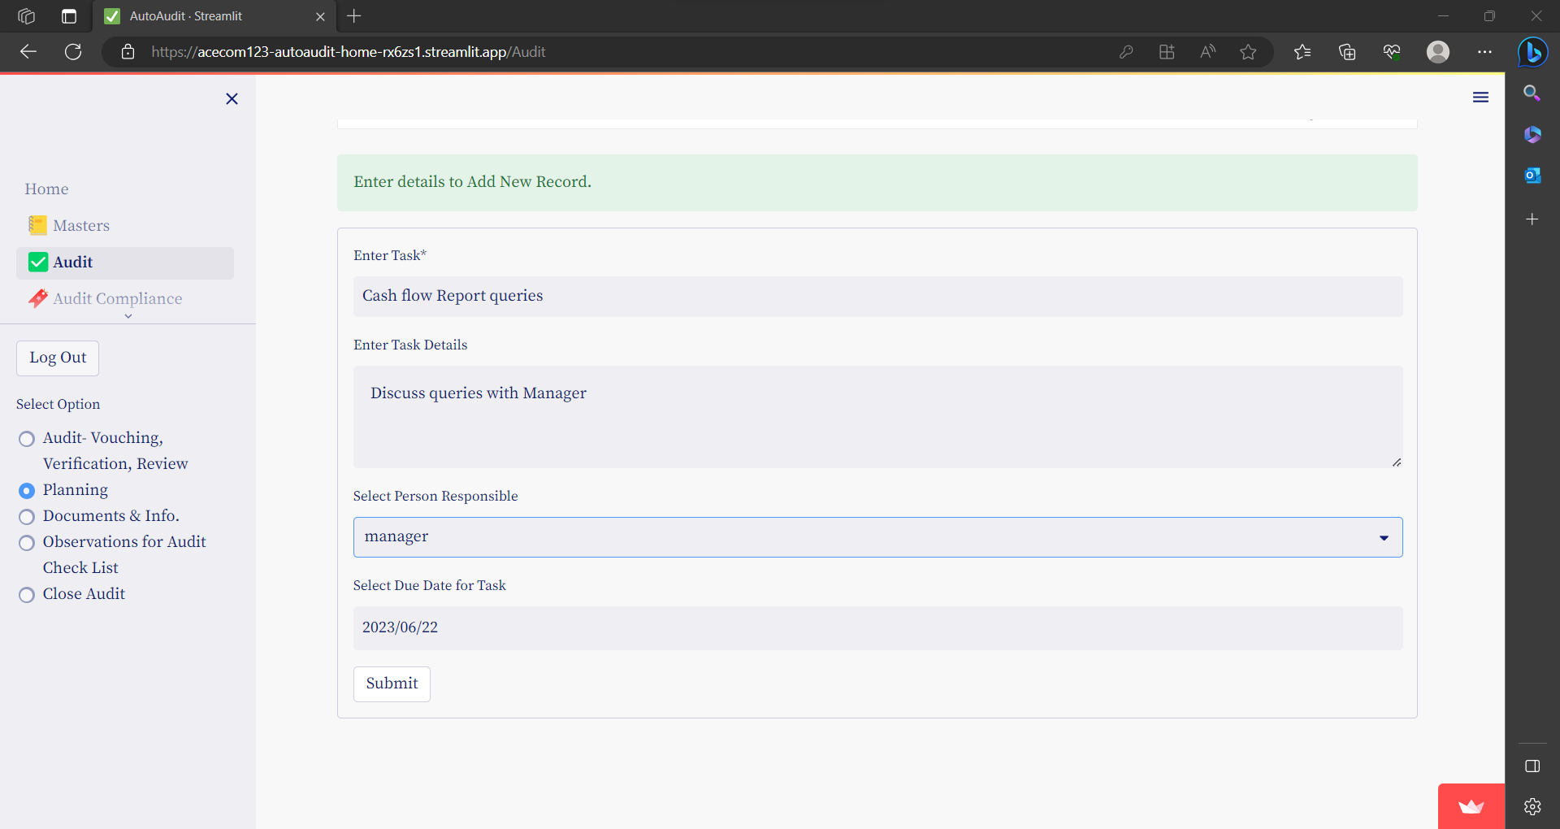

### To Modify task / change status

Only Manager can Modify or Delete the Task or you can Modify or Delete Task created by you only.

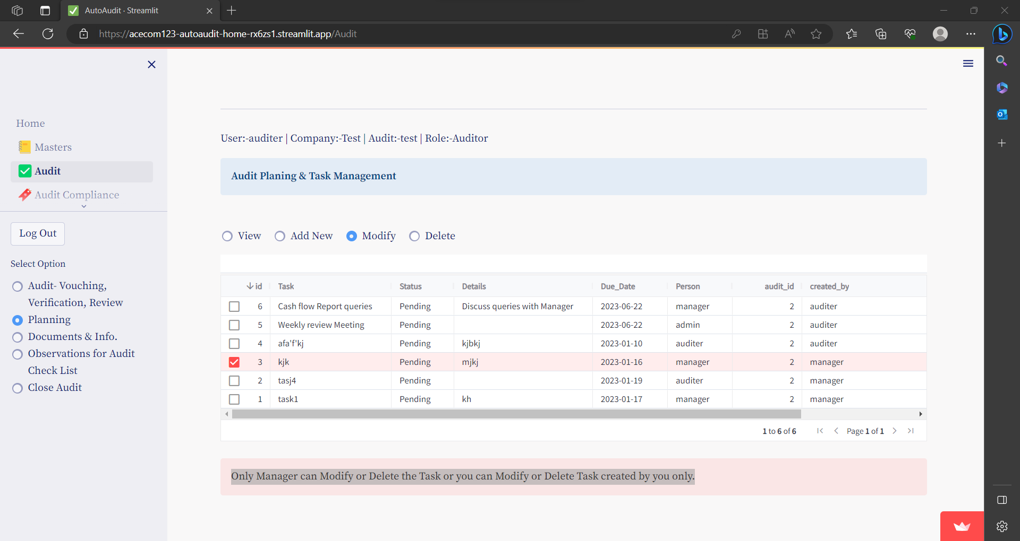

To Change the status – select Completed / Pending

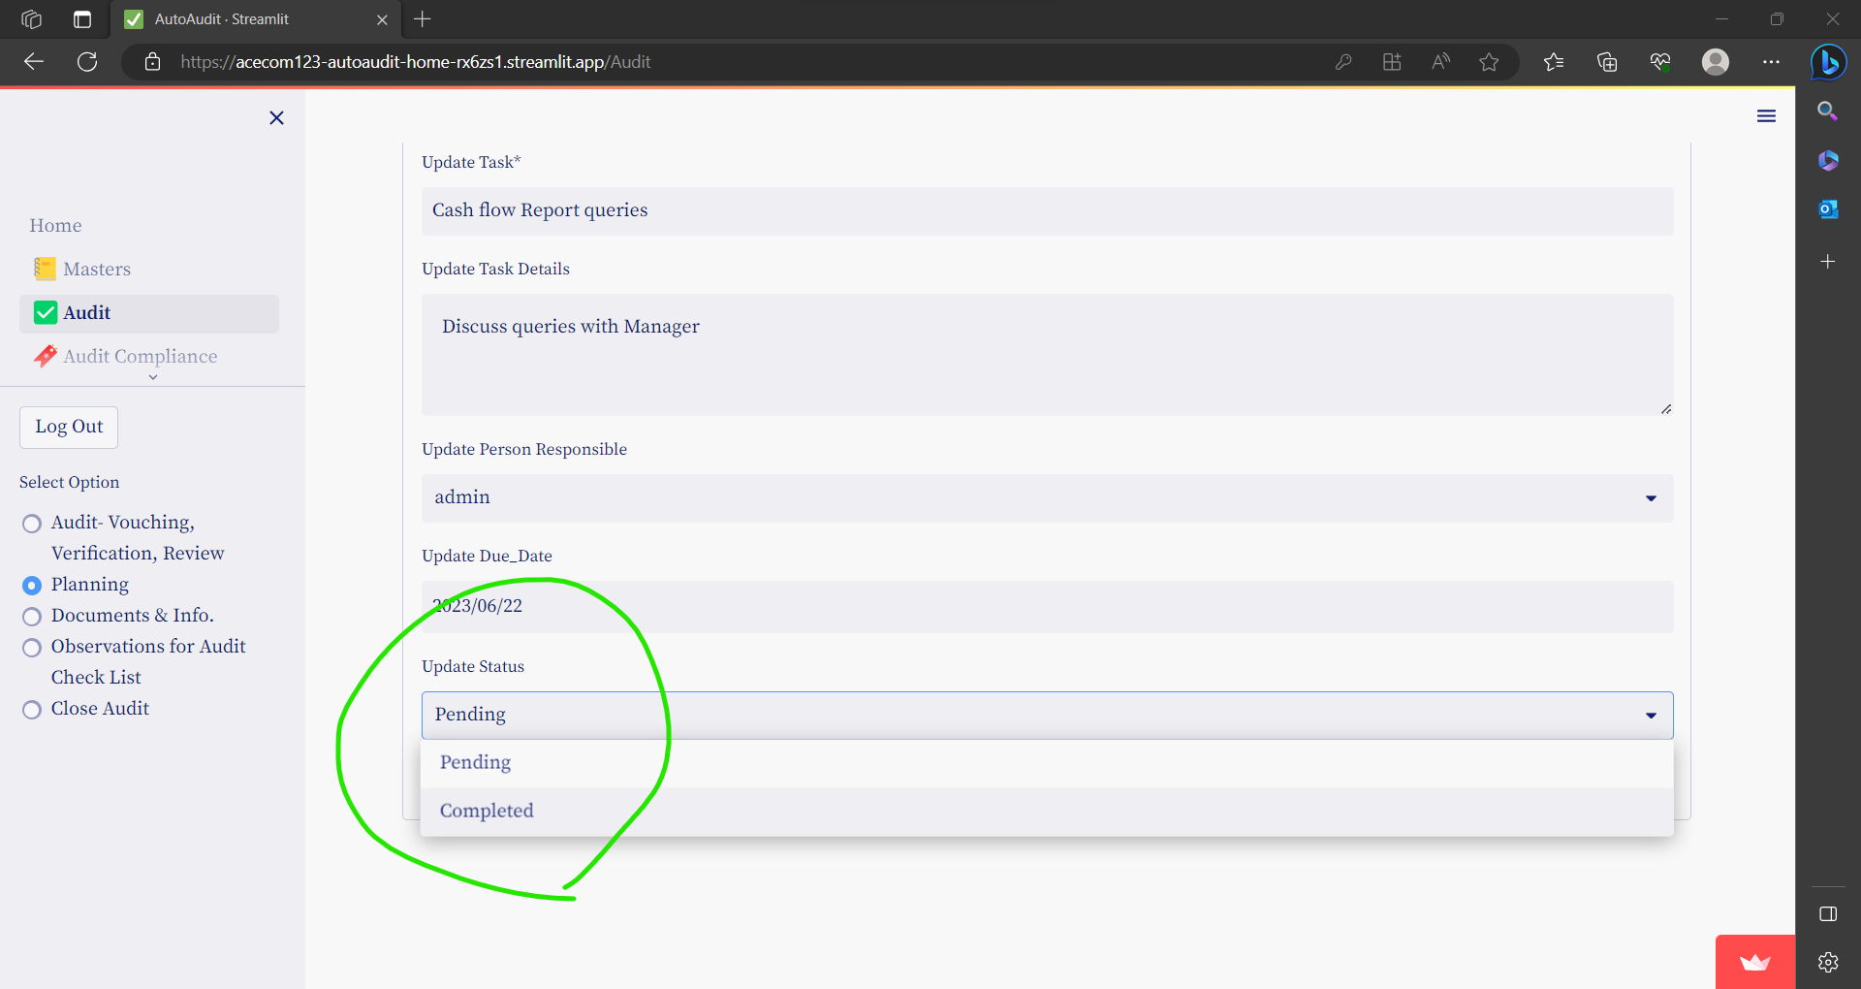

## **Documents Management**

In this section, you can manage Audit working papers.

There are 2 types of Audit files.

1. Company Audit File (Permeant Audit File)
2. Audit Working Papers

* From the **Download Sample Documents**.. drop down option you can down load sample audit files

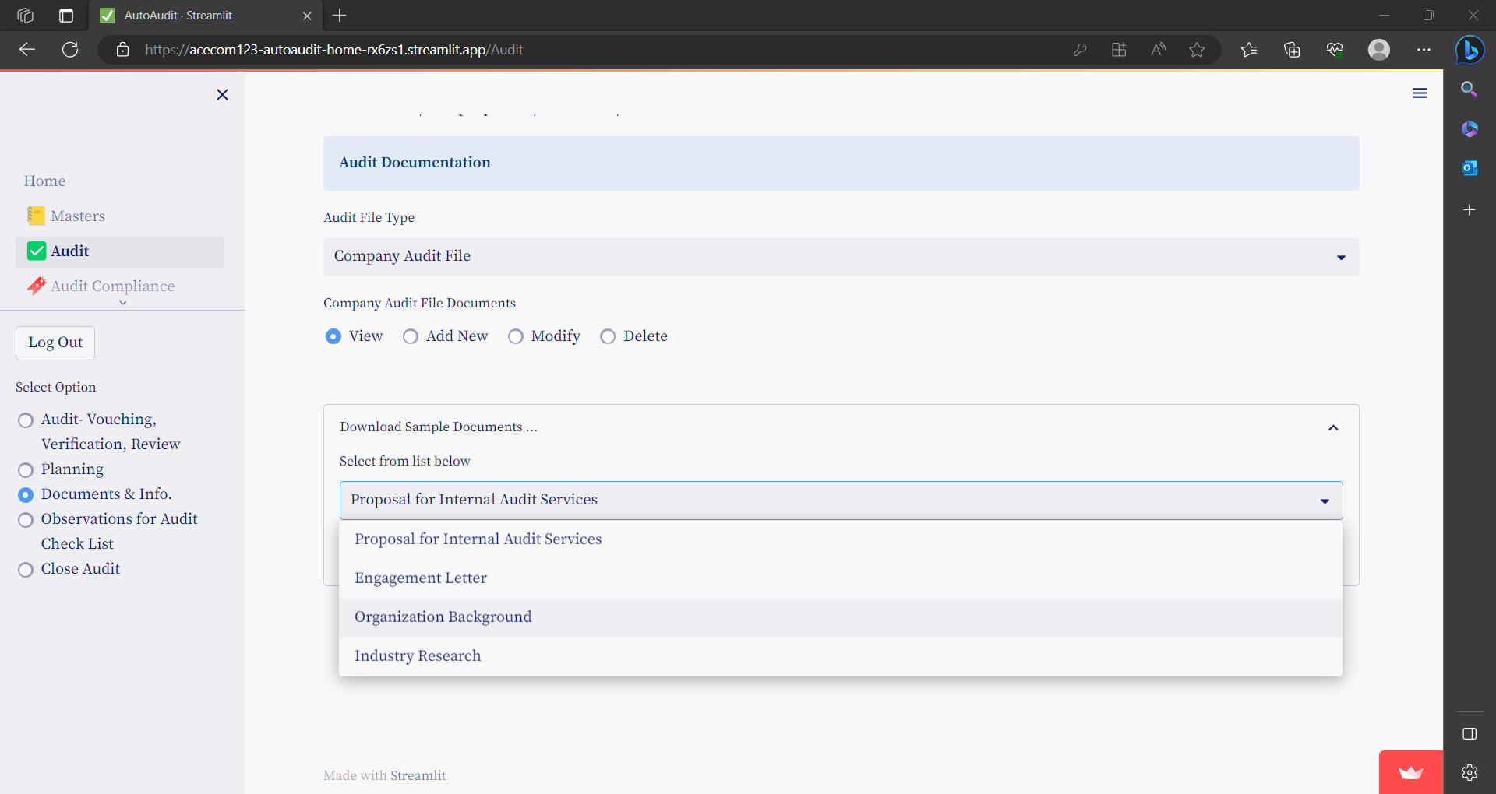

### To Add new file

Select option Add New

Enter details & click on Submit

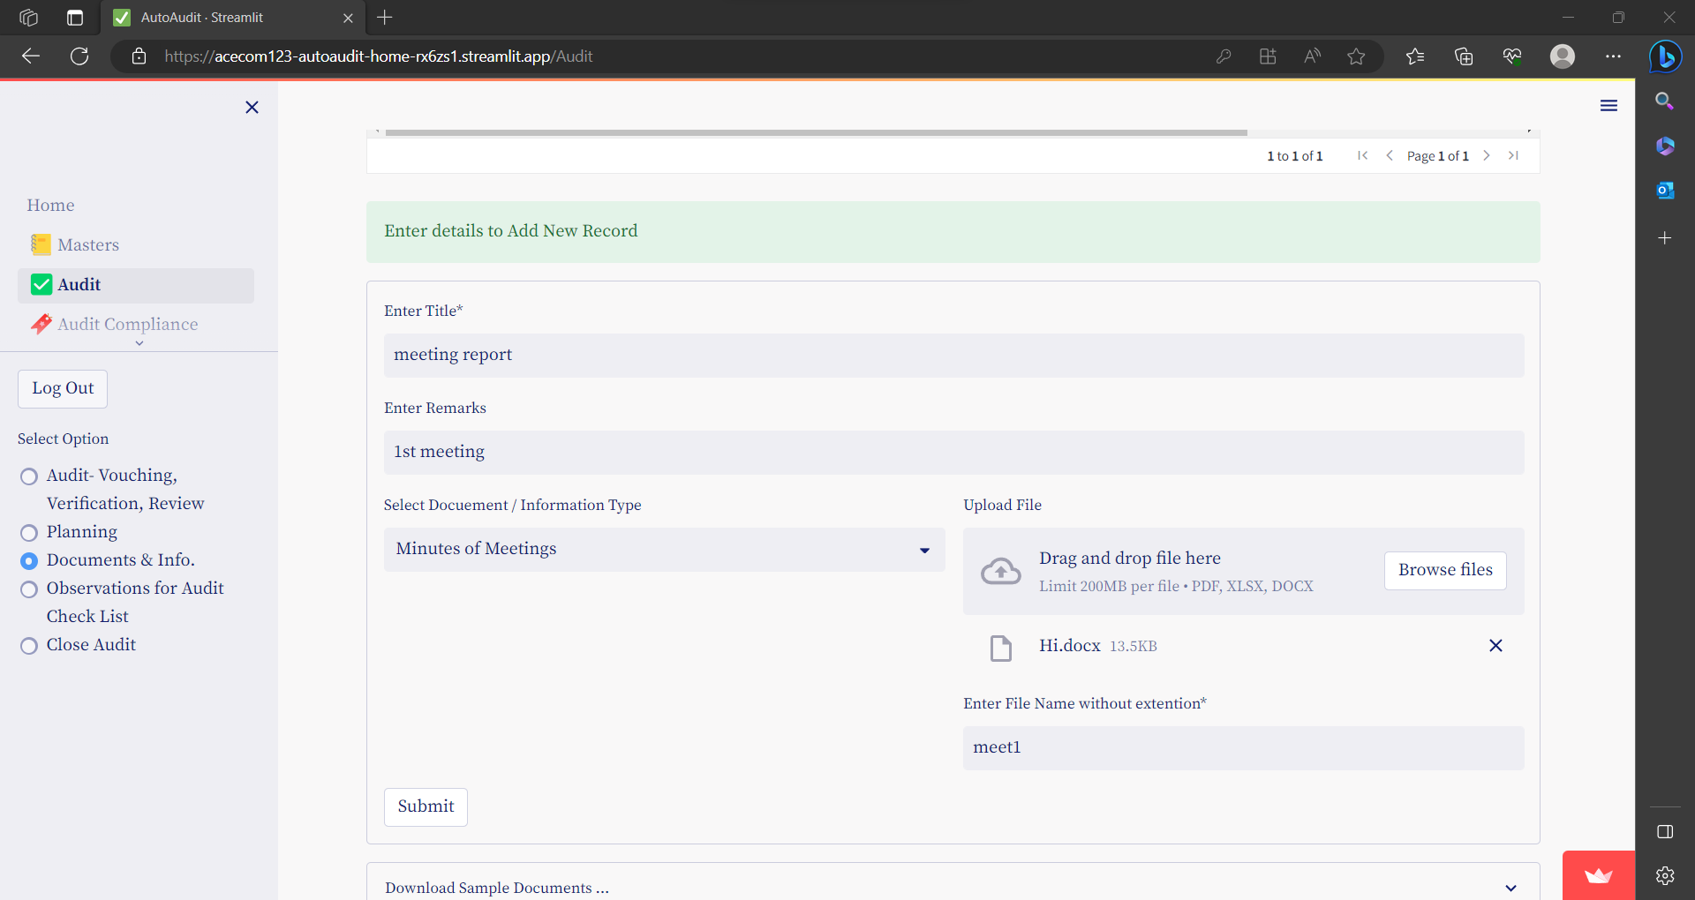

### To Modify /Delete

Select option Modify / Delete

Select a Row – click on Check box

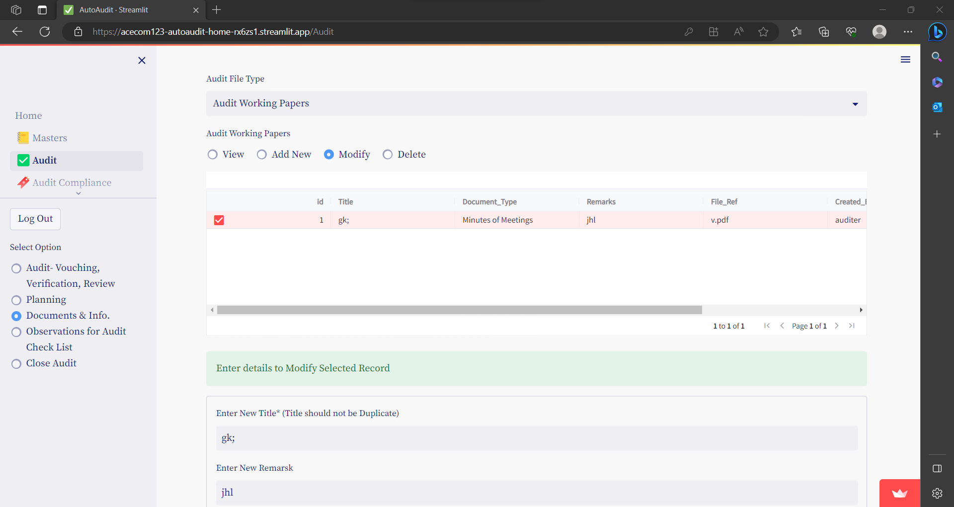

Enter details & click on Submit

## **Observations for Audit Check List**

This option is used to update Audit Observations for the Audit.

Audit Observations for each line item of Audit checklist are updated for various parameters like- condition, cause, effect, impact, recommendation etc.

### To View Audit Observations

Click on option- Show Observations

To export this to excel or CSV, right click on table

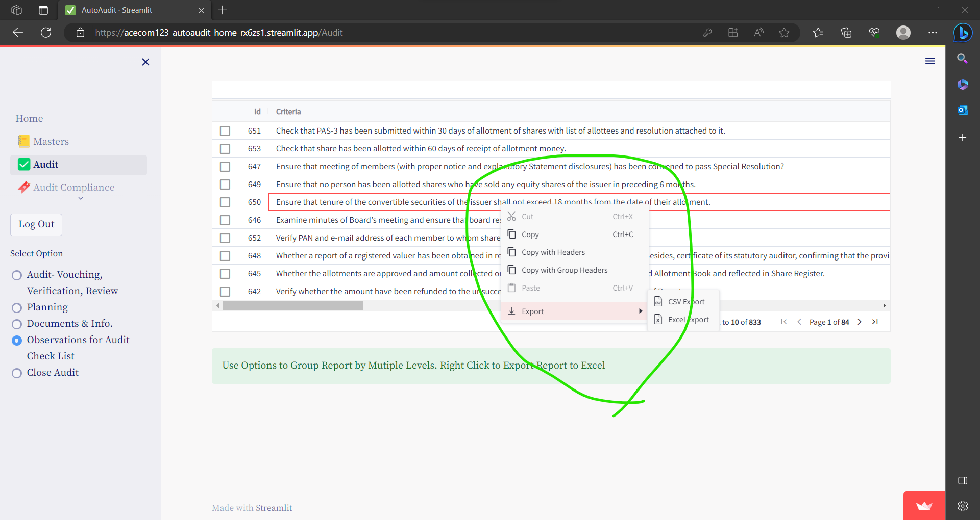

### To Update Audit Observations

Click on option- Update Audit Observations

Select a Row – click on Check box

Enter details & Click on Submit

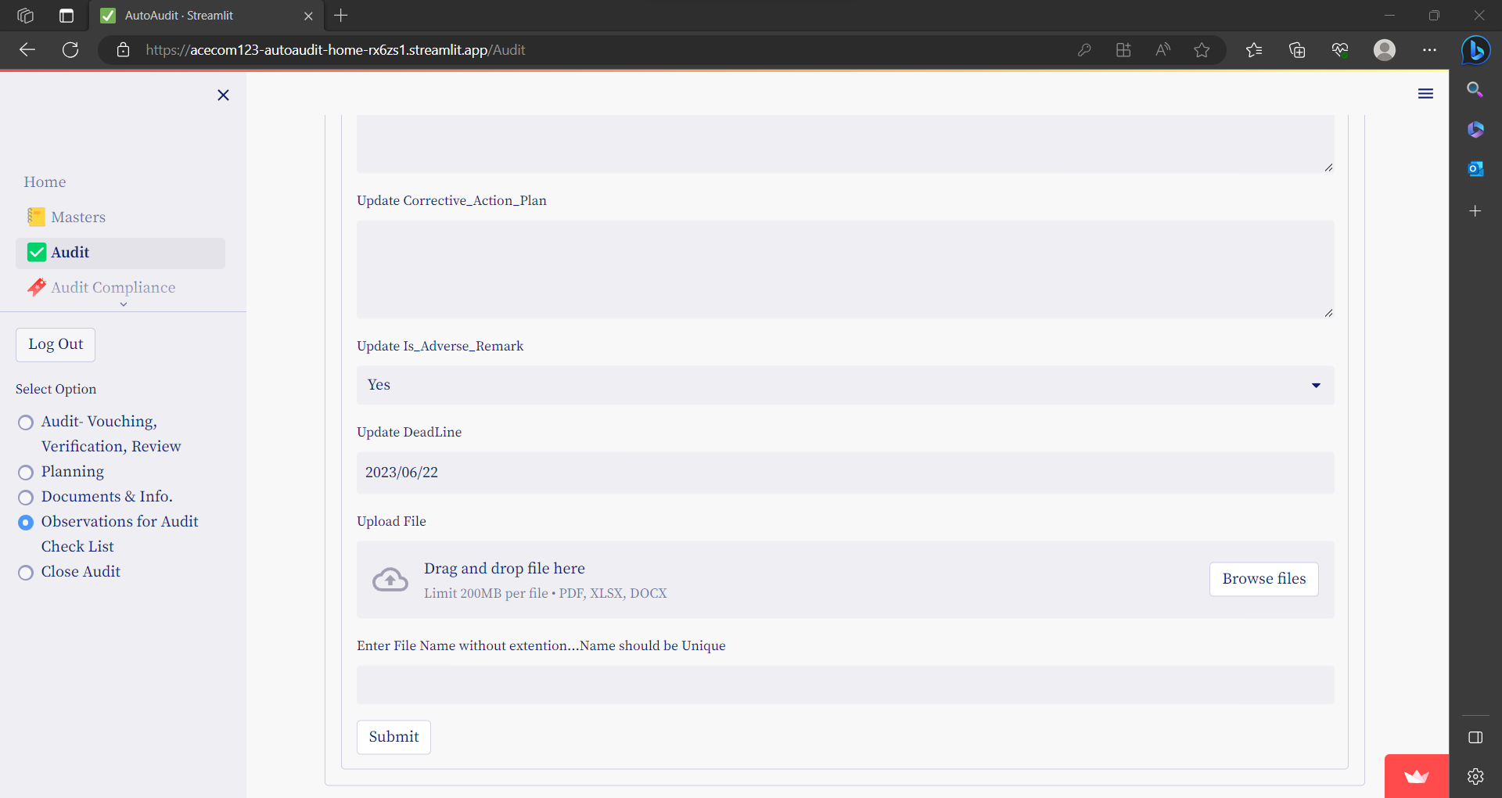

To See Related Queries of Vouching & Verification OR Analytical Review & Other Remarks: Click on expander

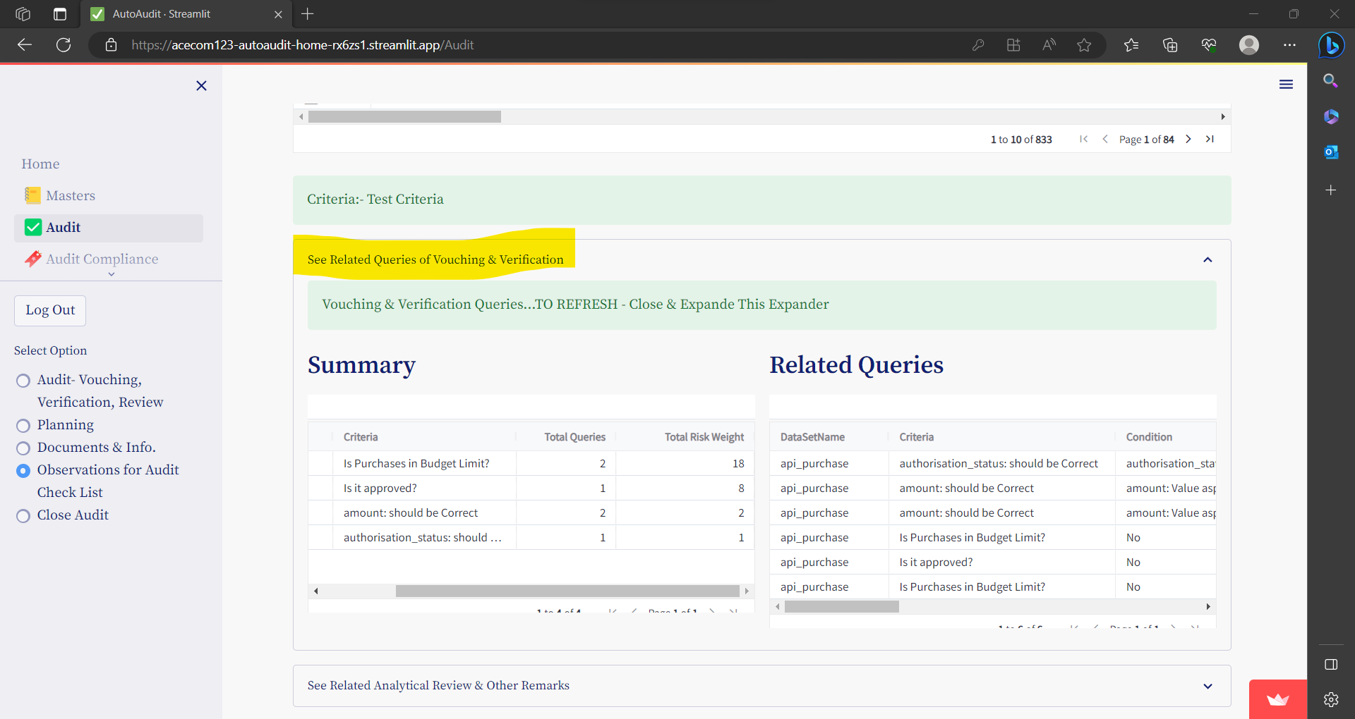

## **Close Audit**

Compliance Status of each Audit Observation is **Open** by default.

Before closing the audit, Close all the open Audit Observations & then only you can close the Audit.

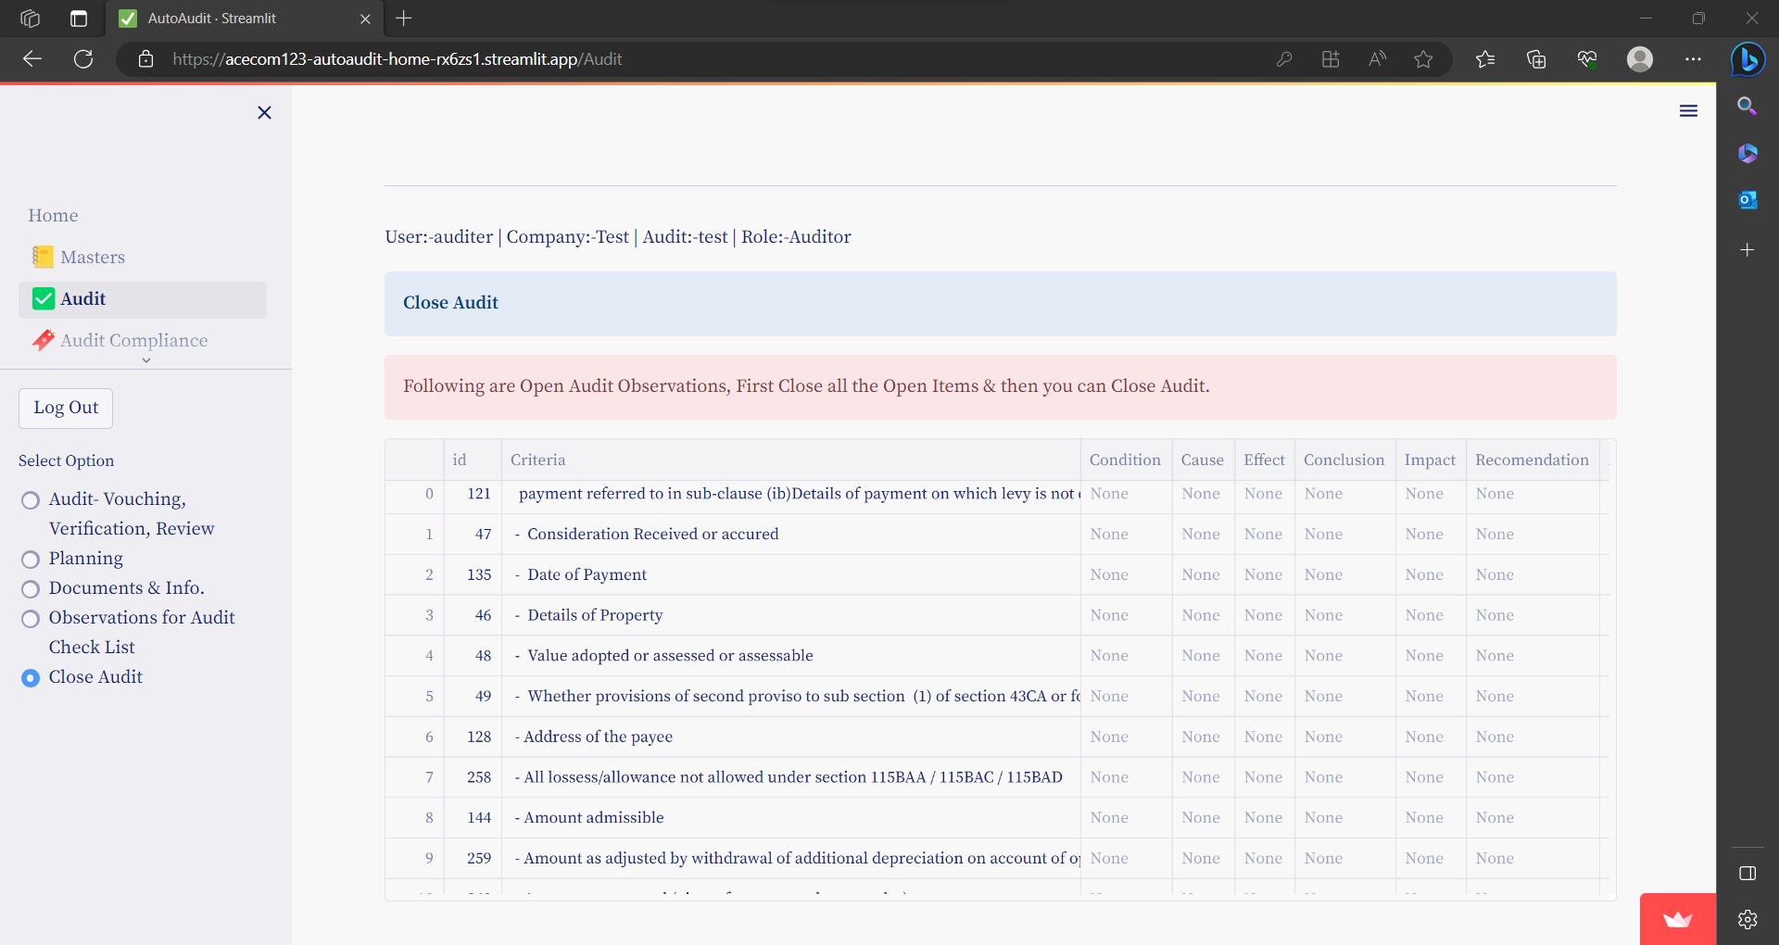

* **Once You Close the Audit , you can not access the same…so before Closing Audit Download all the reports in Excel / Word**

# **AUDIT COMPLIANCE**

## **Compliance by Auditee**

**When an user with Auditee logs in, he can view a dashboard showing Pending Audit Queries related to him.**

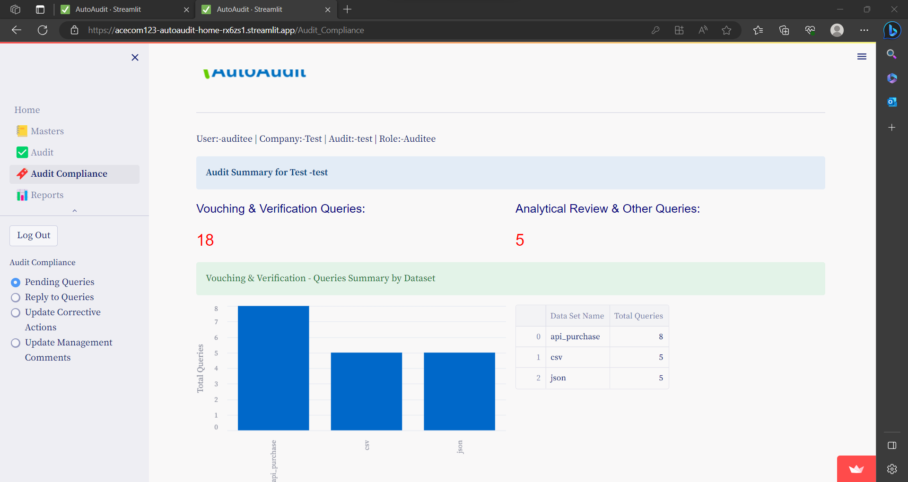

### Reply to Audit Queries

Go to menu **Audit Compliance** and then select option button- **Reply to Queries**

And select Dataset.

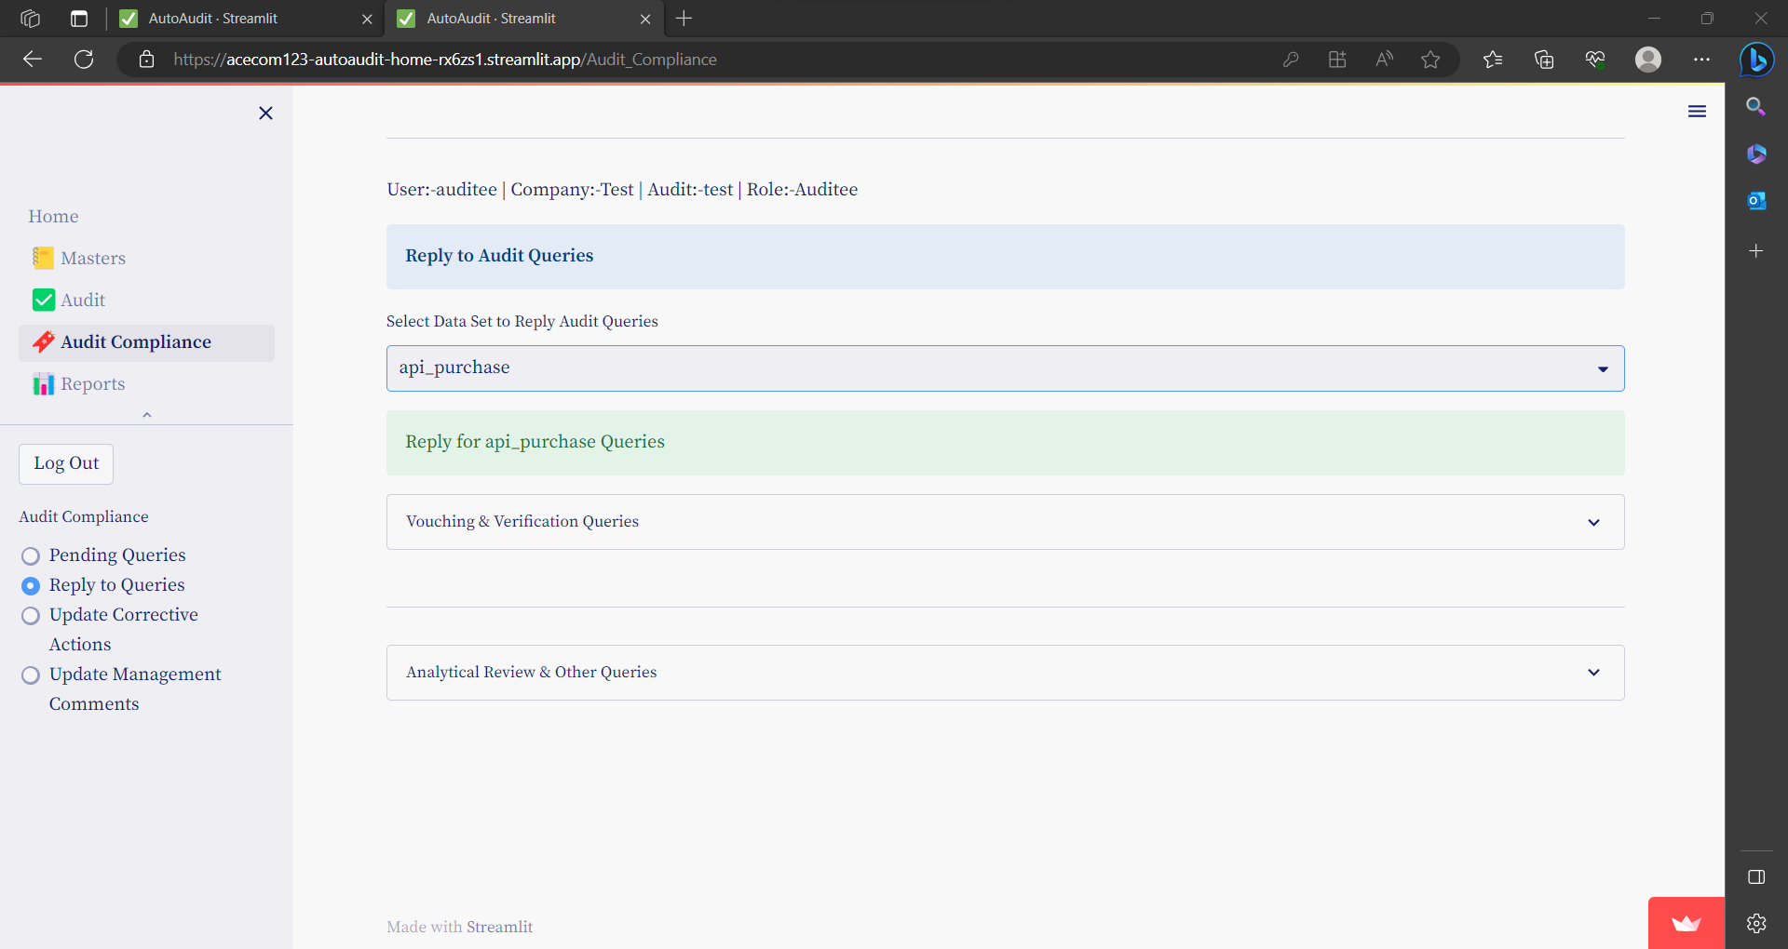

* **Click on expander to select Vouching & Verification Queries or Analytical & Other Remarks**
* Select a Row – click on Check box to add reply
* Add reply for query & press Submit button.

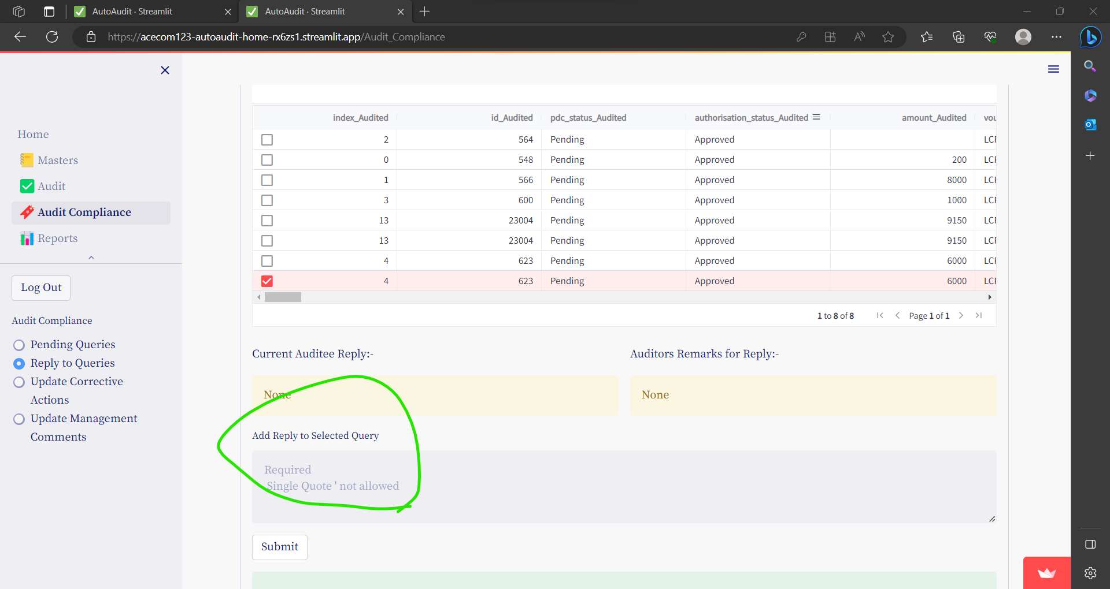

**Reply is saved with Date-Time Stamp with login ID**

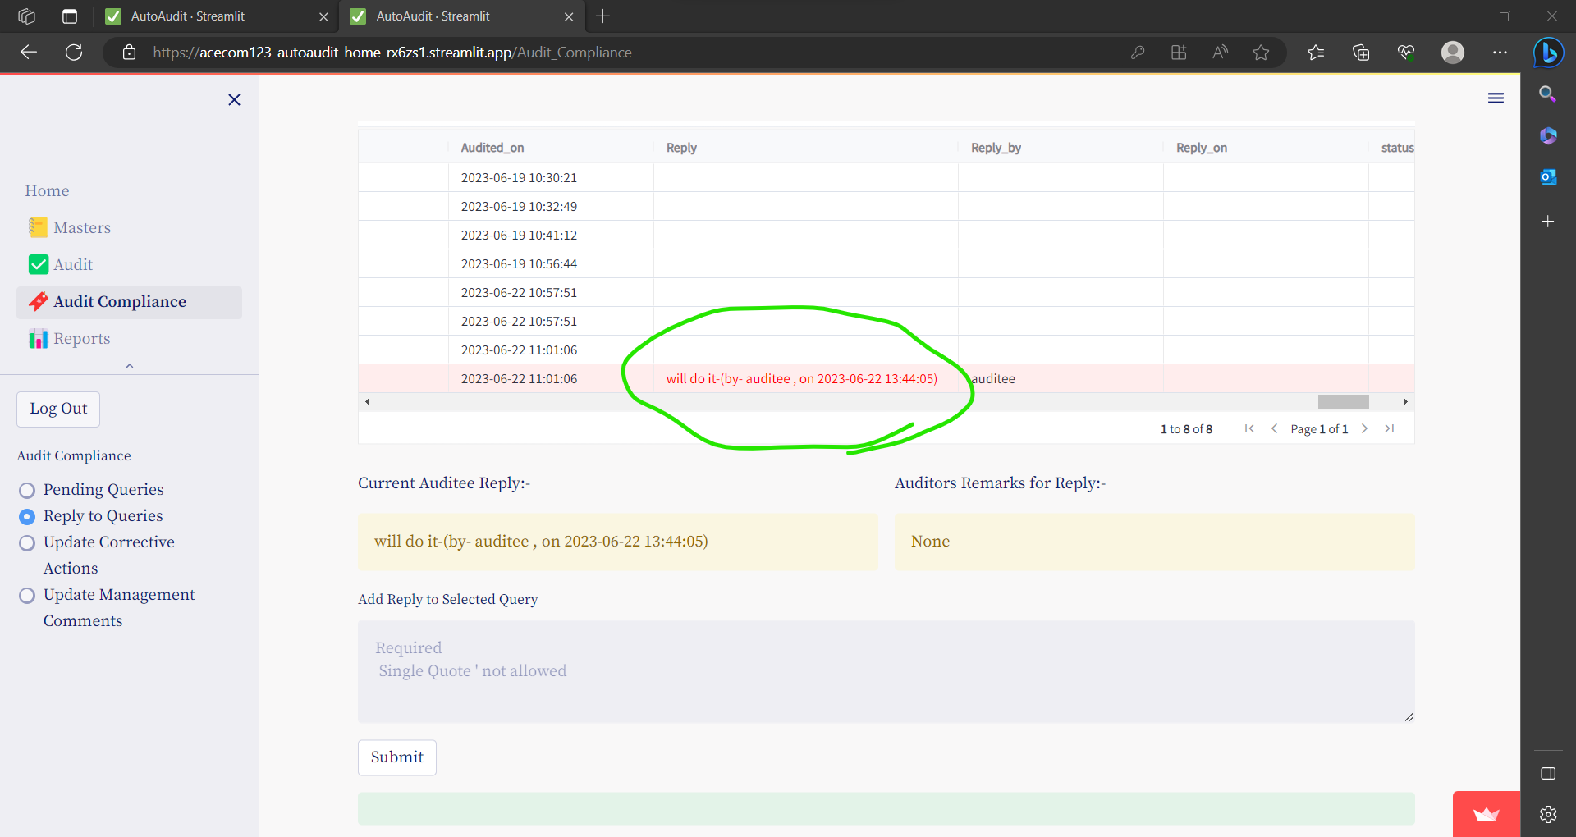

### Compliance to Audit Observations

In this option Auditee can update **corrective action comments** and or **management remarks.**

#### **Update Corrective Actions**

* Select a Row – click on Check box to add reply
* Add Corrective Actions for Audit Observation & press Submit button.

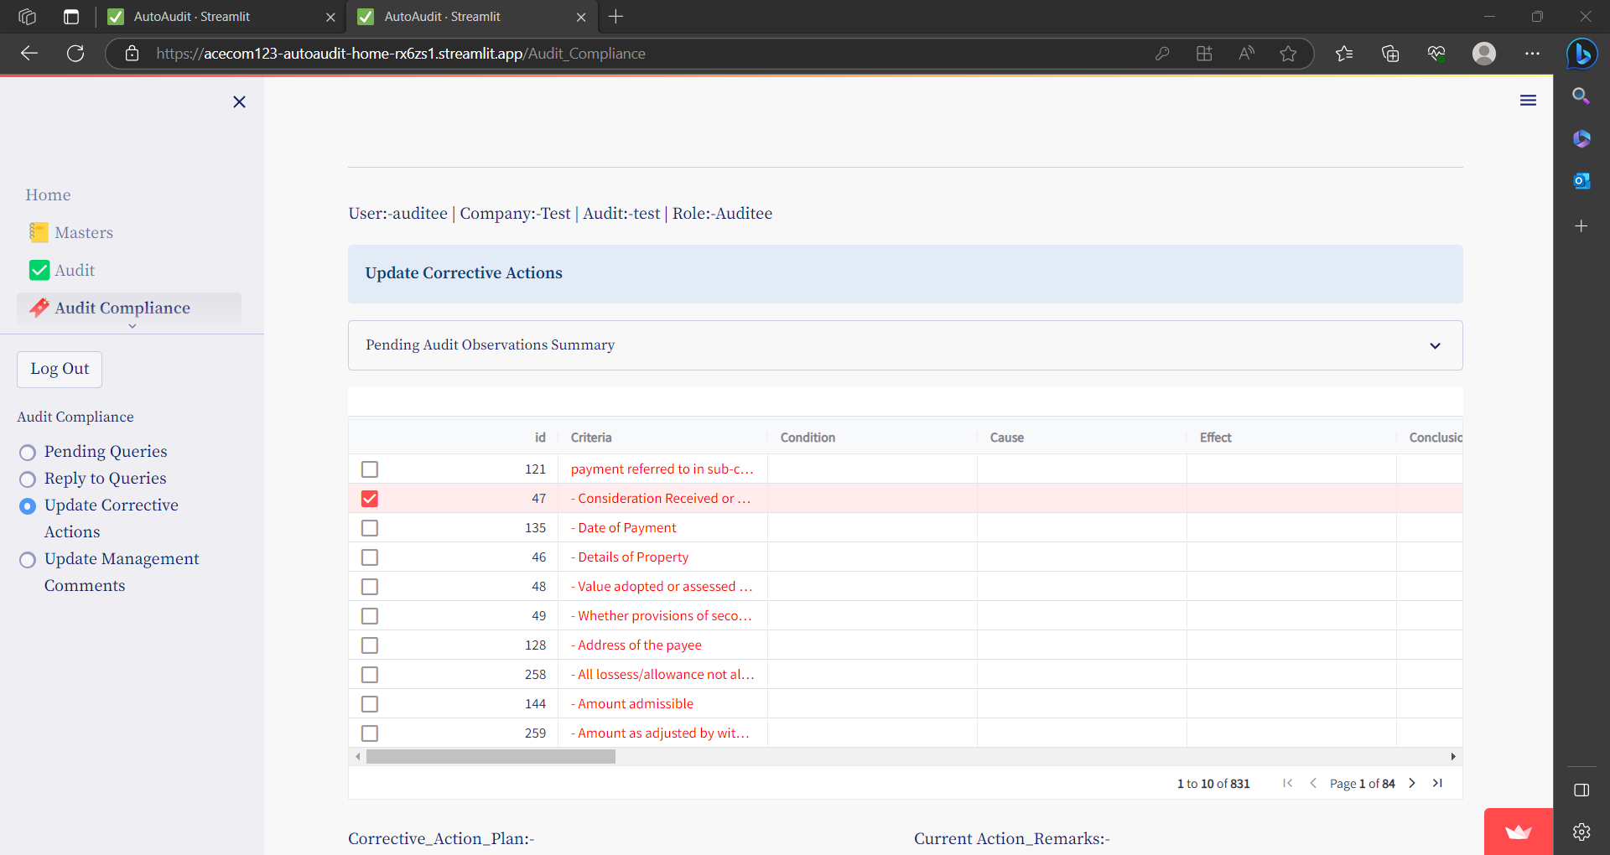

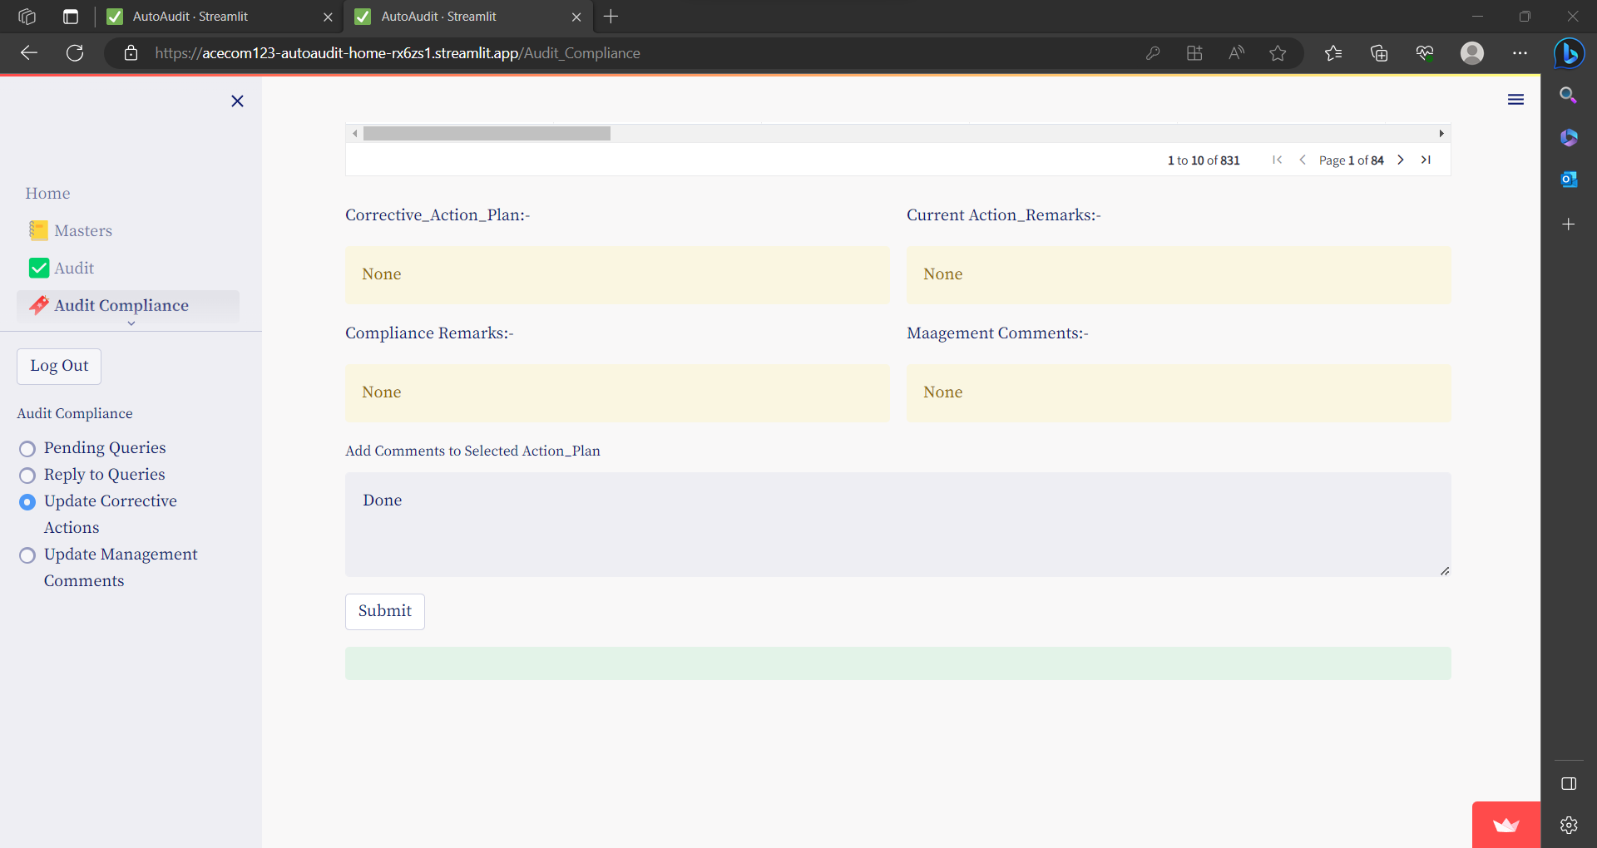

#### **Update Management Comments**

* Select a Row – click on Check box to add reply
* Add Management Comments for Audit Observation & press Submit button.

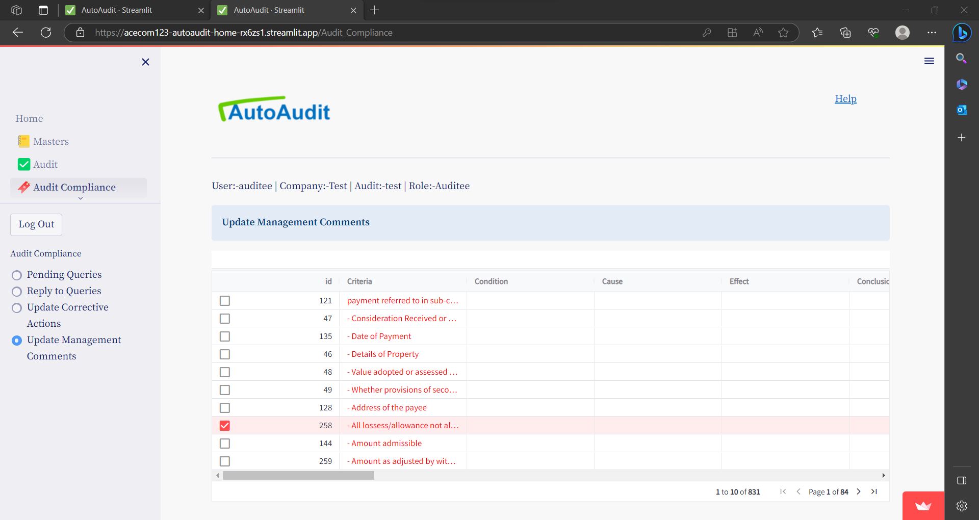

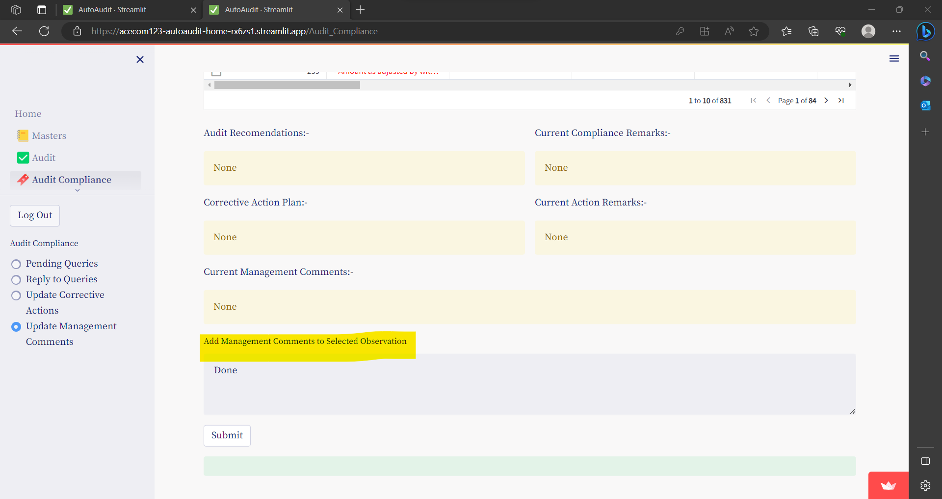

## **Compliance by Auditor**

### Update Query Status

* **Click on expander to select Vouching & Verification Queries or Analytical & Other Remarks**
* Go to menu **Audit Compliance** and then select option button- **Update Query Status** And select Dataset.

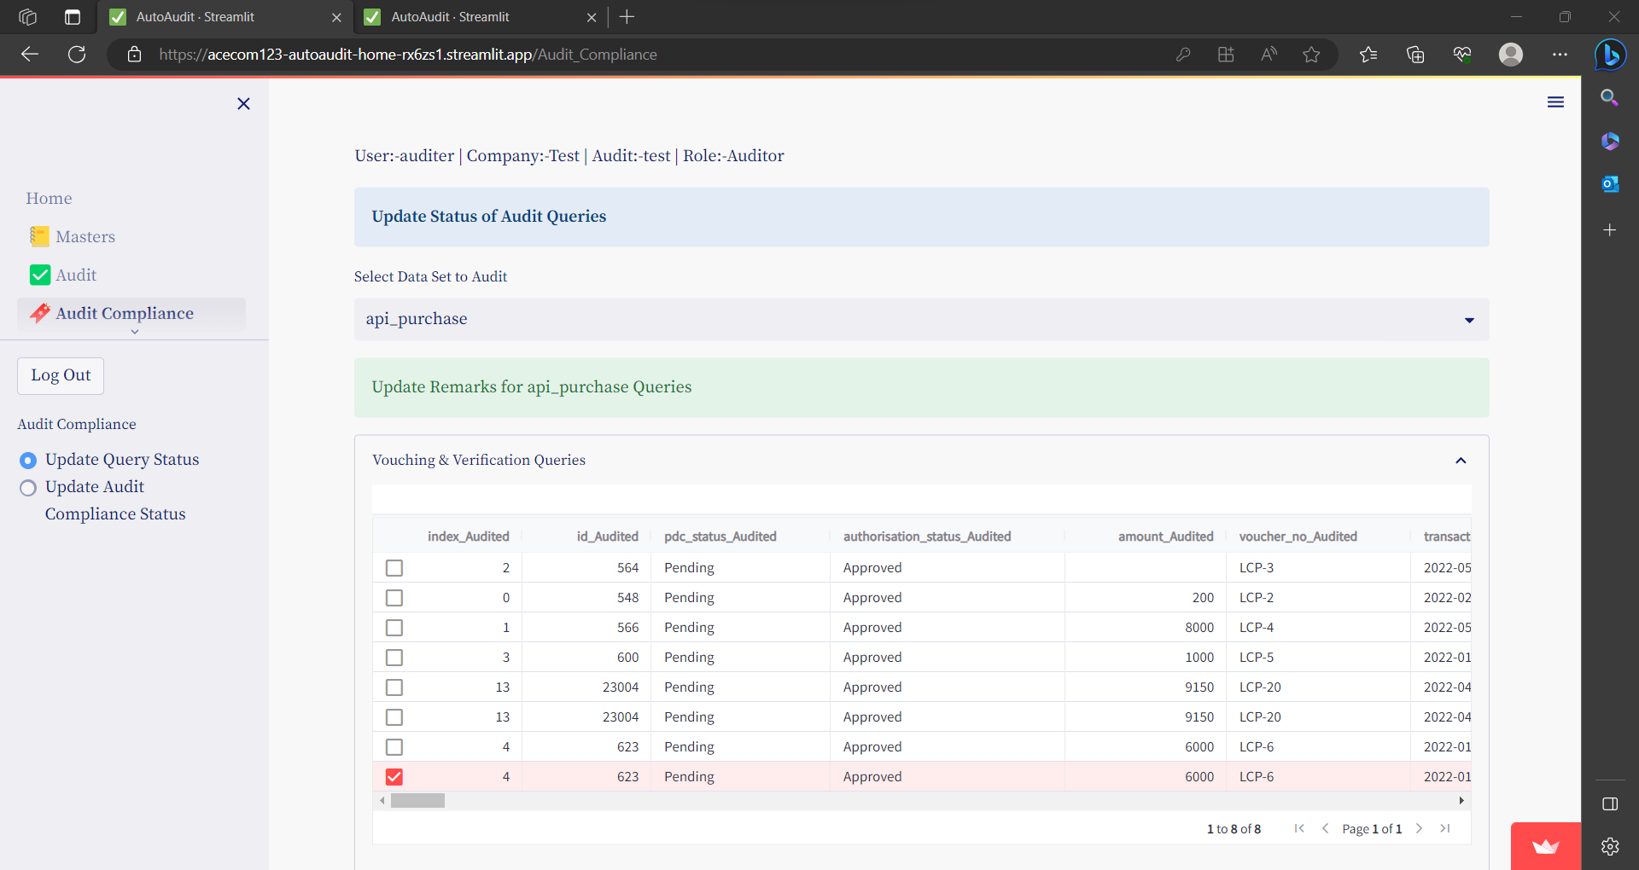

* Select a Row – click on Check box to Update status
* Update Remarks or Change Status of Query to Close

& press Submit button.

### Update Audit Observations Compliance

In this option , based on **corrective action comments** and or **management remarks given by** Auditee , Auditor can update Compliance status for Audit Observations

**To** Update Audit Observations Compliance:

* Select a Row – click on Check box to add Add Compliance Remarks
* Add Compliance Remarks for Audit Observation and / or

Update Status of Audit Observation rom OPEN to **CLOSE**

* To save- press Submit button.

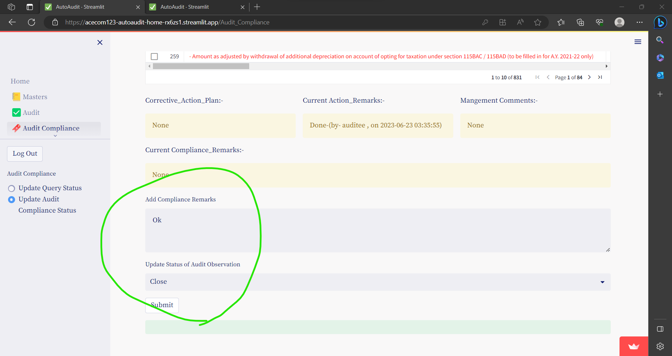

# **REPORTS**

There are three categories of reports.

1. Reports relating to audit queries -based on vouching ,verification, analytical review and other observations.
2. Reports relating to audit observations based on audit checklist.
3. Summary Audit Report

## **Audit Reports - Vouching, Verification, Analytical Review other Remarks**

* Go to menu **Report** and then select option button- **Vouching, Verification, Review**
* Select Dataset.
* Summary of Audit Queries are shown by default

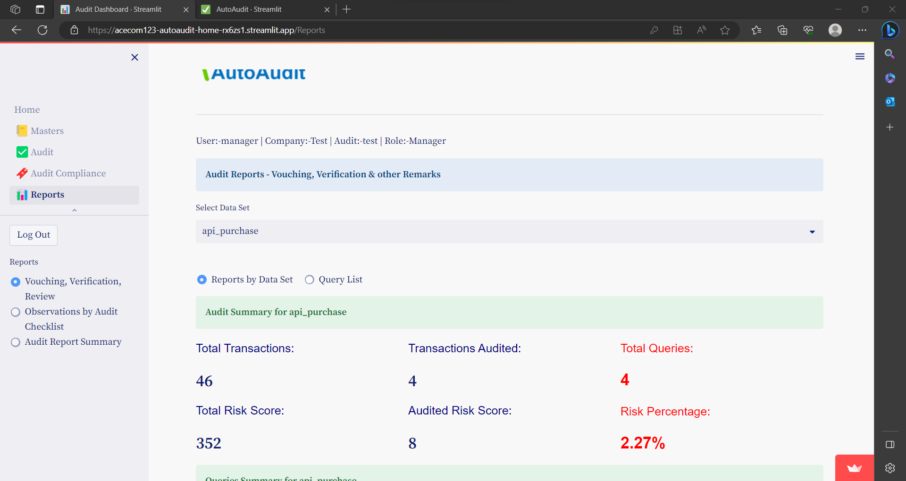

* To view detailed Query List – click on option- Query List

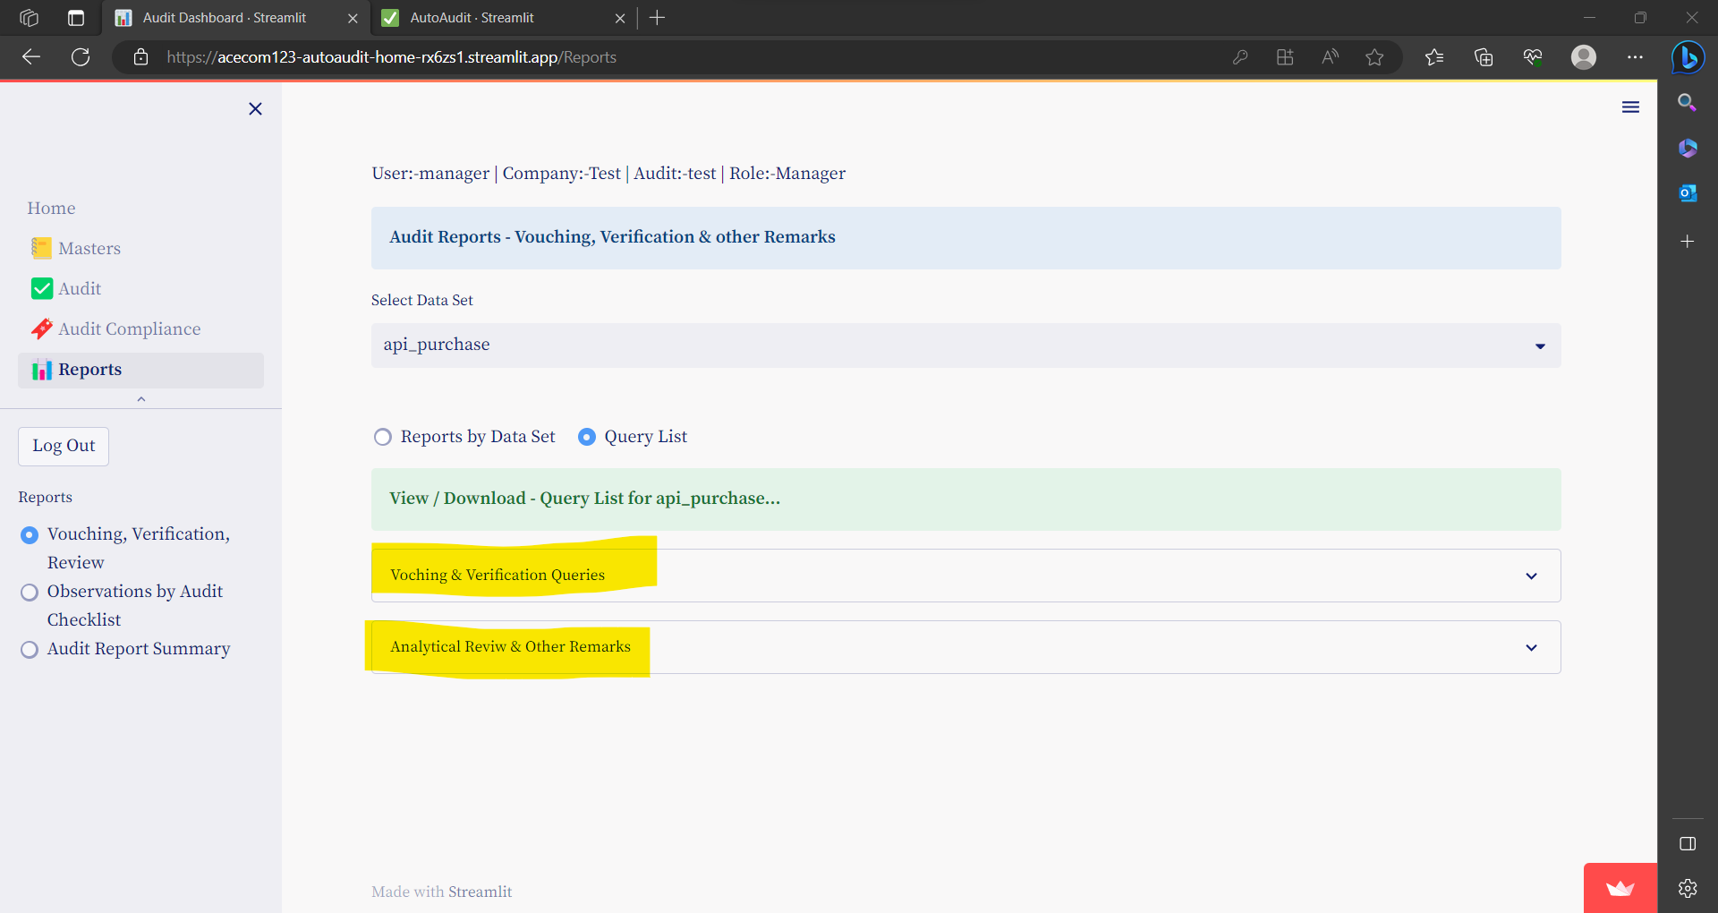

* **Click on expander to select Vouching & Verification Queries or Analytical & Other Remarks**
* To Export data to CSV / Excel – Right click on Data

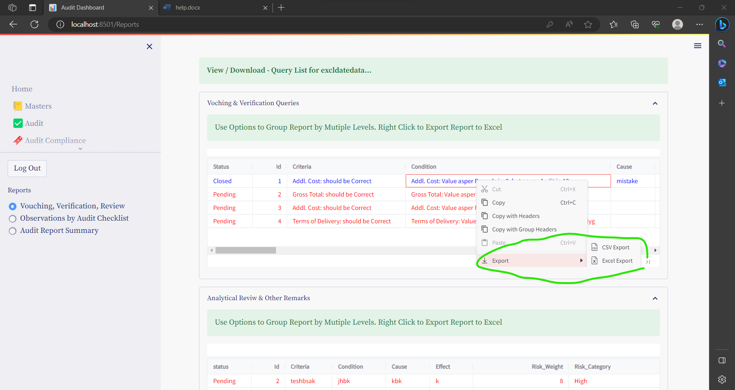

## **Open Audit Observations**

* Go to menu **Report** and then select option button- **Observations by Audit Checklist**

### **Summary Report**

* Summary of Audit Observations are shown by default.
* 1st Summary is Risked Based Audit Summary

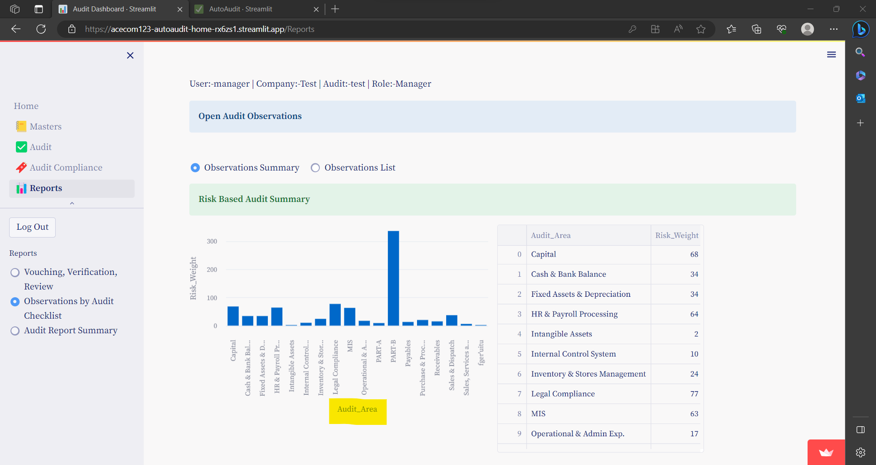

* 2nd Summary is Risked Based Audit Summary- by selected Audit Area

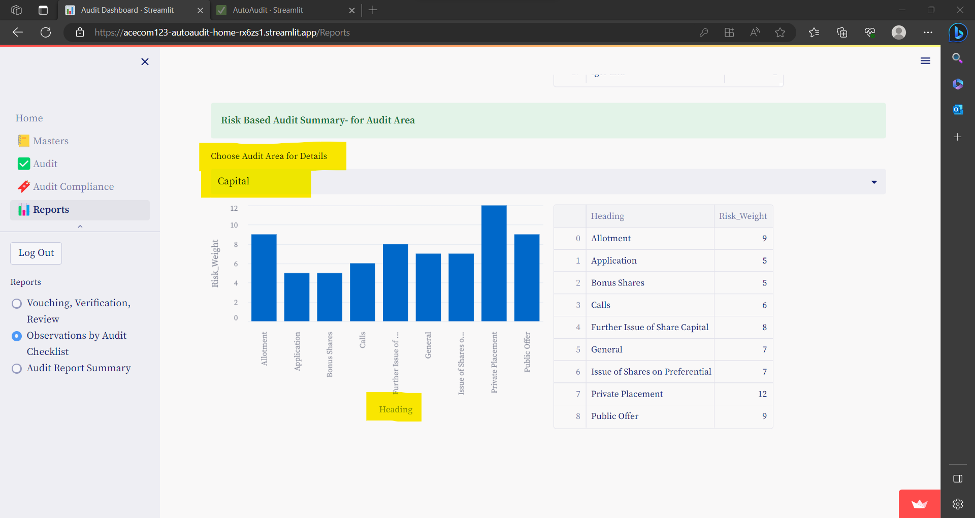

### **Detailed Observation List**

* To view detailed Observations List – click on option- Observation List
* To Export data to CSV / Excel – Right click on Data

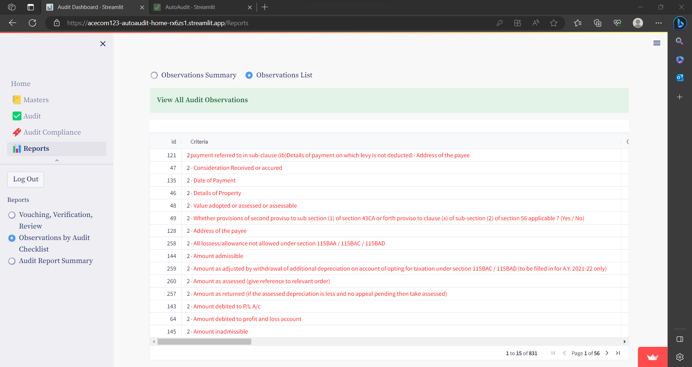

* To download report in word format-
  + Select / deselect the fields you want to show in report
  + click on **Generate & Down Load Report.**

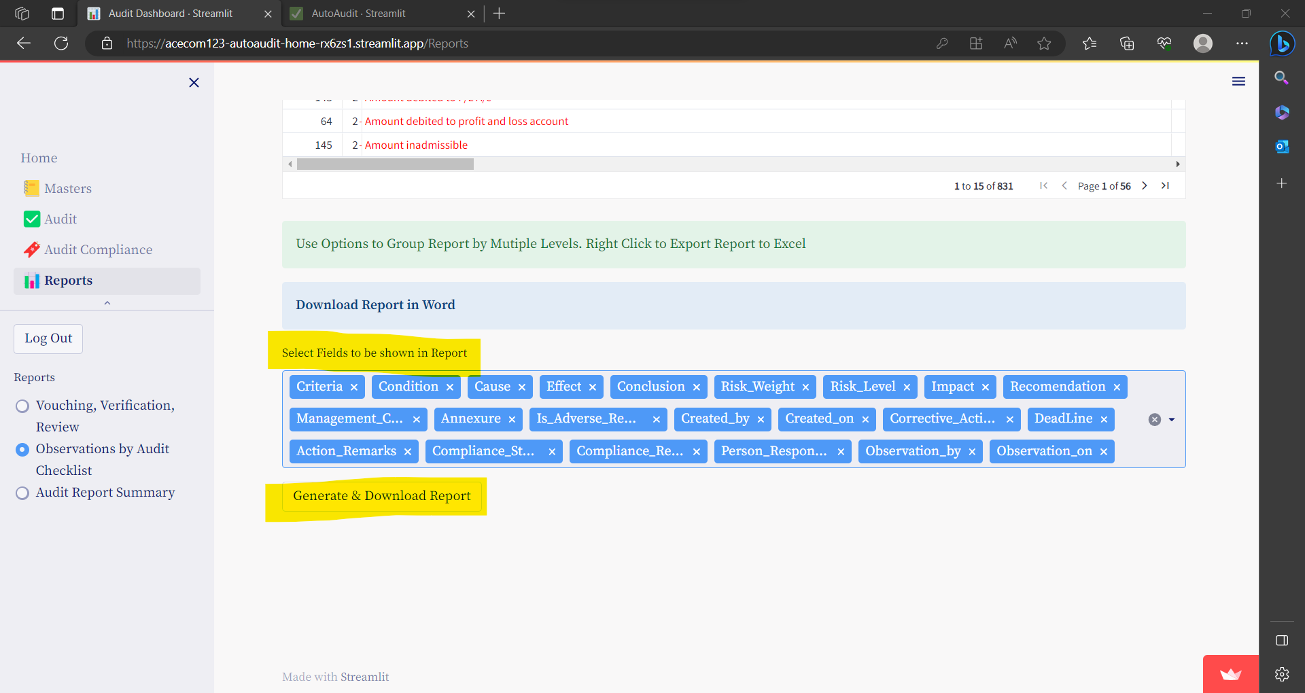

* + Now you can preview the data for report.
  + Click on **Download Report**  to download the same

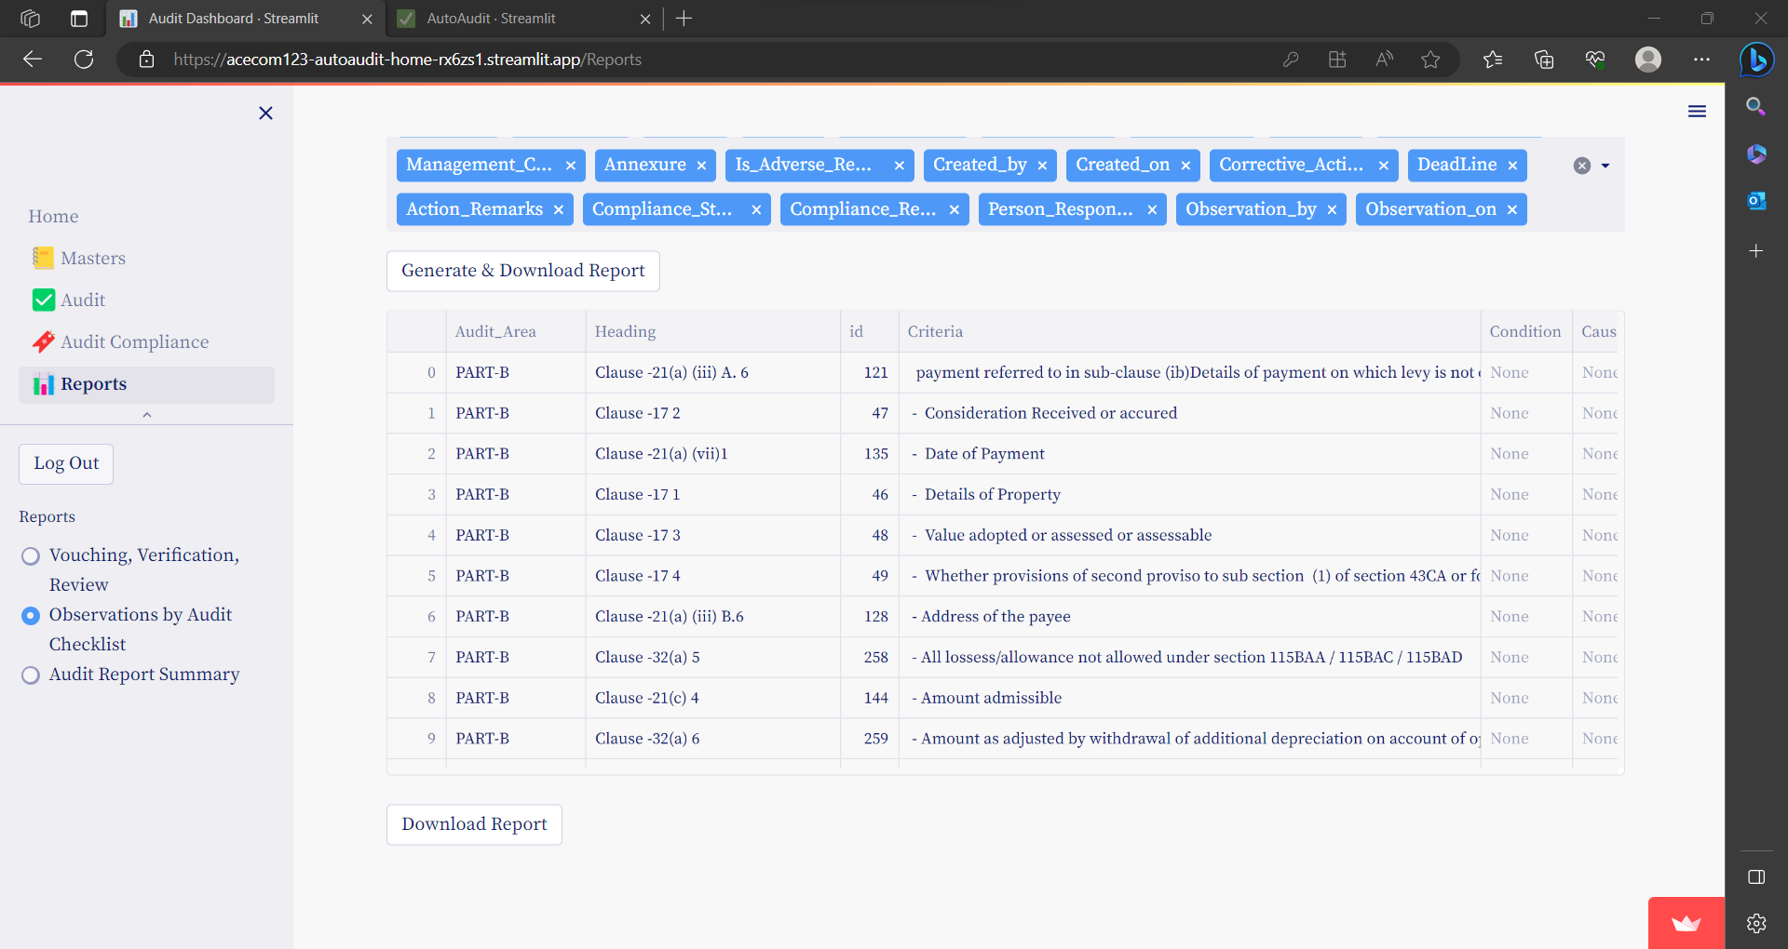

## **Summary of Audit Report**

Apart from audit observations you can manually add audit summary points and generate a summary audit report.

* Go to menu **Report** and then select option button- **Audit Report Summary.**
* **By default you can see the list of Summary points**

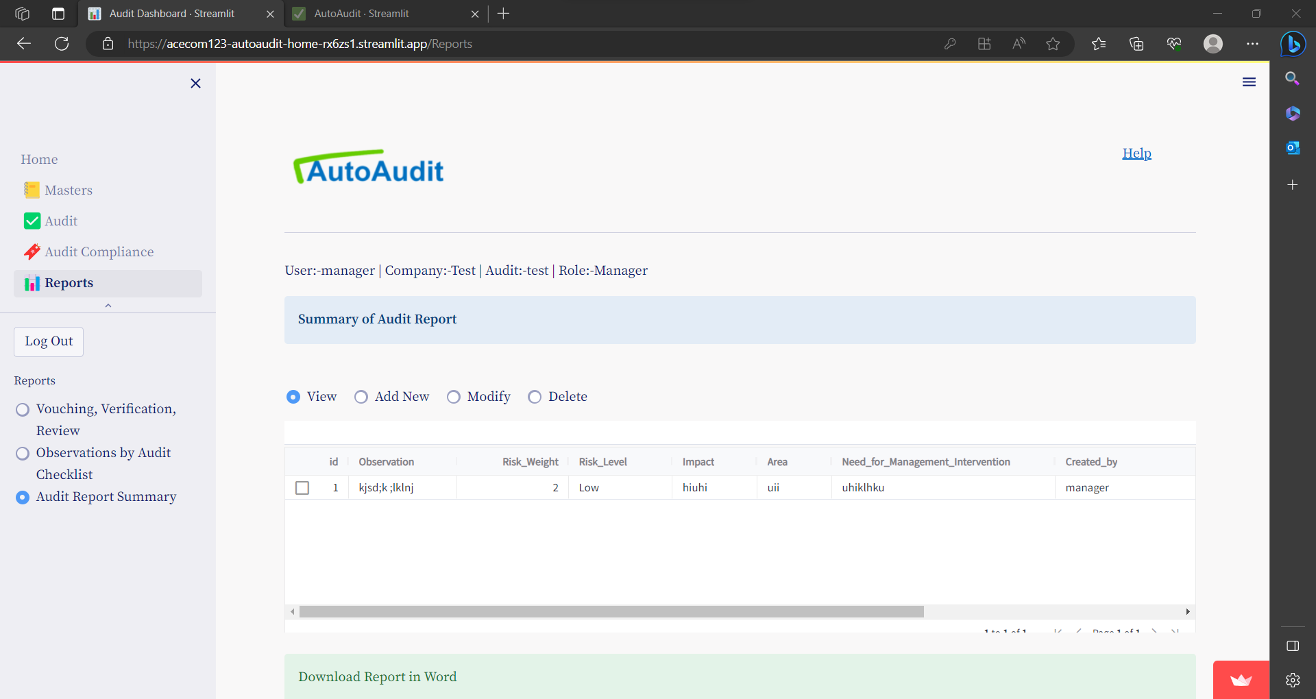

* To download report in word format-
  + Select / deselect the fields you want to show in report
  + click on **Generate & Down Load Report.**

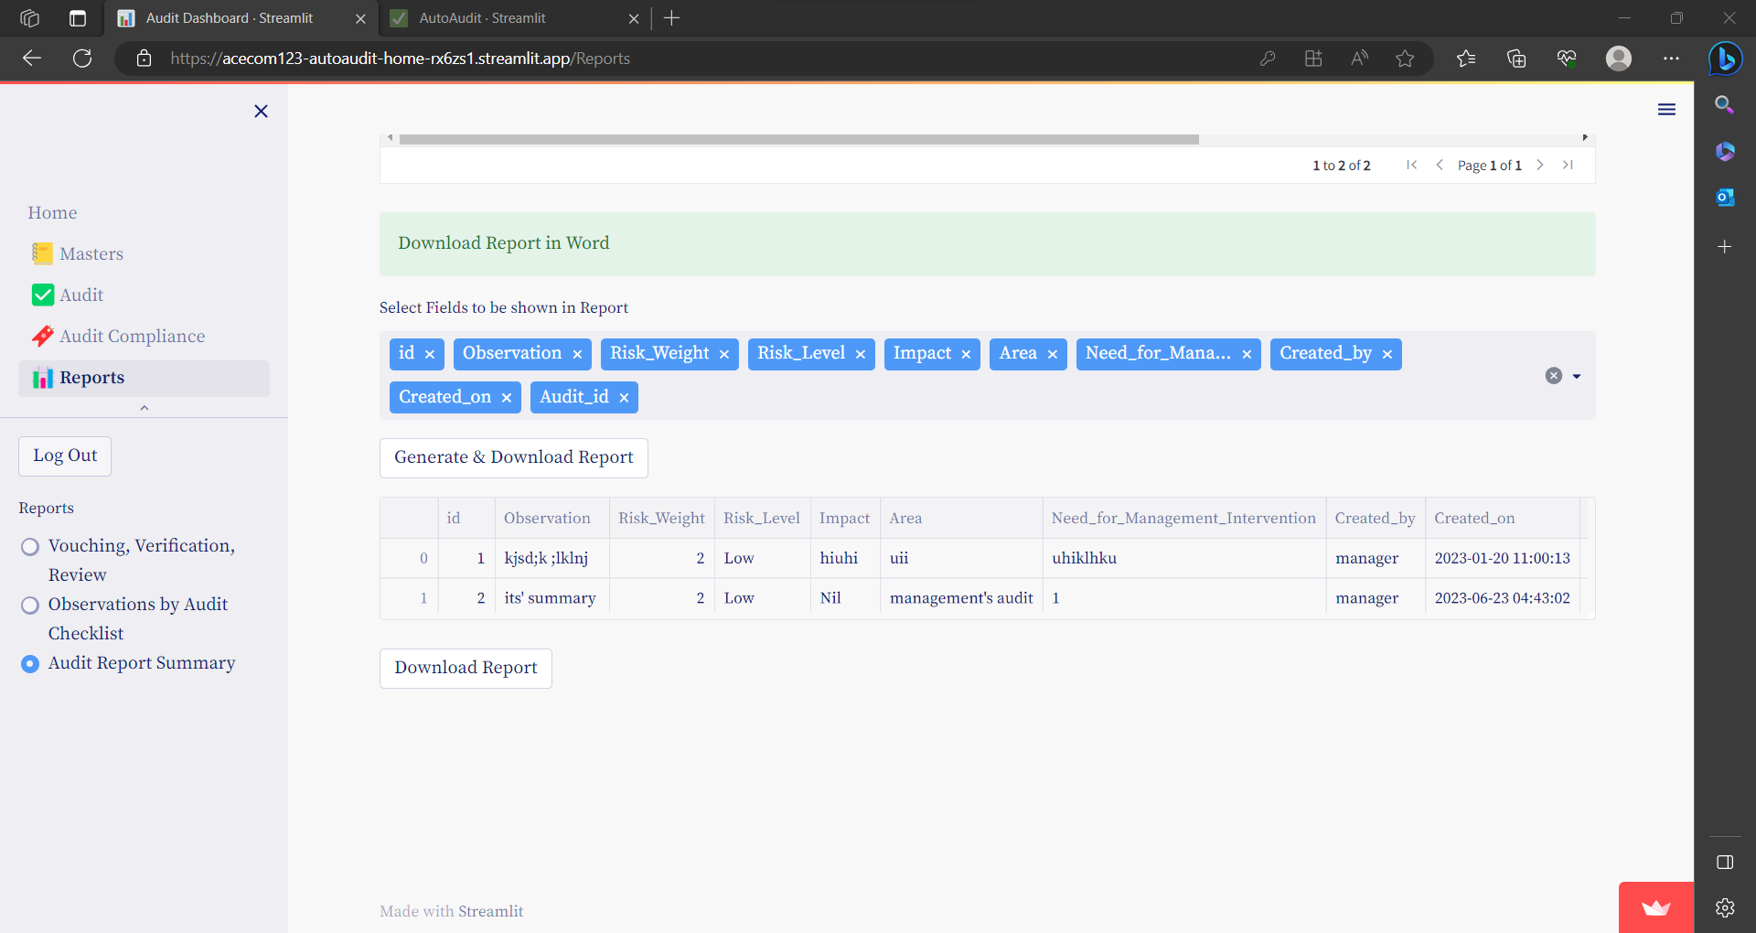

* + Now you can preview the data for report.
  + Click on **Download Report**  to download the same

#### **To Add Summary points**

* **Click on Add New to add summary points**
* **Enter details & click on Submit to save**

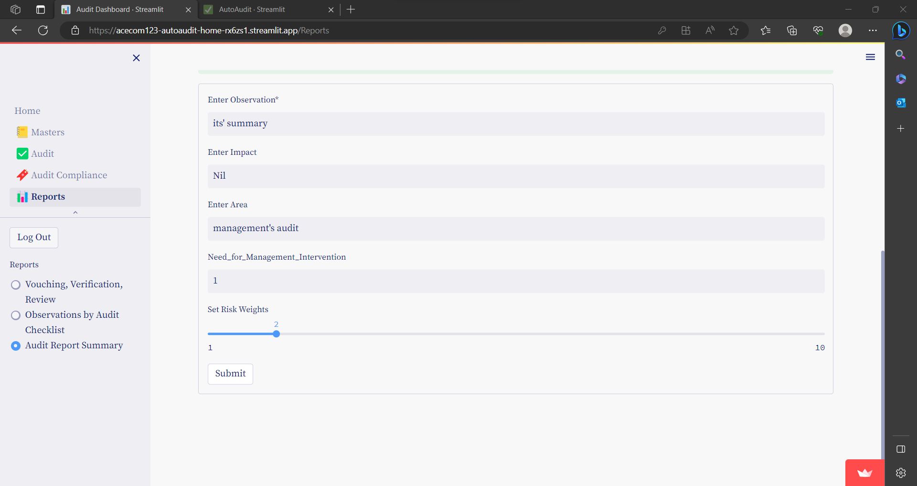

You can Modify / Delete the same.